The History of SIL and BTA Work on Manus Island

Compiled and Edited by Bill Martin (September 2012-July 2013)

Early awareness of translation need
Although SIL started work in Papua New Guinea in 1956, neither SIL nor the Bible Translation Association were formally involved in language and Bible translation work in Manus Province before 1980. A number of influential Manus people, however, were aware of the language and translation work that SIL was doing in other parts of Papua New Guinea, but before that time SIL had not officially started any work in the province.

Throughout the 1970s SIL was moving more and more toward the involvement of PNG nationals in the work of translation and literacy, and had already invited some national workers to fill some strategic roles within the SIL organization. In the mid 1970s SIL Director Karl Franklin had hired Tom Polume to function as an advisor to the SIL directorate at SIL’s center at Ukarumpa. Tom was from Loniu in Manus Province and longed to see Bible translation work happen in his home province.

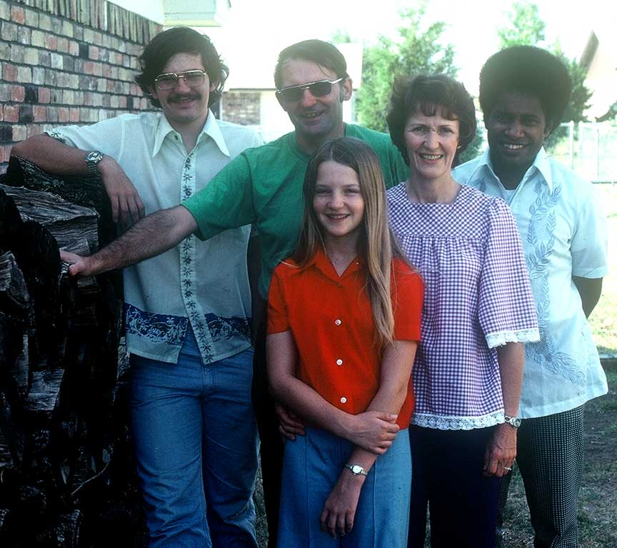 | 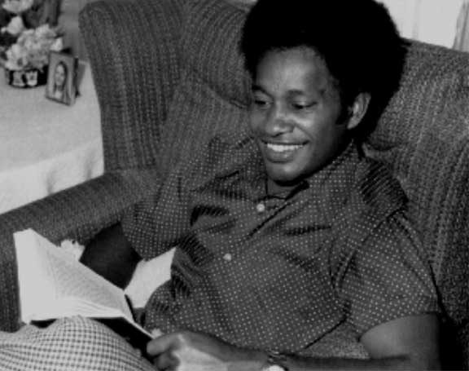
Franklin family and Tom in late 1970s | Tom Polume

Tom played a foundational role along with the next SIL Director Bruce Hooley, in the formation of a Papua New Guinean led organization called the Papua New Guinea Bible Translation Association (PNG-BTA, or just BTA), and getting BTA recognized and registered with the PNG government. Bruce Hooley asked Tom to be the director of BTA and eventually live in Port Moresby.

In 1979 Bruce Hooley invited Karl Franklin to return to PNG to develop a training course for Papua New Guinean nationals. In Port Moresby Karl and Tom went to a meeting of the Tertiary Students Christian Fellowship where Karl met David Gela who had been recruited by Tom to function as the new leader of BTA.

Tom maintained a vision for translation efforts in Manus but by 1980 had left BTA and SIL to work for the national government.

SIL conducts Sociolinguistic Surveys in Manus Province
While Karl continued to develop the BTA training course, he also laid plans for the survey of the language situation in Manus province. Karl asked Stephen and Janice Schooling to conduct a comprehensive sociolinguistic survey of Manus province. Karl accompanied the Schoolings to Manus as they commenced their survey, which they did in early 1980 over a period of 7 weeks. Karl spent the first week of that time with Cholai Polume at Loniu.

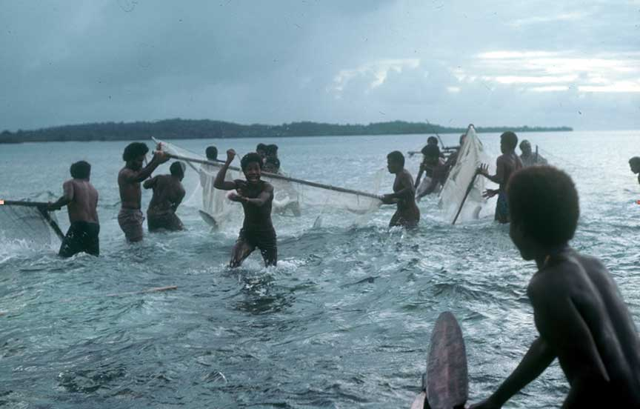
A fishing expedition in which Cholai and other village men harvest mullet.
A couple of the men were traditional fish calling experts.

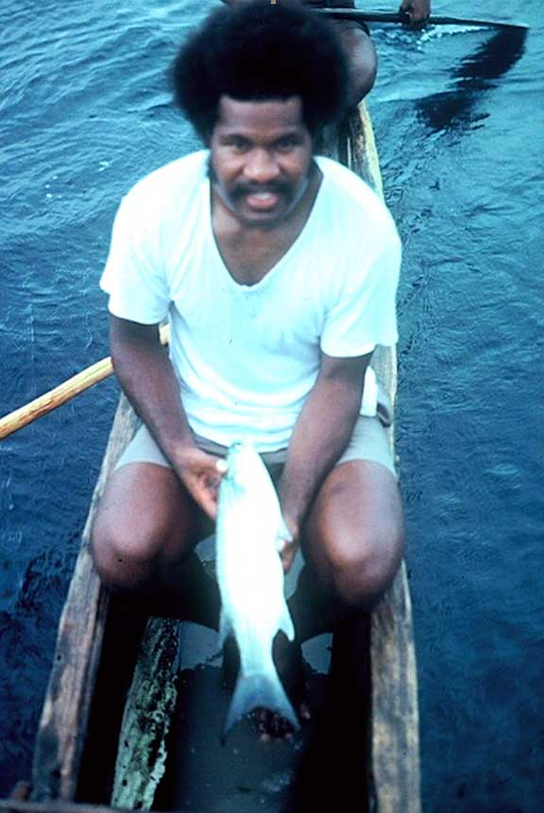 | 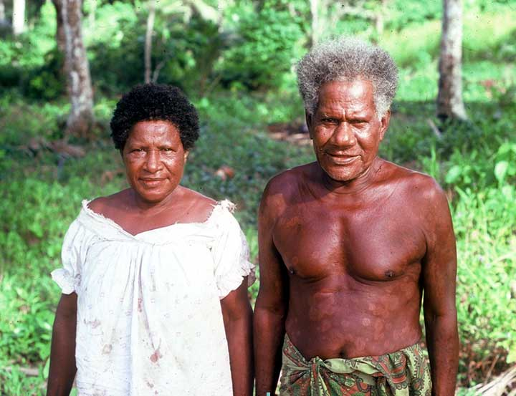
Cholai displaying a mullet | Mr. & Mrs Polume – Tom and Cholai’s Parents
The results of the Schooling’s survey indicated that the vernacular languages on Manus were still alive and well, and that many Manus people would like to see Bible translation and literacy programs conducted in their language groups. Others felt that language and literacy programs would help to preserve their cultural identities, customs and languages that they felt were being threatened with extinction.

Some people (mostly expatriates) claimed that Manus people were all eventually going to learn English and would not need a Bible translated into any of the 30 language groups that existed in Manus Province. Other people, notably many Manus Islanders themselves, felt that having the Bible translated into their own languages would be very desirable to help people understand clearly God's message as recorded in the Bible. Some also realized that the development of Manus languages would be good for vernacular education, and would be helpful for the preservation of Manus cultures and languages.

In addition to the Polume brothers, other Manus people had worked outside the province and had become familiar with Bible translation and vernacular literacy programs in other parts of PNG where Bible translation had already been done and vernacular literacy was being promoted with success. Many of those people who had worked outside Manus Island were Christians who longed to see the Bible translated and vernacular literacy promoted in their own languages back in Manus. They began asking God for help in establishing Bible translation and literacy programs back in their own language areas of Manus Province. Among them were people like Samuel Bolaubeu, a community school teacher, who as early as 1970 began praying daily that God would somehow establish a Bible translation and literacy program in his own native language of Nyindrou,

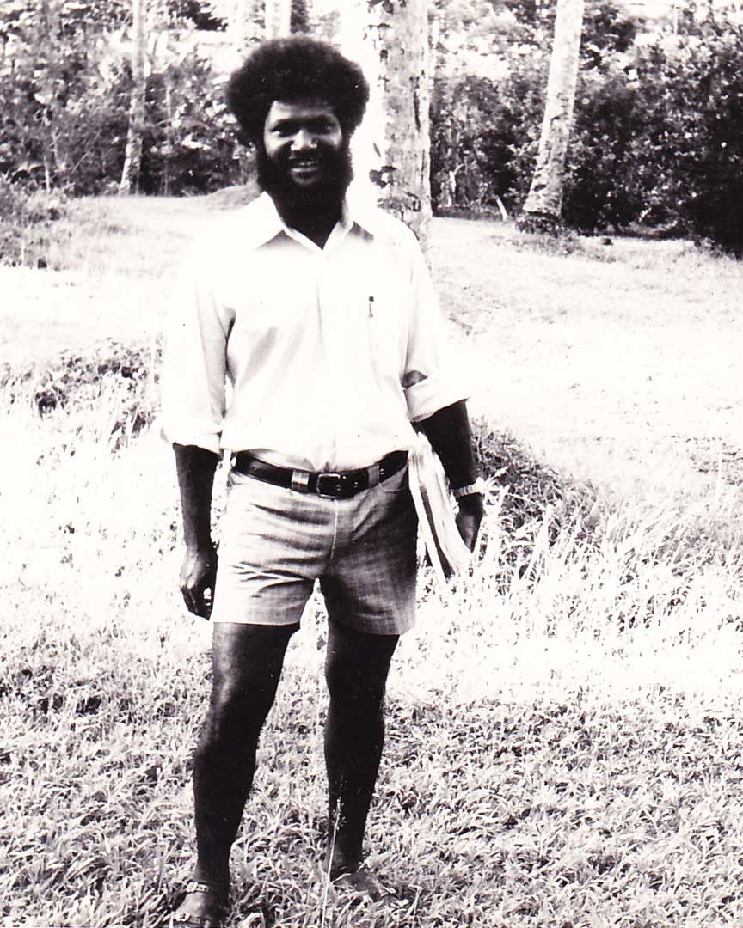
Samuel Bolaubeu started praying in 1970 that God would send someone
to help translate the Bible into the vernacular languages of Manus Province

There were also certain traditional leaders or “big men” such as Daniel Bogandi of Lessau village in the Nyindrou area who had embraced Christianity early on and supported the work of Bible translation through his prayers and influence.

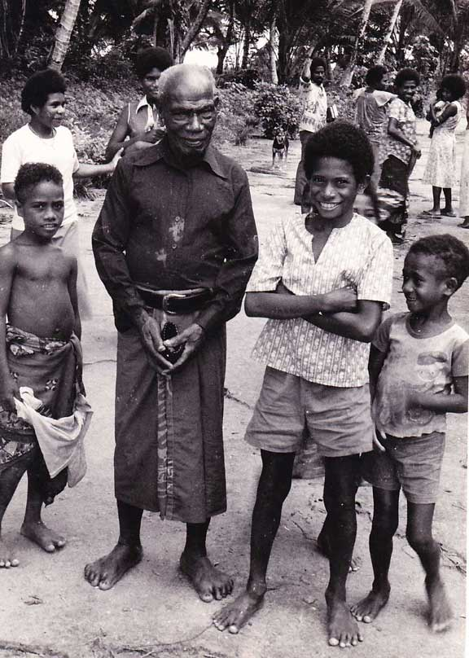
Big Man Daniel Bogandi – one of the first to welcome Christianity in Manus

In early 1980 Karl Franklin asked two SIL families who had recently come to PNG and were completing their South Pacific Field Training Course (SPFTC), to spend several weeks living in Manus villages in order to follow up and build on the earlier survey done by the Schoolings. One family was Dixon and Doralice Barthel (and their 3 children Vincent, Tony and Nathan). The other family was Keith and Ruthann Lusk (who later had a girl Carrie Beth).

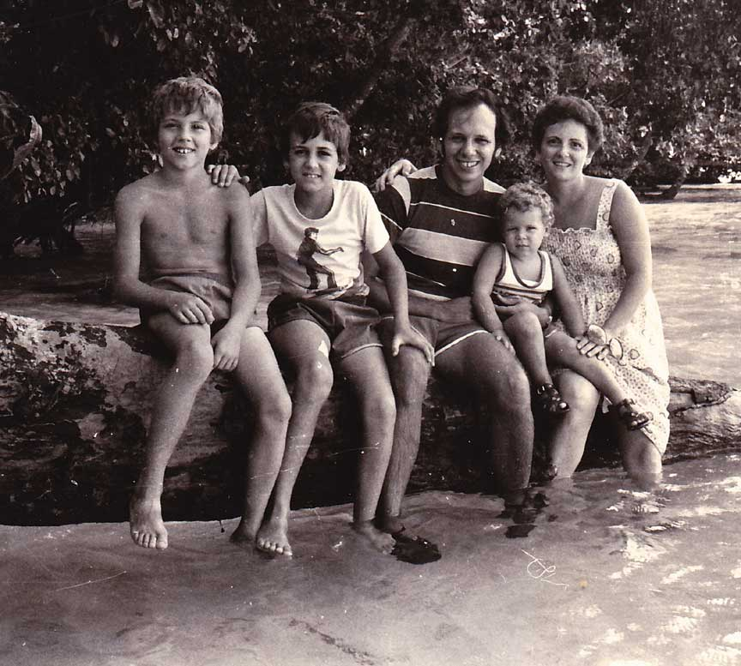 | 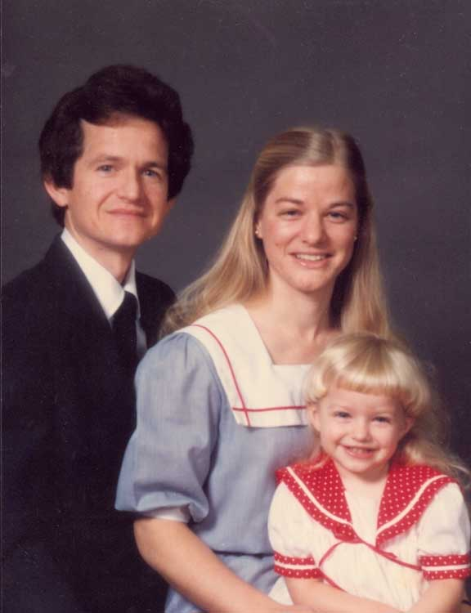
The Barthels  Tony, Vincent, Dixon, Nathan & Doralice | The Lusks  Keith, Ruthann and Carrie Beth

The Barthels lived as guests of the Lele people in Tingou village, and the Lusks lived as guests of the people in Loniu village. Based on their individual survey work the Barthels felt God's call to work among the Lele people, and the Lusks felt God's call to work among the Titan people living at Langendrowa plantation on Rambutso Island.

Before they started living among the Titan people, Keith gathered census data and prepared the first comprehensive language map of Manus Province (see next page). Keith spent countless hours in the Lorengau market and other places interviewing people from all over Manus Province in order to determine the borders of the language areas in Manus Province, and he used electoral maps and village population counts to estimate the size of each language group.

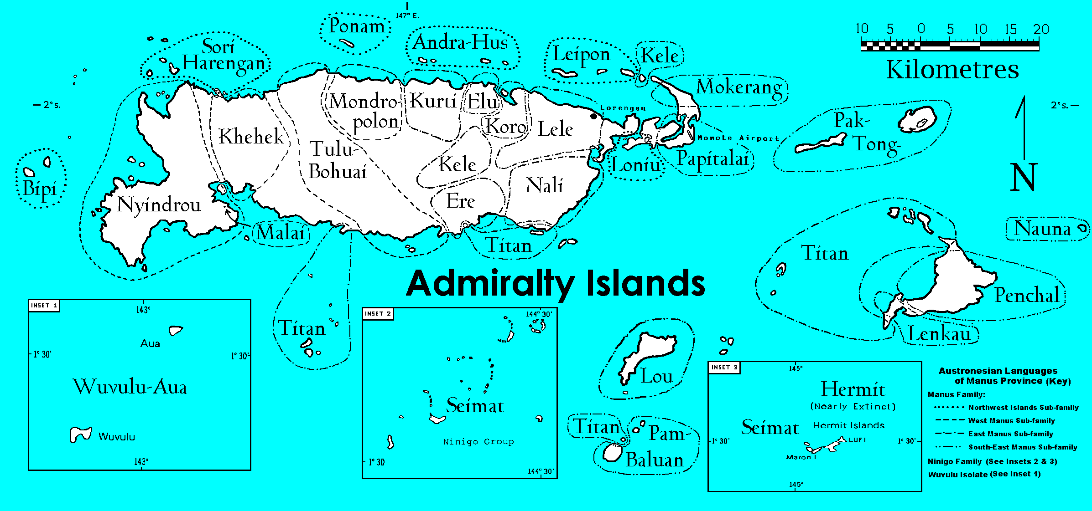
Manus Languages and Population Data (2000 Census Total – 44,180)

1. Andra-Hus 1410 | 6. Kele 1460 | 11. Lele 3400 | 16. Mokerang 300 | 21. Pak-Tong 1090 | 26. Seimat 1240
2. Bipi 1380 | 7. Koro 810 | 12. Lenkau 380 | 17. Mondropolon 530 | 22. Pam-Baluan 2000 | 27. Sori-Harengan 770
3. Elu 600 | 8. Khehek 1620 | 13. Loniu 780 | 18. Nali 2900 | 23. Papitalai 420 | 28. Titan 5100
4. Ere 1400 | 9. Kurti 3500 | 14. Lou 1230 | 19. Nauna 420 | 24. Penchal 1060 | 29. Tulu-Bohuai 1970
5. Hermit < 10 ? | 10. Leipon 1320 | 15. Malai 90 | 20. Nyindrou 4800 | 25. Ponam 630 | 30. Wuvulu-Aua 1560

As the Lusks and Barthels wrote up the findings of their experiences in Manus they invited two other new families (who already were friends of the Lusks and Barthels at SPFTC and had a prior interest in Manus) to also become involved in surveying and launching new language and translation programs in other strategic parts of Manus Island. Those families were Bill and Lenore Martin (and their two children Joel and Jason), and Wes and Alta Beasley (and their two children Jonathan and Adam, along with Adam and Jonathan's school teacher Dianne Miller).

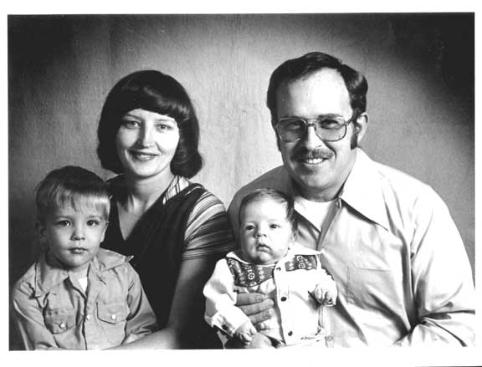 | 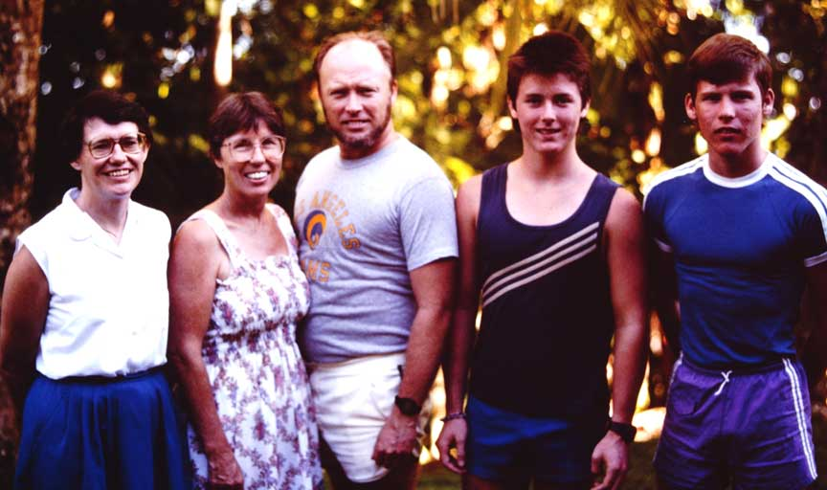
The Martins – Joel, Lenore, Jason and Bill | Diane Miller, Alta, Wes, Adam & Jonathan Beasley

After visiting Manus Island and conducting their own sociolinguistic surveys, the Martins felt called to begin work with the Nyindrou people on the west coast (based at Lessau), and the Beasleys felt called to begin work among the Kurti people (based at So-uh).

The Beasley family came to PNG under the direction of Pioneer Bible Translators and the other three families came to PNG under the direction of SIL. All four expatriate families were of one mind in working under the direction of the PNG BTA, and cooperating with the churches and missions on Manus Island.

Language and cultural learning
After extensive survey work the Barthels, Lusks, Martins and Beasleys began living among the four largest language groups in Manus Province in 1981. Each family lived in a village within the language area - interacting daily with the local people, and learning their language and customs.

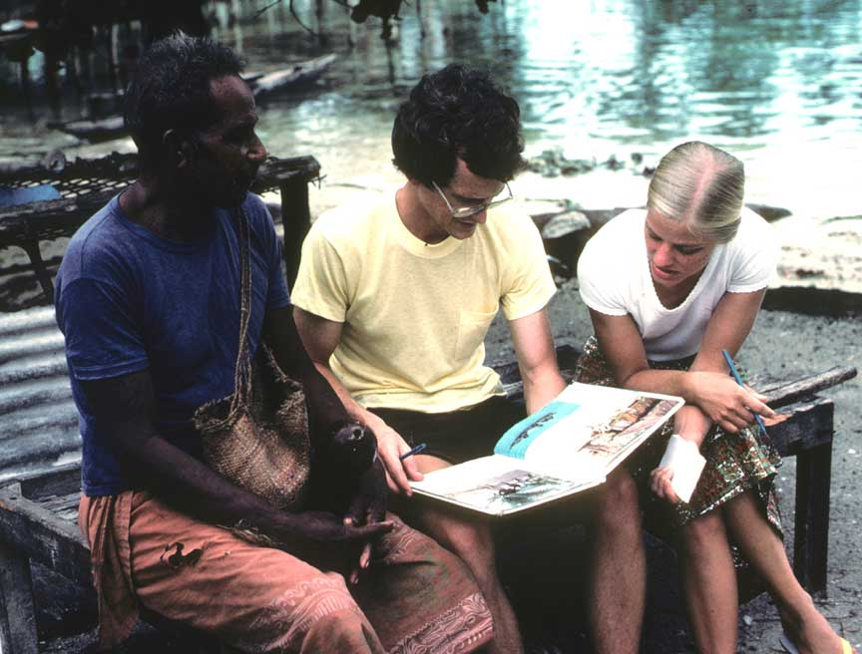 | 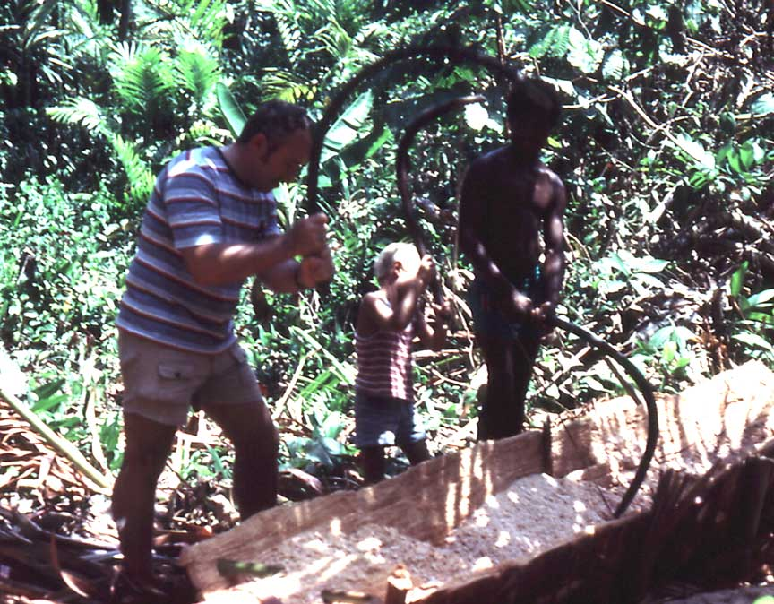
Keith and Ruthann learning the Titan language | Bill & Joel learn to beat sago

As they progressed in their understanding of the local people, they began encouraging local people to become involved in the language, translation and literacy work. They offered training courses at the village level in Alphabet formation, Bible translation techniques and literacy.

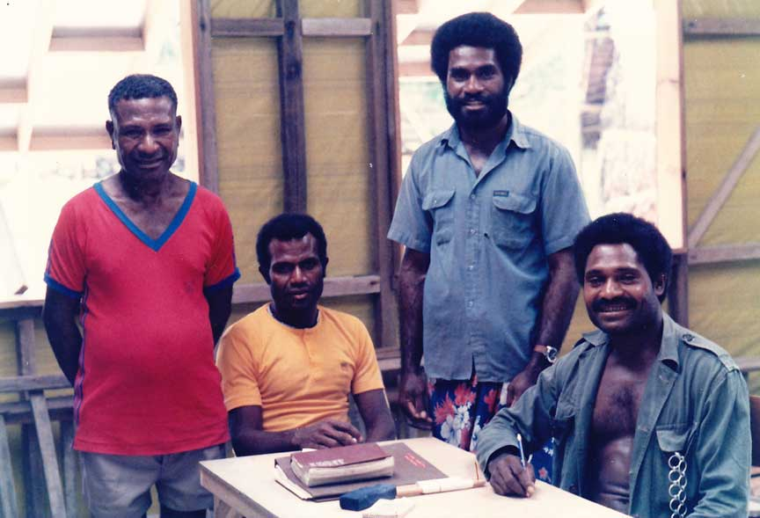 | 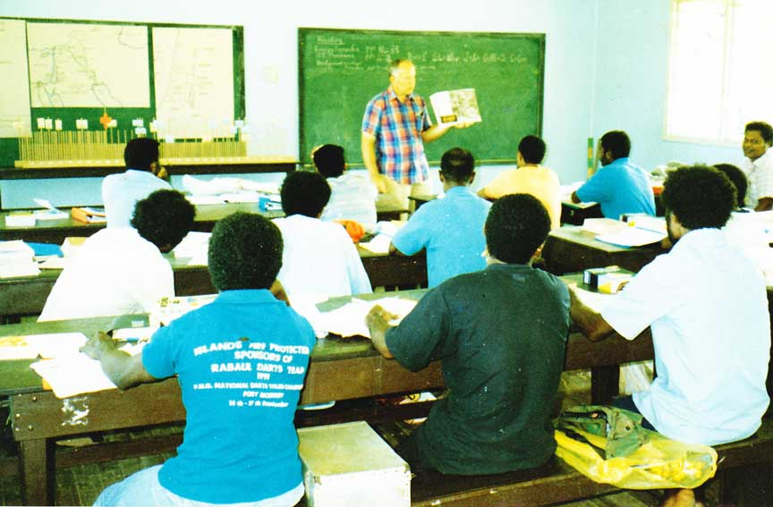
Francis Tule-eu, Michael Lus,  Timothy Kundrake & Bernard Laban | 1993 National Translators Course held in Lorengau town.

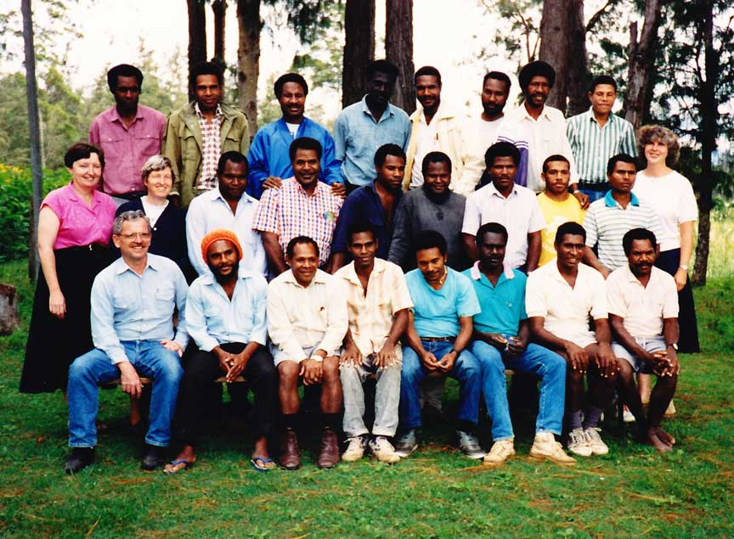
Students and Study Skills staff at a National Translators Course Ukarumpa

In most cases, local Manus people form committees to help oversee the language alphabet and translation work. For example, in the Nyindrou area the Nyindrou Alphabet Committee was composed of Timothy Kundrake, Bernard Laban, Robert Kowak, Charles Kowak, Samuel Bolaubeu, Jessie Siraon, Jonah Labanas and Matthew Kubesan. Bill Martin met weekly with them for several months and helped them to devise a suitable alphabet for the Nyindrou language. Bill Martin compiled the results of their work in a Nyindrou-English Practical Phonology which became a practical guide usable by Nyindrou people interested in reading and writing the Nyindrou language as well as resource for the development of vernacular prep school materials.

Committees also formed to oversee and to review the translation work drafted by their national translator coworkers. Committees often rely on older villagers as they discuss the best and most natural way to translate key Biblical terms in the local language. The committee also becomes a sounding board for village testing of a translation before it is submitted to a translation consultant who works with the national translator and other local speakers in order to conduct checks that test the translation for accuracy and clarity in the language.

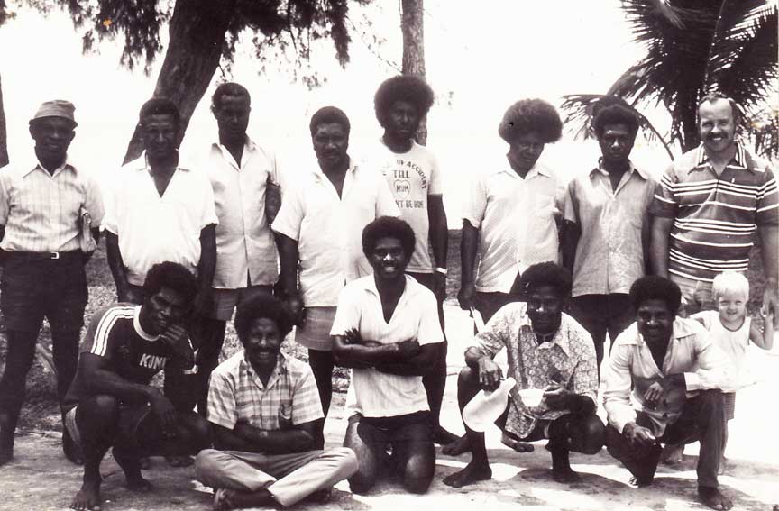
The Nyindrou Translation Committee 1982-1983

Consultants and advisors from SIL and BTA have led a number of workshops and training courses in Manus. These have included courses in translation principles, literacy teacher training, Bible culture and communications, and workshops focused on a particular book of the Bible.

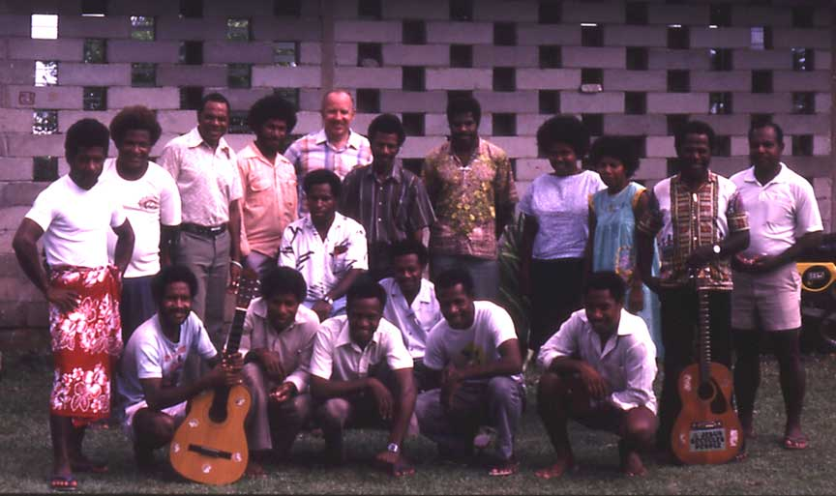
1989 National Translators Course held in Manus

A Tok Ples School Teacher Training Workshop was held up the highway in Manus in which was staffed by Luke Pahun, Charles Kowak, Bernard Laban, David Ndrayeu and Bill Martin.

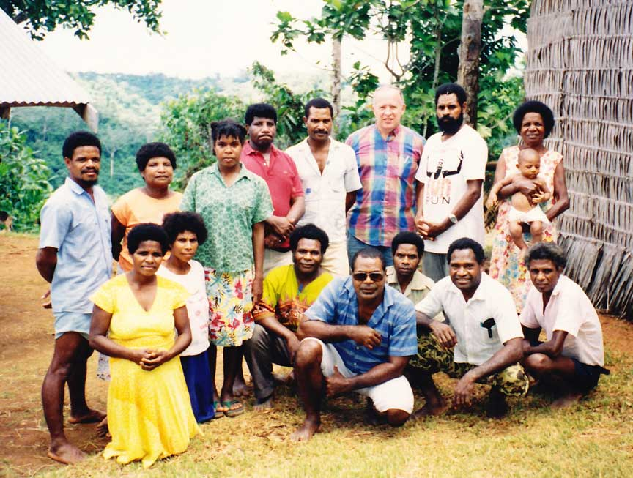
1993 TPS Teacher Training Workshop

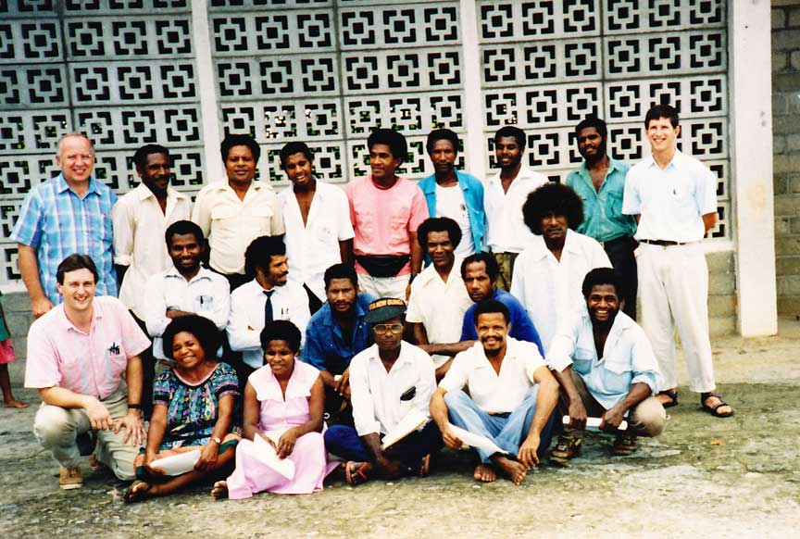
National Translators Course 1a – Lorengau 1994

A one book workshop was conducted by BTA personnel Duncan Kasokason and Daryl Brenton on the book of Jonah at Lugos in Manus Province from February 19th to March 8th 2007. There were 30 participants representing 8 languages in Manus.

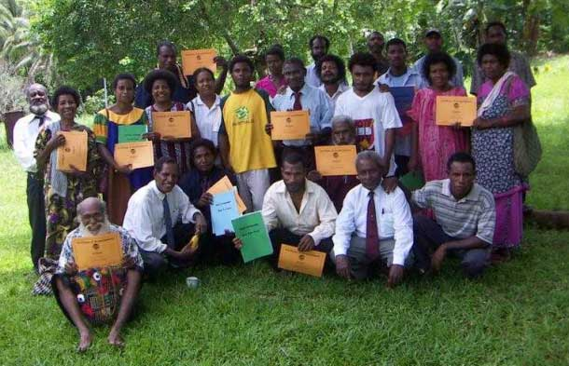
2007 Manus Jonah Workshop Graduates

During graduation many important people from government and churches were invited. The Manus administrator Mr. Web Kanawi and ECOM President and Chairman of the churches of Council Mr, Tim Ponpon attended the graduation. They pledged to support the work of Bible Translation and Literacy in Manus Province. During the Jonah workshop, former Governor Mr Stephen Pokawin came to the class and encouraged the participants in the work of Bible Translation. Mr. Pokawin had translated a Lele Dungou Hymn Book and has also been working on a translation of the whole New Testament.

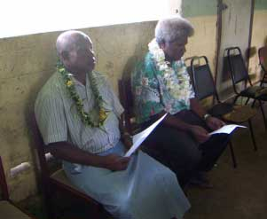
Mr. Web Kanawi & Mr. Tim Ponpon | Daryl, Steven Pokawin & Duncan

Besides Bible translation, other language development activities are also part of the goals of SIL and BTA.

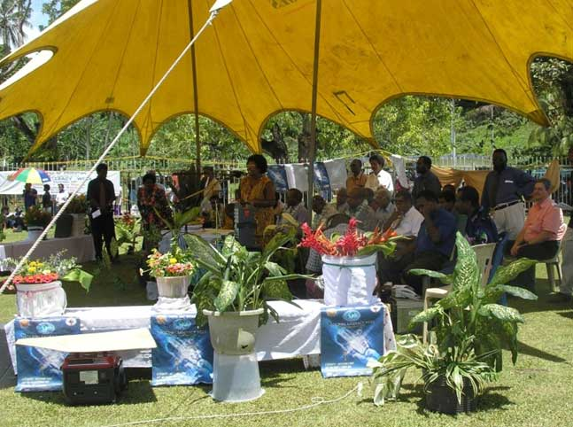
On 4 September 2007, Jerry Pfaff (far right) represented SIL and BTA at the opening of National Literacy Week ceremonies at the Lorengau Market

There are many Manus people who work in jobs outside Manus Province. One of the goals of the Manus translation programs is to connect with those people and involve them as much as possible in the translation programs that are happening in their own language areas back in Manus. Efforts are made to get copies of Scripture books into the hands of Manus people working outside the province. In 2011 and 2012, some of the translation work from Manus Province became available on the Internet in a form that can be downloaded and read on smart phones.

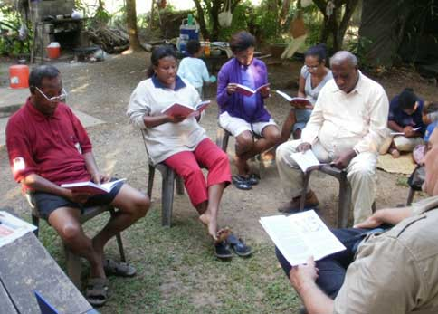 | 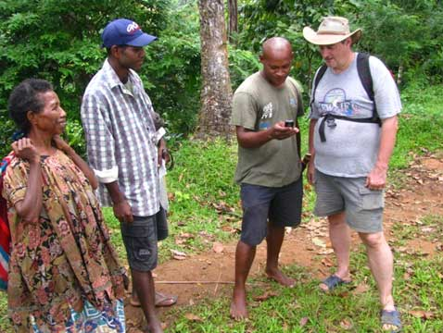
Jerry Pfaff meets with a number of Nali speakers at the Waigani Christian Centre in Port Moresby in July 2011, to read some of the translation of Nali Genesis. (Elias, Mishelle, and Paul Masta in foreground.) | Nali translators Martha and Thomas Pohonum (left) watch as another Nali speaker gains access to Genesis 1 in Nali on his smart-phone.

Expanding SIL/PNGBTA involvement in other Manus language groups
Jerry and Susan Pfaff - 1987 Nali (Karun); NT nearing completion
Stephan Beard – Khehek (Ndrehet)1989
Robert and Verna Stutzman – 1991 Lou Island
Vinton and Audrey Goff – 1992 Wuvulu in Western Islands
Bob and Marla Uebele – 1993 Kurti (Kari)
James and Lois Hafford - 1995 Wuvulu Wuvulu; Completed NT dedicated in 2005
Bob and Barbie Hauser – 2001 Titan (Pere)
Beata Wozna and Theresa Wilson - 2002 Seimat in Western Islands; Completed NT dedicated in May 2013

Time line of SIL/BTA involvement in Manus Province

1979 – Stephen and Janice Schooling conduct preliminary sociolinguistic survey of Manus Province. Translation need established.
1980-1981 – Four teams allocate to open up Manus as a “BTA” Province (Bill & Lenore Martin/Nyindrou, Keith & Ruthann Lusk/Titan, Dixon & Doralice Barthel/Lele, and Wes & Alta Beasley (PBT)/Kurti
By 1987 two teams had left (Lusk, Barthel), and the third (Beasley-PBT) left soon thereafter as well.
1987 – Jerry & Sue Pfaff allocate with Luke Pahun (BTA) to Nali language area
1989 – Stephan Beard allocates to Khehek
1991 – Robert & Verna Stutzman allocate to Lou;
1992 – Vinton & Audrey Goff allocate to Wuvulu
1993 – Bob & Marla Uebele take over vacated Kurti project
1995 – James & Lois Hafford take over vacated Wuvulu project
2001 – Bob & Barbara Hauser take over vacated Titan project
2002 – Theresa Wilson & Beata Wozna allocate to Seimat language area in Ninigo Islands
2002 – Nyindrou New Testament dedicated
2005 – Wuvulu New Testament dedicated
2013 – Seimat New Testament dedicated
201? – Lele New Testament to be dedicated. Stephen Pokawin is working on a translation in his Lele dialect and hopes to finish some books by 2014
201? – Nali New Testament to be dedicated
As of 2012 Titan, Kurti, Khehek, and Lou have no current expatriate involvement

Limitations of expatriate involvement in Manus
The expatriate members of SIL and PBT are all volunteers who have come to PNG at their own expense. They do not receive a guaranteed salary for their volunteer work, but are supported by Christian friends, Churches and family members who pray for them and contribute monetary gifts to meet their financial needs. The length of time SIL and PBT expatriate families are able to spend working in a language program away from their home countries varies and is dependent on many factors. Those factors include their health, the level of financial support they receive from their home country donors, the level of involvement they receive from individuals and churches in the local language communities, and the needs of their children on the field, as well as parents and other family members back in their home countries.

A number of SIL and PBT families were not able to continue their language and translation programs in Manus Province:
Keith and Ruthann left the Titan program 1987 after Keith Lusk died of liver cancer. (Bob and Barbie Hauser resumed SIL's involvement in the Titan program in 2001).
Barthels left the Lele program in 1987.
Beasleys left the Kurti program in 1988 (Bob and Marla Uebele resumed SIL's involvement in the Kurti program in 1993).
Vinton and Audrey Goff left the Wuvulu program in 1994 (James and Lois Hafford resumed SIL's involvement in the Wuvulu program in 1995).
Robert and Verna Stutzman left the Lou program 1995.
Stephan Beard died in 1999 while on furlough.
Bob and Barbie Hauser left the Titan program in 2004.
Bob and Marla Uebele left the Kurti program in 2004.

Manus Language Programs with SIL/PNGBTA Involvement

Lele
SIL members Dixon and Doralice Barthel began living in Tingou village with the Lele people in 1981.

Below are a collection of images that depict some of the activities the Barthels undertook and the people they got to know while on Manus during their seven years there with SIL.

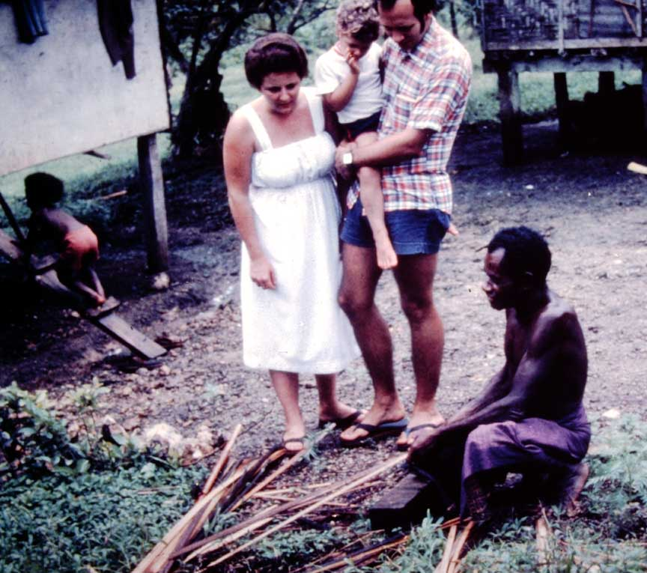
Dixon, Doralice and Nathan watching the preparation of house building materials

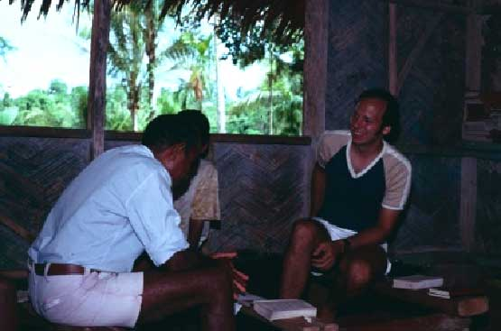 | 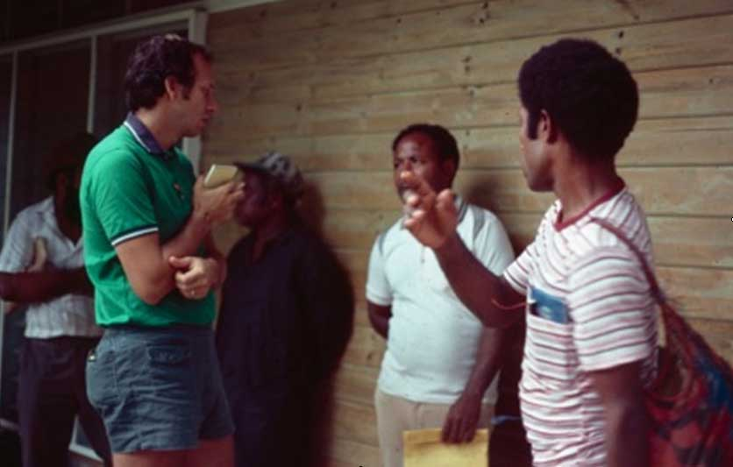
Going over texts with some friends | Hanging out with more friends

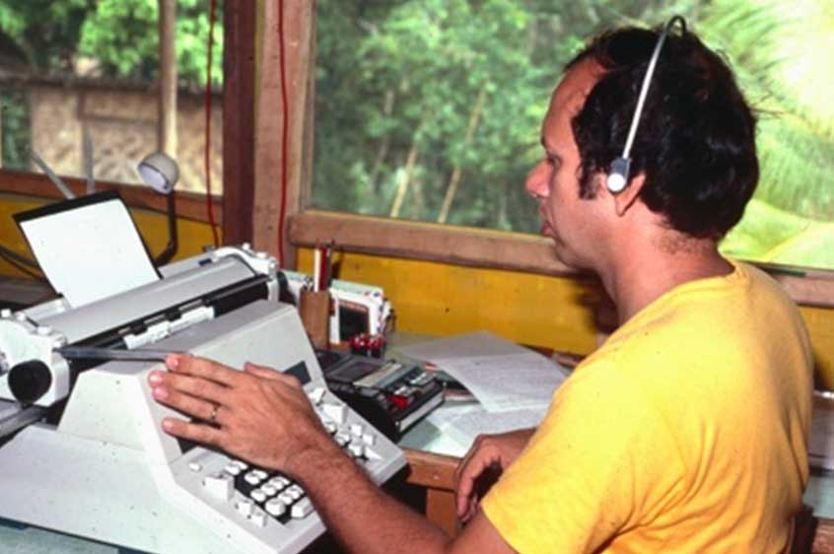 | 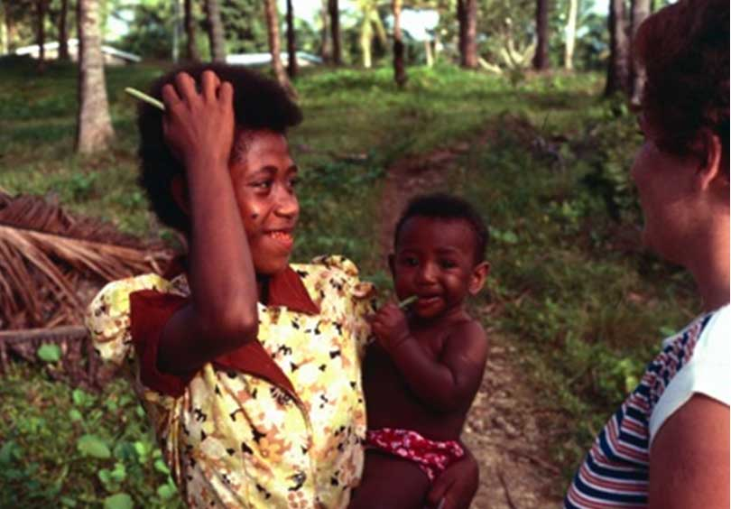
Dixon transcribing recorded stories | Doralice gets to know some folks

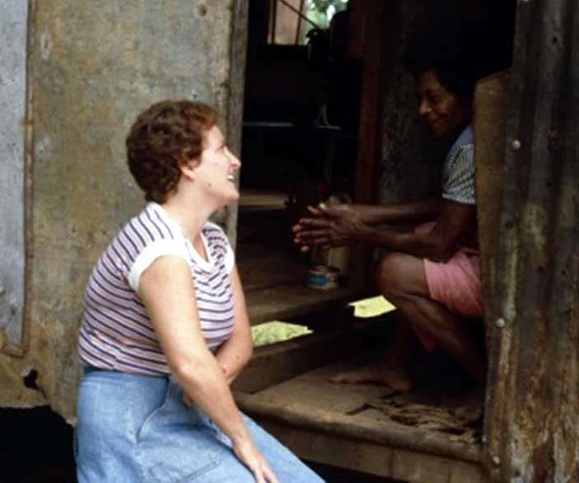 | 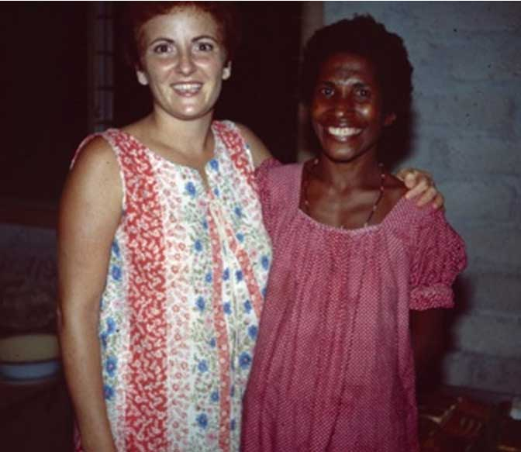
Doralice visiting with Sees | Visiting with Pisouka

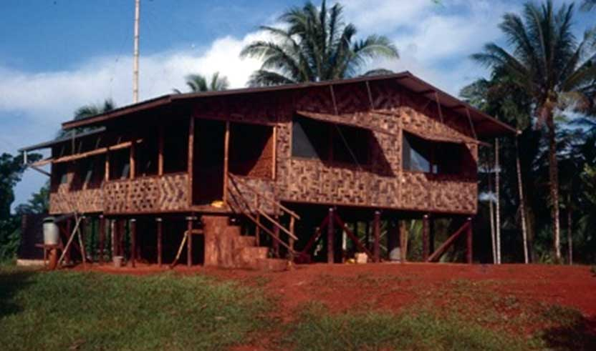
Barthel’s house in Tingou

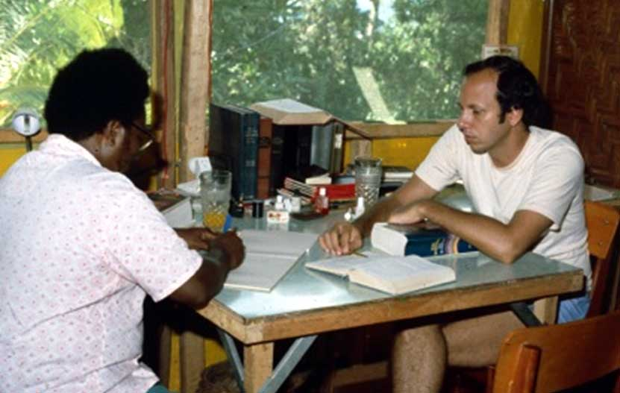
Gideon Pranis and Dixon working on translation

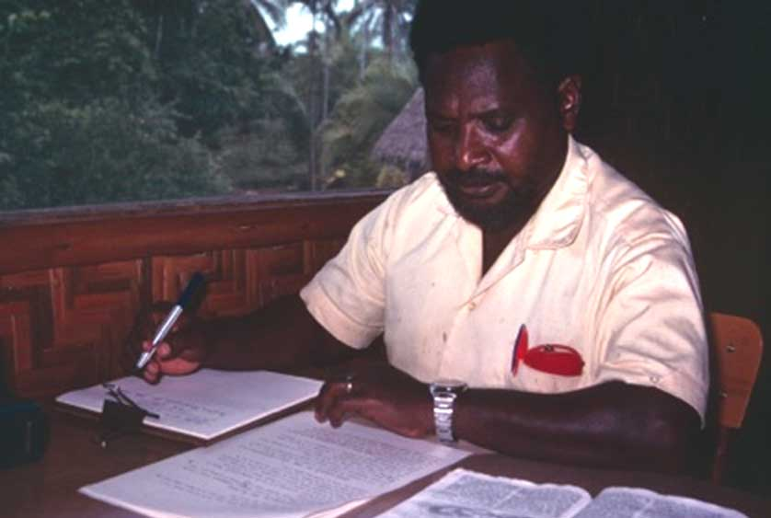 | 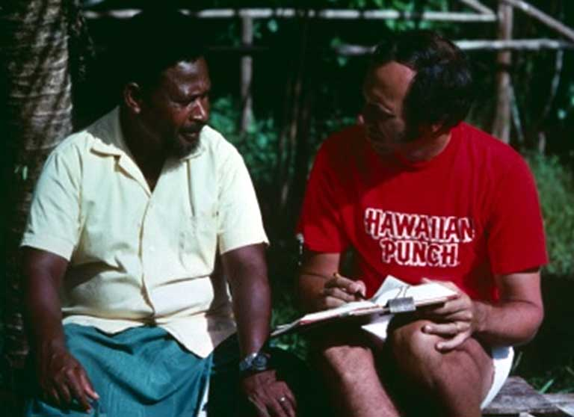
Gideon hard at work | Gideon and Dixon checking translation

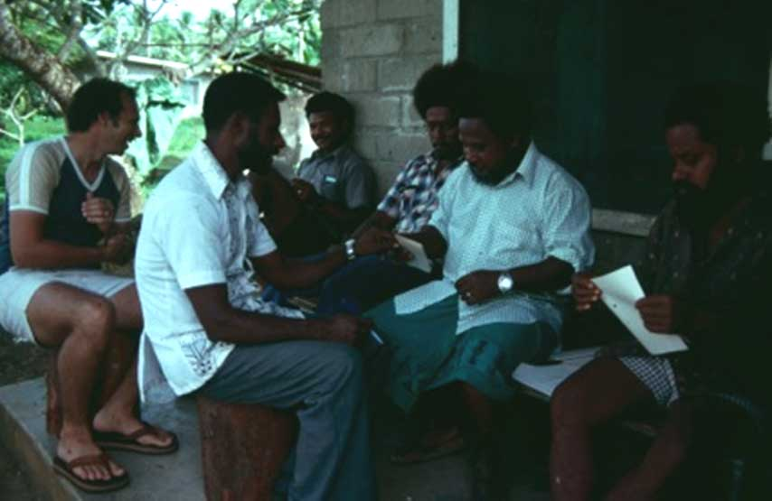
Reading each other’s stories

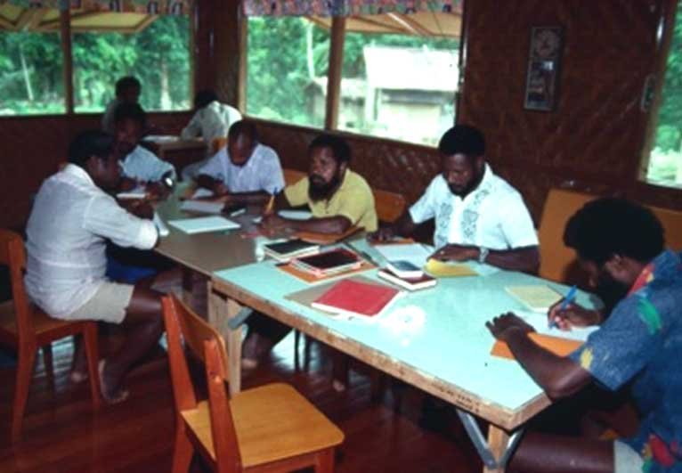
A writer’s workshop – writing and printing stories in Lele

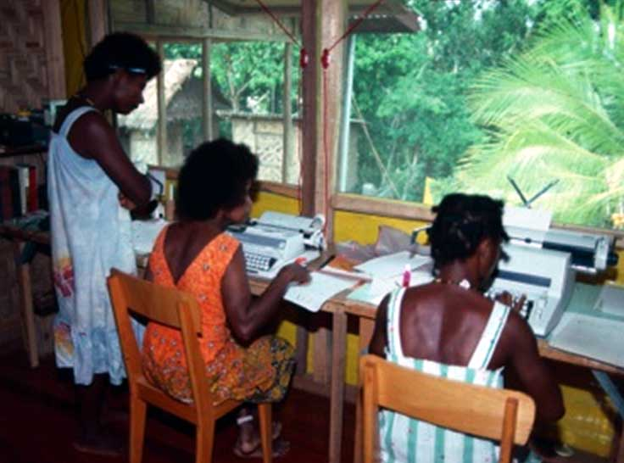
Typing stories from the writer’s workshop

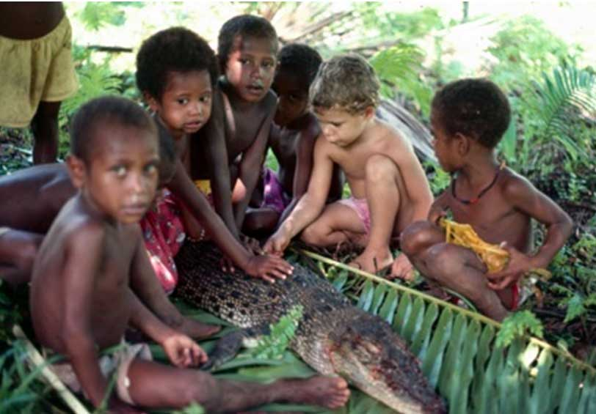
Nathan and his friends checking out a pukpuk

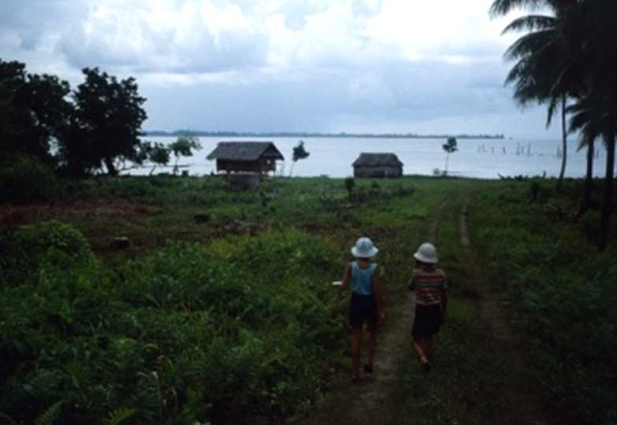
Vincent and Tony head for the beach

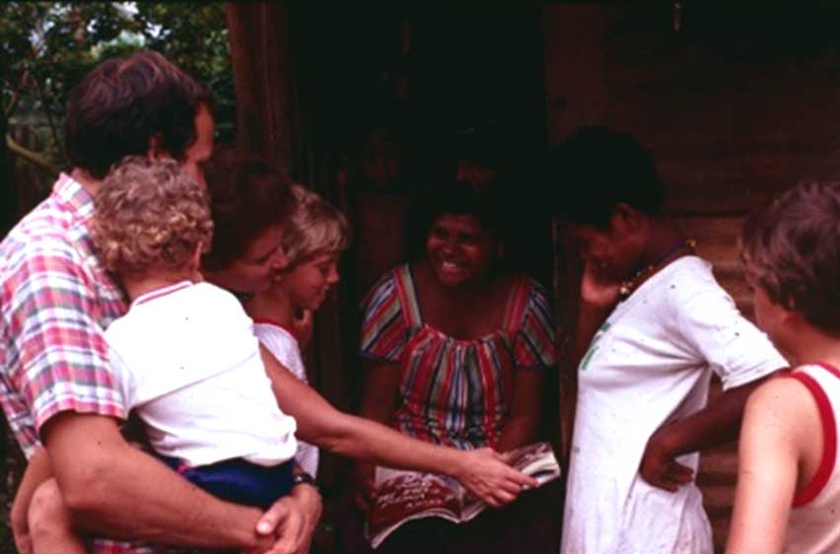
Visiting in the village

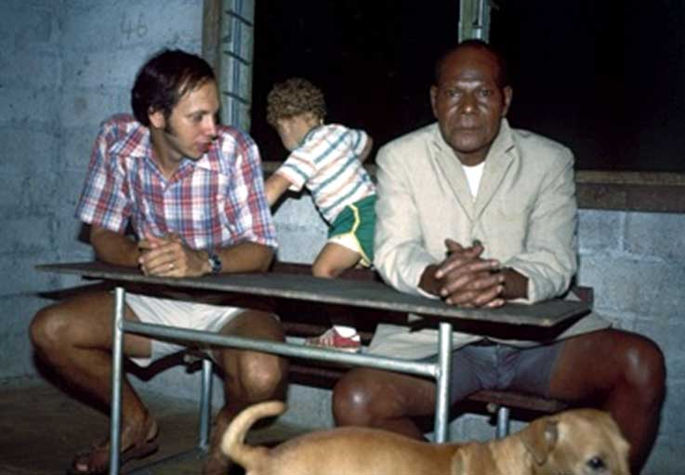
Hanging out with village Papa – Job Posing

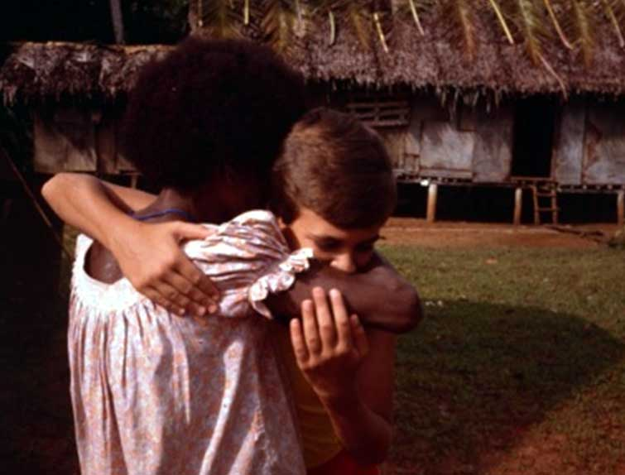
Saying goodbye

Nyindrou
SIL members Bill and Lenore Martin began living in Lessau village with the Nyindrou people in 1981.

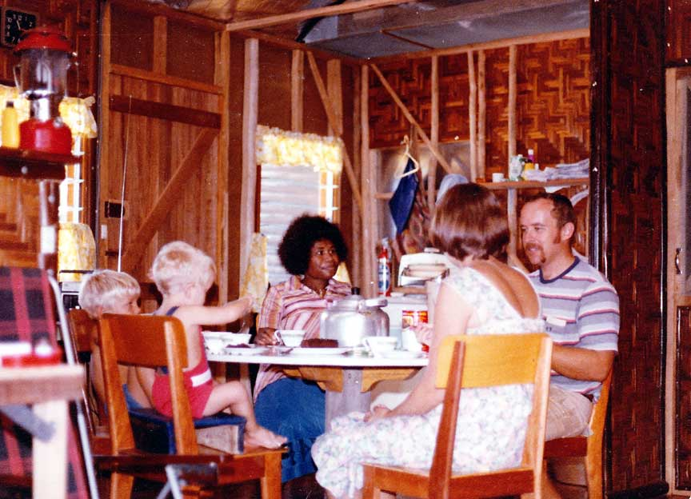 | 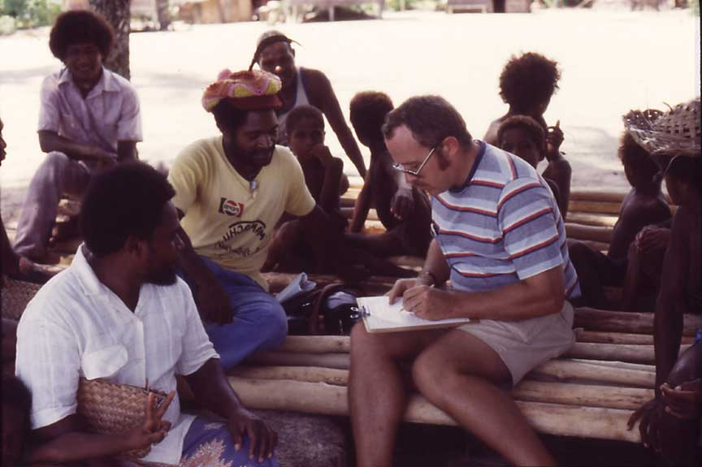
Martins eating lunch with Maria | Bill collecting language data

They were welcomed by the Lessau community who helped them to learn their language and culture.

When the Martins first arrived in the language area the village committee Peter Kewas allowed them to use his new bush house for about 6 months while Bill and Lenore built their own house with the help of a number of Nyindrou people.

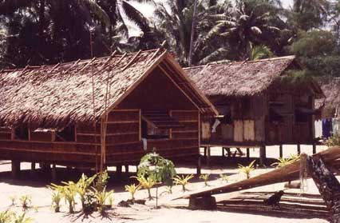 | 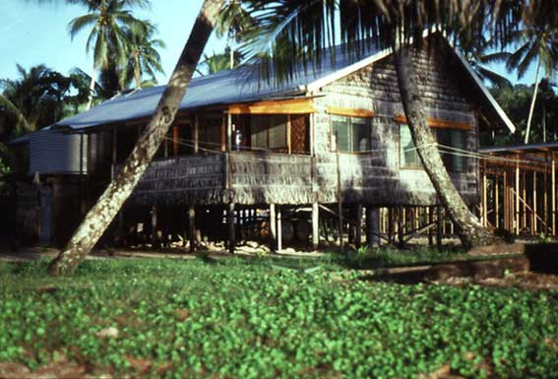
Peter Kewas’ new house (on left) | Martin’s own house at Lessau village

As Bill and Lenore learned the Nyindrou language, Bill organized the language data he had been gathering and began meeting with a group of Nyindrou people on a weekly basis to discuss with them how to spell the Nyindrou language. The alphabet meetings were composed mostly of Nyindrou speaking community school teachers, and they formed the Nyindrou Alphabet Committee.

Lenore was kept busy home schooling their sons Joel and Jason.

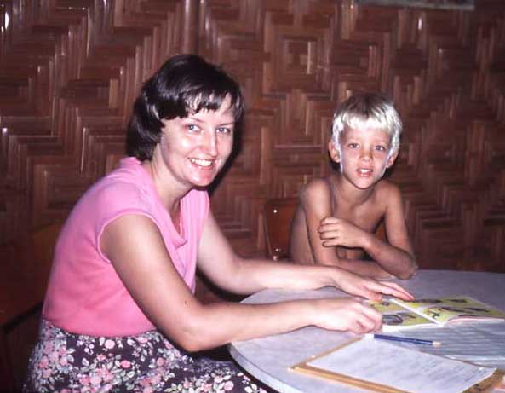 | 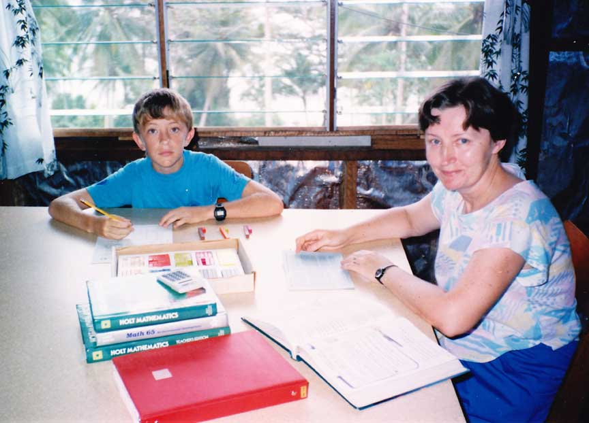
Home schooling Joel in the village | Home schooling Jason in the village

The Martins made it known that their desire was to train Nyindrou people in all aspects of the Nyindrou language and translation program. By 1982 they began working with Timothy Kundrake who was keen to translate the Bible into his own language.

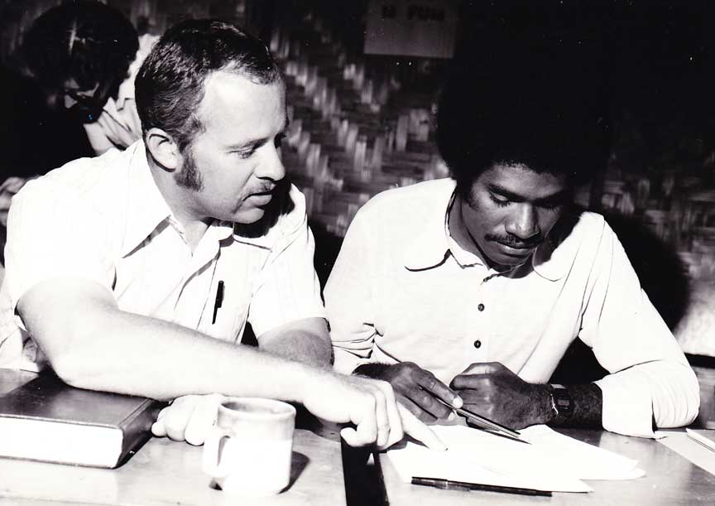 | 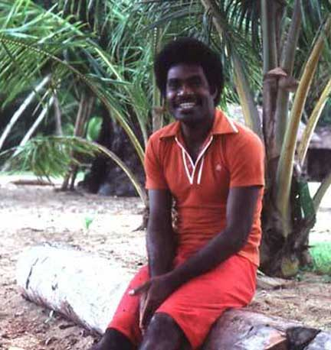
Bill and Timothy | Timothy at Nihon village

Bill mentored Timothy in the village and also by functioning as his advisor during three National Translators Courses held at SIL's Ukarumpa center in the PNG Highlands from 1982 through 1984.

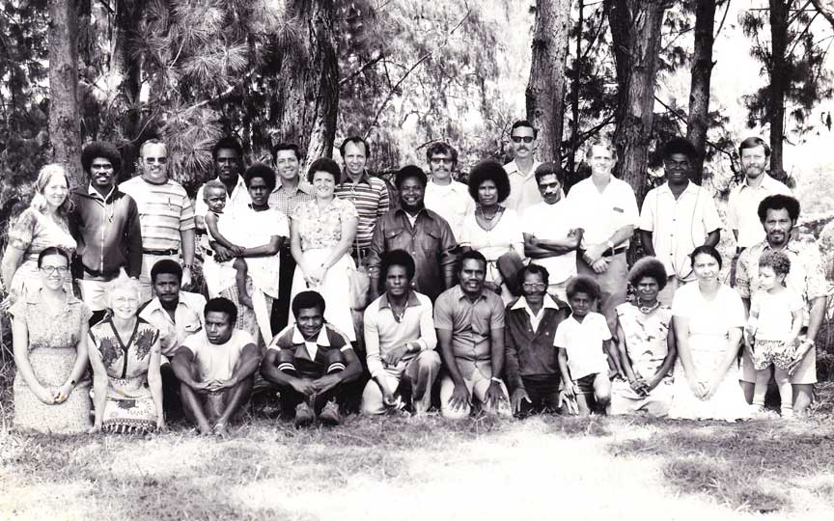
National Translators Course Ukarumpa 1982

During that period Timothy and other interested village people formed the Nyindrou Translation Committee which functioned to oversee the Nyindrou program.

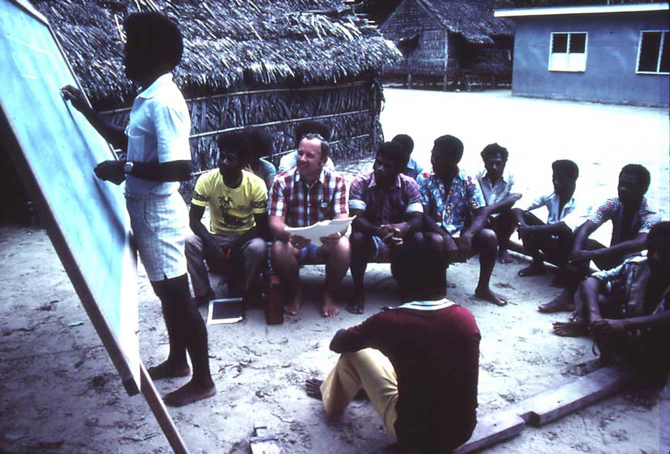
The Nyindrou Translation Committee discussing key Biblical terms

Bill, Timothy Kundrake and Charles Kowak contributed to a Nyindrou Dictionary that was published in the “Comparative Austronesian Dictionary An Introduction to Austronesian Studies” edited by Darrell T. Tryon. De Gruyter Mouton. 1995. Pages 667-672. eBook ISBN: 9783110884012.

The Nyindrou Translation Committee was composed of older Nyindrou speakers as well as young speakers. The younger members had the energy and creative ability to draft translation. The older speakers could speak with authority and experience in matters of making the translation sound like genuine Nyindrou speech, suggesting ways to enhance the fine details of the translation.

The translation work advanced like the work of creating a canoe out of a large tree trunk. The strong younger canoe builders would rough cut out the main proportions of the canoe's shape and do the hard work of hollowing out the interior of the canoe and pulling it through the jungle to the ocean where it could be floated to the village for its completion.

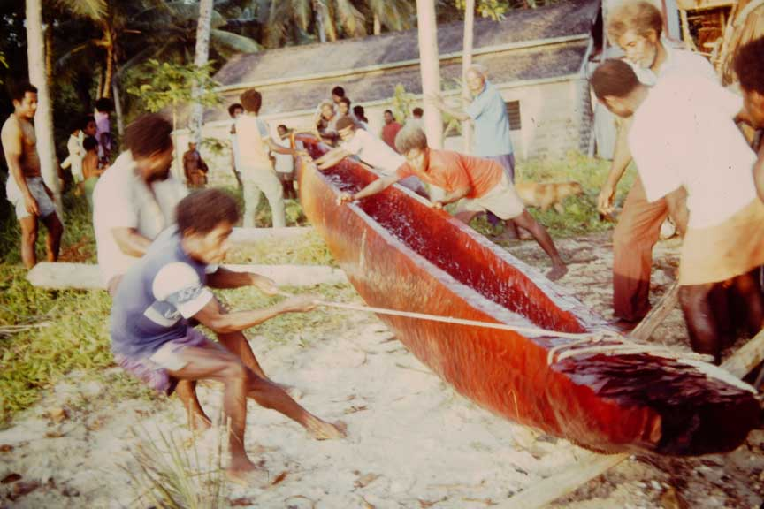 | 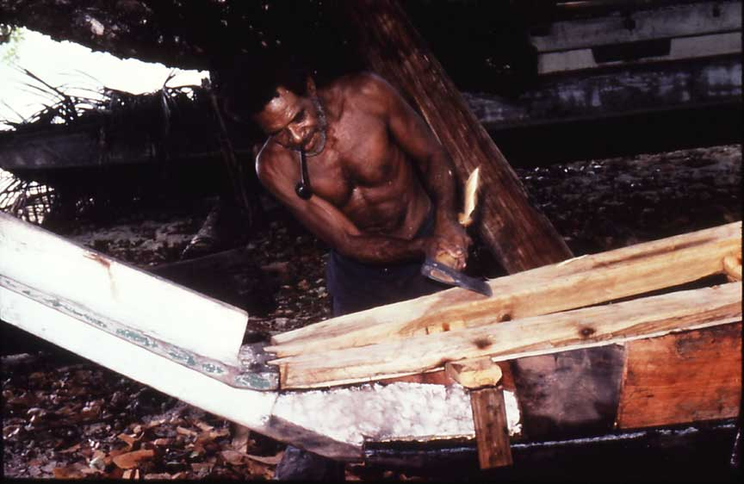
The work of getting the rough canoe to the village is like the rough draft of a translation | The work of crafting the canoe into a work of art is like the village testing, checking and polishing of a translation

The older experienced experts then were called in to refine the fine details of the work, giving advice on how to shape and polish the work into a masterpiece. This process is called village testing of the translation.

When Timothy could no longer continue as the main translator, Charles Kowak volunteered to carry on the Nyindrou Bible translation work. Charles received his training at the National Translator Courses at Ukarumpa from 1993 through 1995, and he was able to continue as the main translator through to the publication of the Nyindrou New Testament in 2001.

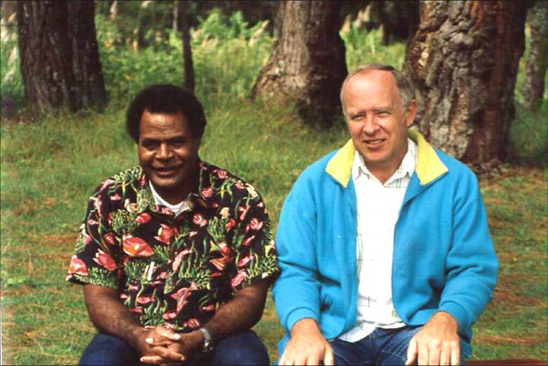 | 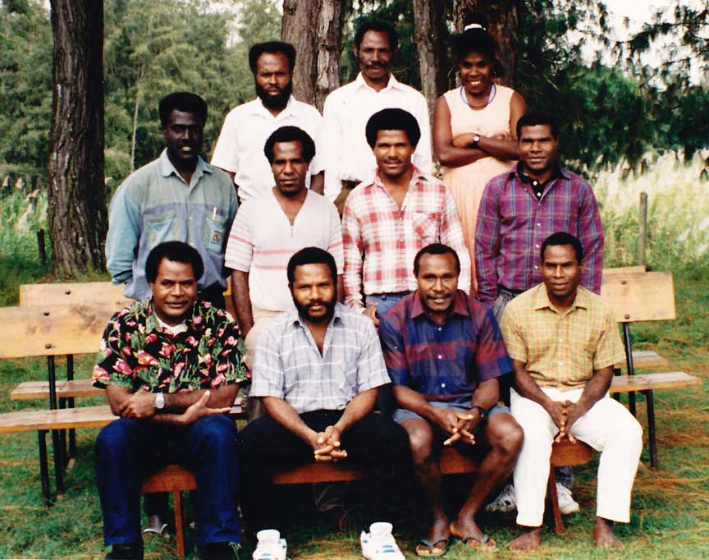
Bill and Charles at Ukarumpa | Third year students at National Translators Course

From its beginning, the Nyindrou Bible Translation Program has served all of the churches within the language area. The translation committee had members representing all of the churches. Charles Kowak represented the Evangelical Church of Manus. Charles was assisted by other villagers who were able to work part time as translators, translating certain books of the New Testament into Nyindrou. Among those part time translators were Alphonse Sibawih and Belden Sirip. Alphonse is the Catholic Catechist in Lessau village. Belden is actually from a different Manus language group (Harengan), but he is highly bilingual in Nyindrou. He is a member of the Seventh Day Adventist Church. The experience he had in helping with the translation of the Nyindrou New Testament has helped him to work virtually unassisted on a translation of the Bible into his own Harengan language.

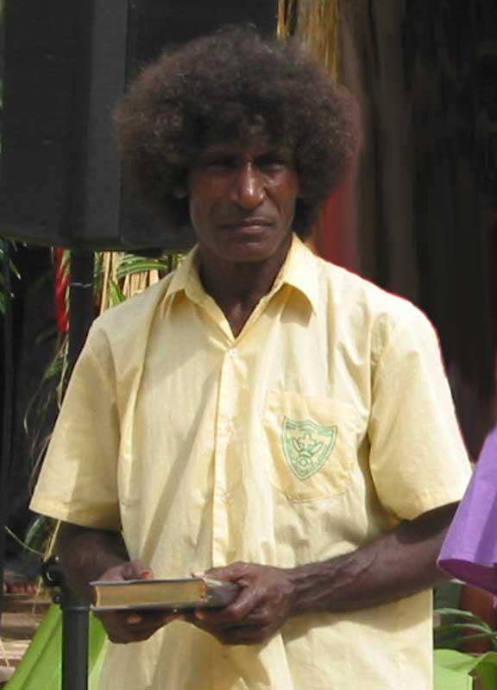 | 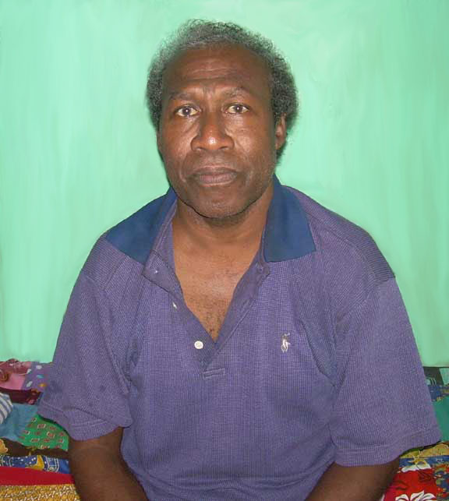
Alphonse Sibawih translated Nyindrou Matthew | Belden translated several Nyindrou epistles

To ensure accuracy of meaning and faithfulness to the original languages of the Bible (Hebrew and Greek) a literal translation is made of the Nyindrou translation back into English. This is called a “back translation”. The back translation is then sent to an outside translation consultant, who studies it in preparation for leading formal translation consultations. Most of these translation consultations were held at Ukarumpa.

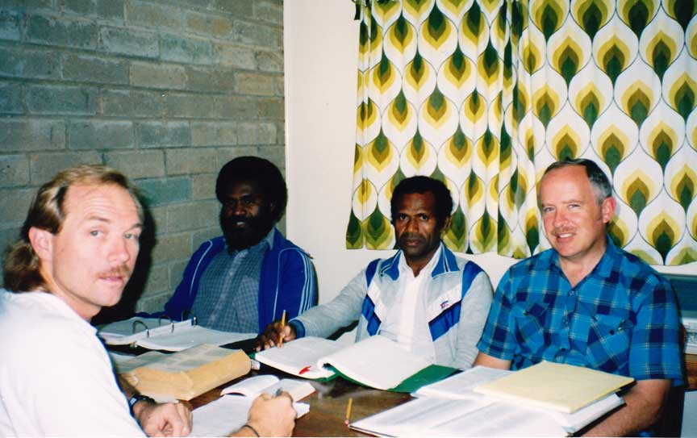 | 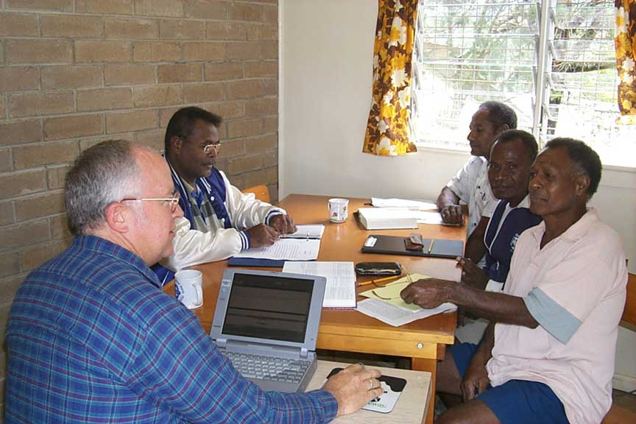
Barney Barnes checking the Nyindrou translation with Timothy Kundrake and Michael Lus  and Bill at Ukarumpa in 1992 | Nyindrou team preparing for final stage consultant checking at Ukarumpa

Translation consultants use the back translation to make up questions that they ask the speakers of the language who are brought in from the village during consultant sessions. Those questions help the team to see whether the translation is communicating the meaning accurately and clearly, and spot areas that need more work.

Joe Bwisikalei is a grass-roots Nyindrou man who had never gone to school and never learned to read. He also was not a Christian and spent most of his time gambling with other village men. In a dream God persuaded Charles to ask Joe to go to Ukarumpa to attend a translation consultant session that included checking the Nyindrou Gospel of John. At the consultant check Joe faced a big challenge. As Charles read the Gospel of John to Joe, and Joe responded to the questions asked by the consultant about what the words meant, God spoke to him about the condition of his own heart, and Joe became a Christian. Joe was so moved by what he had heard that he determined that he must learn to read the Bible himself. In a very short period of time, while still at Ukarumpa, Joe taught himself to read the Nyindrou New Testament and feast on the Words of Life in his own language. Now Joe spends his time praying for village people who do not yet know the Lord.

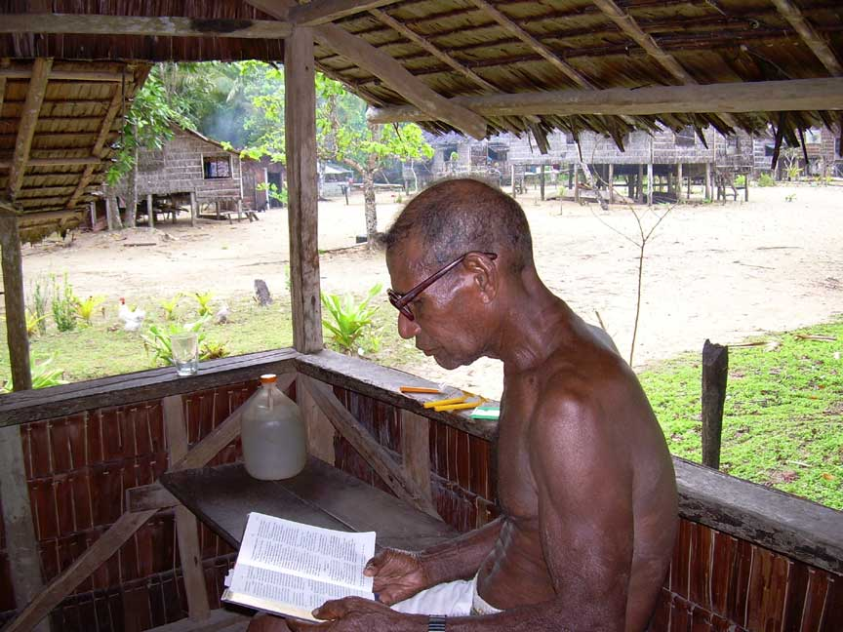 | 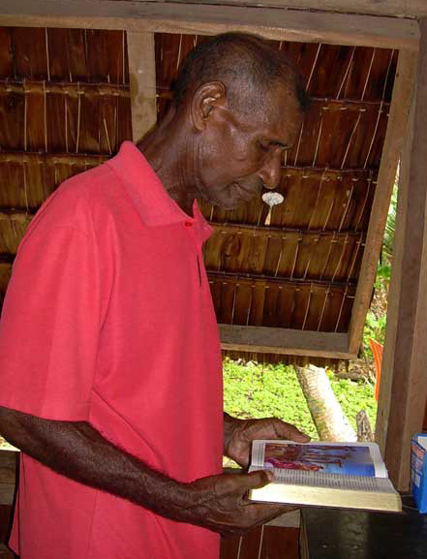
Joe reading his Nyindrou New Testament in the village | Joe prays for others to accept Christ

While the translation work was continuing, the Martins also held writers workshops in the village in which interested village people could learn how to read and write their language as they composed traditional stories. They learned how to use silk screens to make copies of their stories compiled into books.

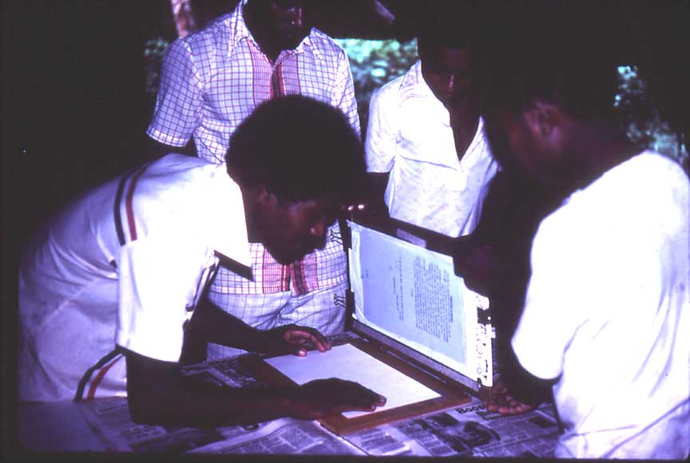 | 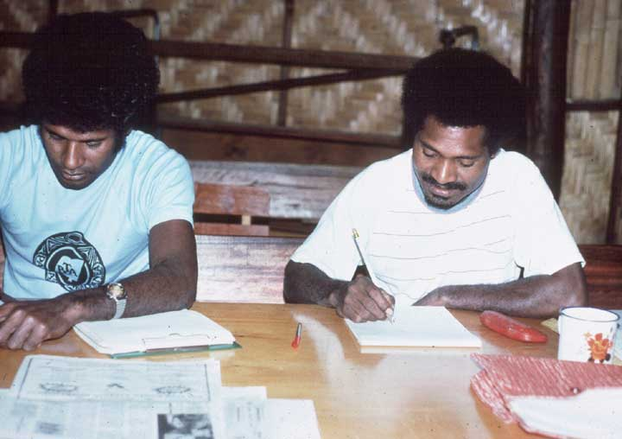
Silk-screening books in a village writer’s workshop | Jessie and Bernard at Ukarumpa 1983

To advance the literacy part of the program the Martins mentored Bernard Laban and Jessie Siraon in literacy courses held in the village and at SIL's Ukarumpa center.

While the Martin's were on furlough in the USA Bernard put his training to good use and organized his own vernacular prep school in Lessau village – one of the very first vernacular prep schools in Manus Province.

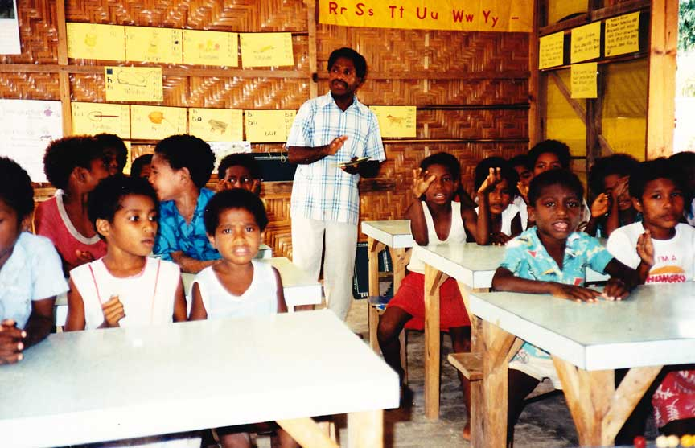
Bernard leading his vernacular prep school in Lessau village

The school was a great success and helped the parents of the children who attended to realize the numerous advantages that their children were getting by learning the skills of reading and writing - first in their own mother tongue - as a foundation for excelling later in the community schools.

To help identify village people with artistic talent, the Martins asked Michael Harrar to come out to Lessau village for two weeks to run an art workshop for the benefit of those interested in describing their culture and illustrating their own story books.

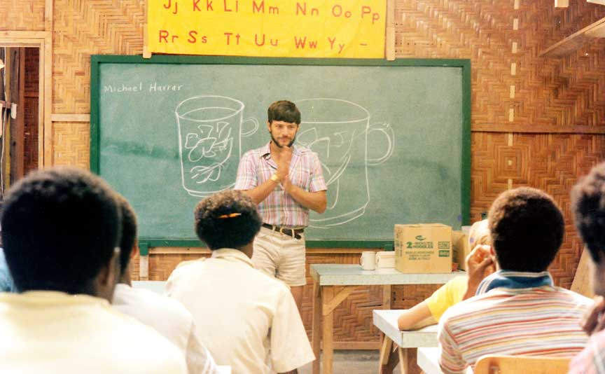
Michael Harrar leads an art workshop in Lessau village

To encourage more village people to learn to read their own language, reading contests were held in later stages of the translation program as more and more books of the Bible were completed. The reading contests also helped to identify those villagers who were especially good oral readers. As the Nyindrou New Testament was nearing completion the best readers were invited to gather at the NBC studios of Radio Manus where recording specialists recorded most of the Nyindrou Gospel of Luke, and dubbed it into the Jesus video. The Jesus video has continued to be a powerful witness among the Nyindrou people since it was first shown in 2002.

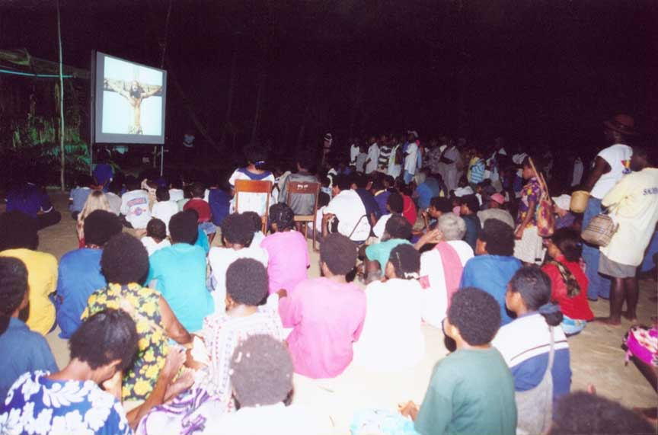
The Nyindrou Gospel of Luke (Jesus video) has had a great impact in the Nyindrou area

By 2000 all of the translation work on the Nyindrou New Testament had been completed. All of the necessary consultant checks were done, and it was polished for publication.

The Nyindrou New Testament was typeset by a Papua New Guinean named Emma Biblio at SIL's Ukarumpa center in early 2001, and after proof reading, the typeset manuscripts were sent to Korea for publishing.

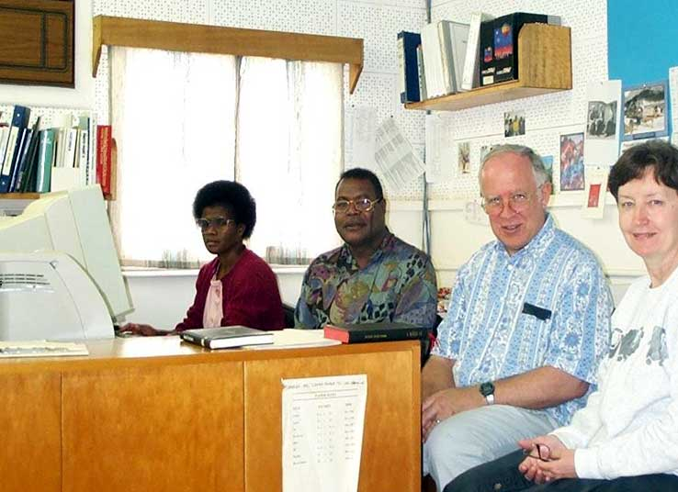
Charles, Bill and Lenore at typesetting with Emma Biblio at Ukarumpa 2001

The finished New Testaments were then shipped back to Lae, PNG and trans-shipped out to Manus Island. Charles and a large number of Nyindrou people then organized a joyous dedication of the Nyindrou New Testament which took place in July 2002.

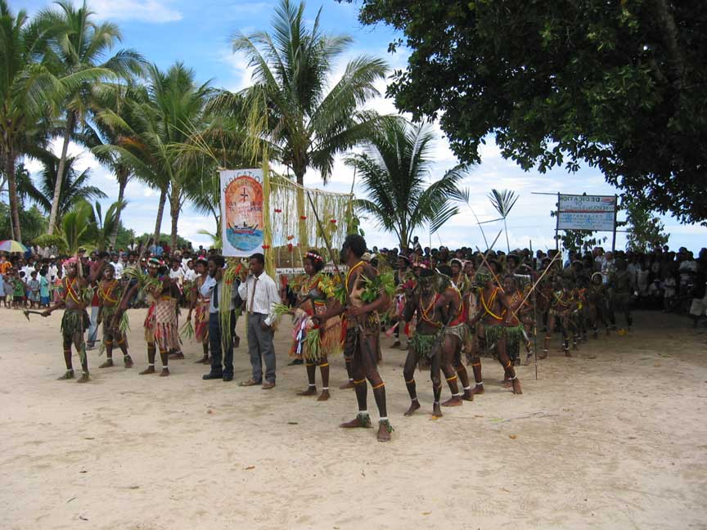
Welcoming the Nyindrou New Testament at the dedication in July 2002

It was only fitting that Samuel Bolaubeu, who had prayed faithfully for over 30 years for the work of translating God’s Word into his language, would be presented with the first copy of the Nyindrou New Testament at the dedication in 2002.

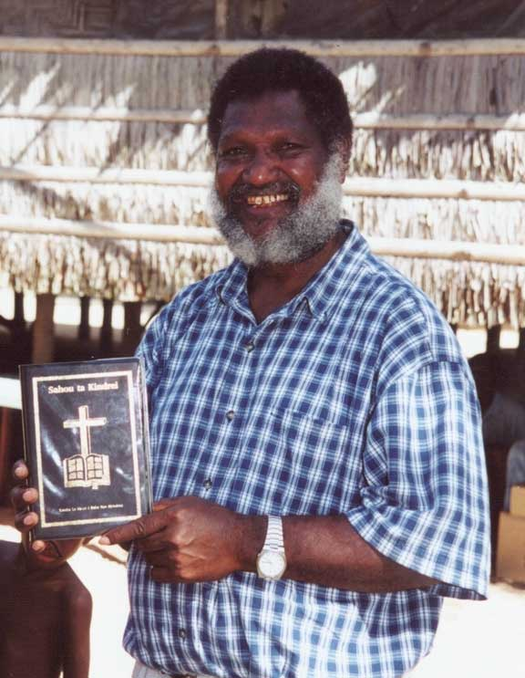 | 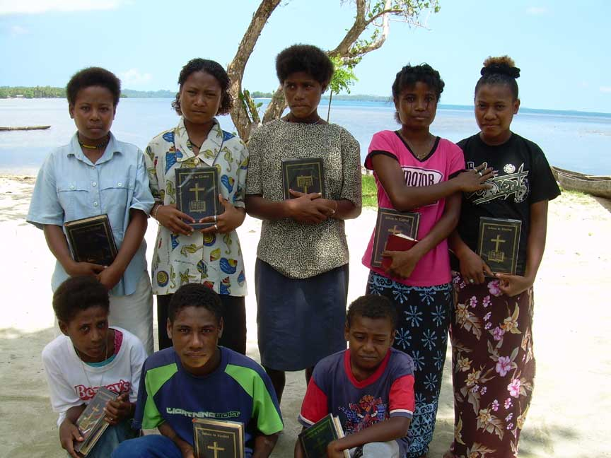
Samuel Bolaubeu gets the first copy | Young people treasuring their Nyindrou New Testaments

Charles continues to work in the Nyindrou program, encouraging the Nyindrou people to read and study their New Testaments. He works with Sunday school teachers in their preparation of materials, and he continues to show the Jesus Luke video in the Nyindrou villages. Charles also travels by boat to assist Manus people from neighboring language areas of Manus in their efforts to provide God's Word in their own languages.

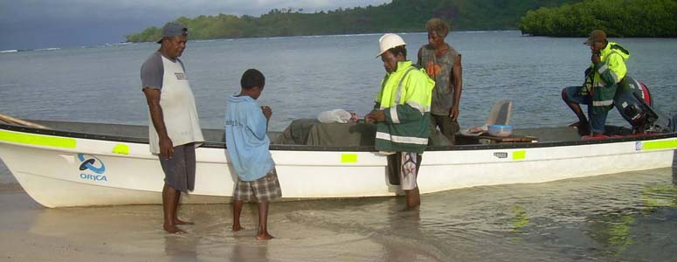
Charles praying for a safe trip and fruitful ministry outreach to the Nyindrou villages

Titan
SIL Members Keith and Ruthann Lusk began living at Langendrowa Plantation with the Titan people in 1981.

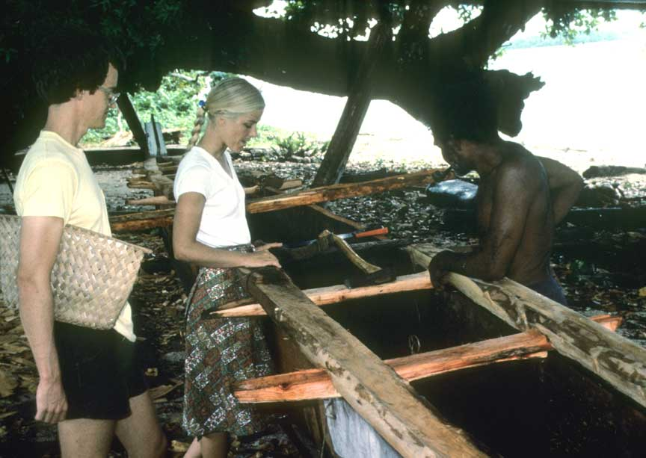
Keith and Ruthann learning the details of canoe building

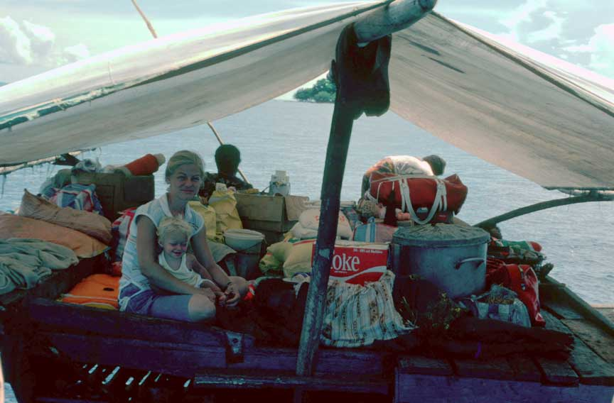
Ruthann and Carrie Beth awaiting departure for Rambutso Island on a large seagoing canoe

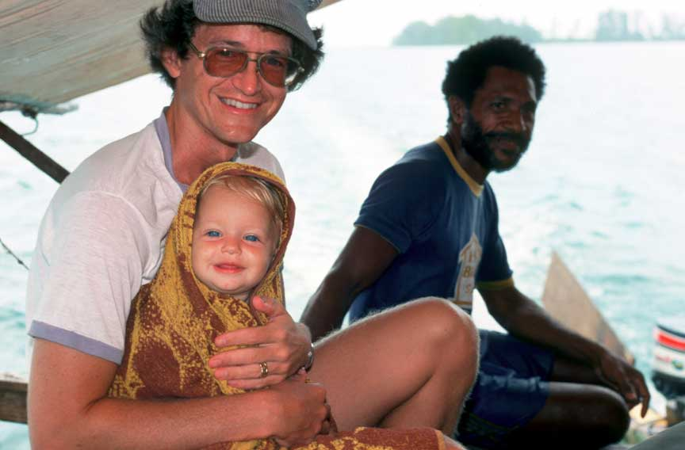
Keith and Carrie Beth take shelter from the sun on the canoe

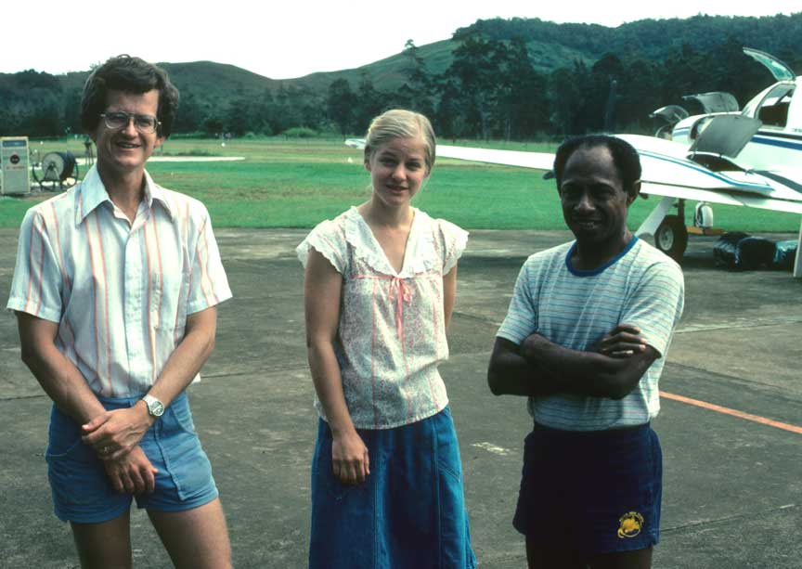 | 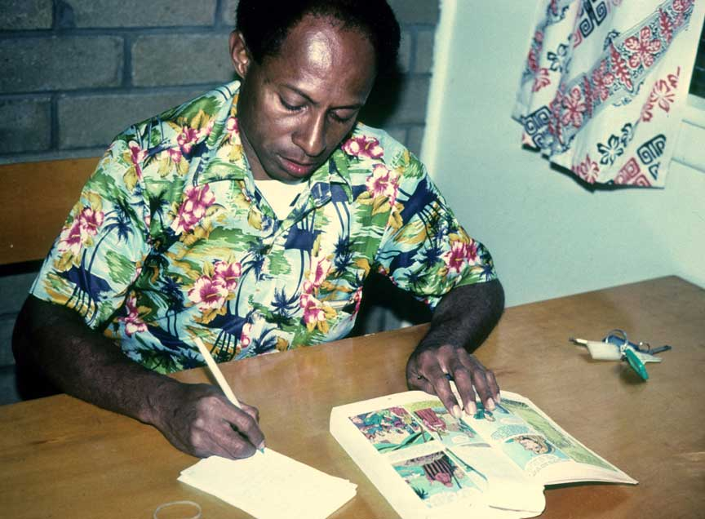
Keith, Ruthann and Kumulau Tawali at Ukarumpa | Kumulau working on the Titan Picture Bible

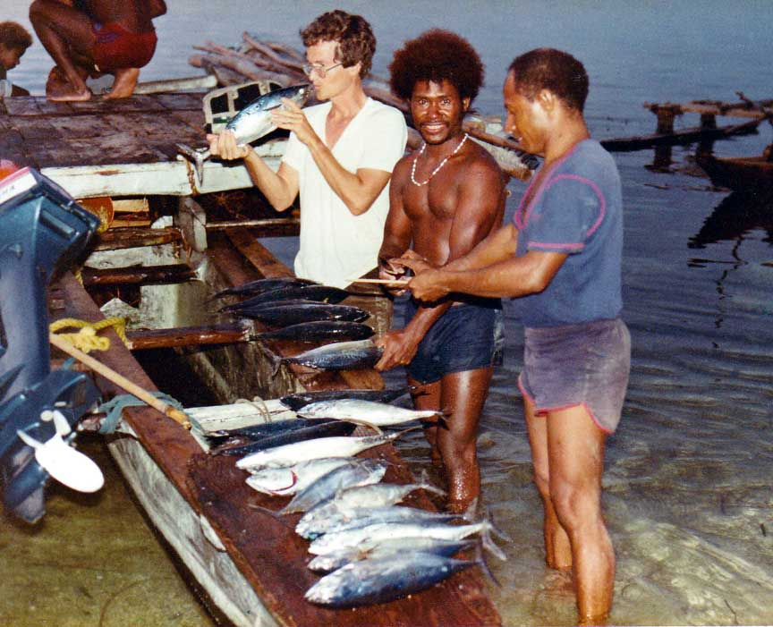 | 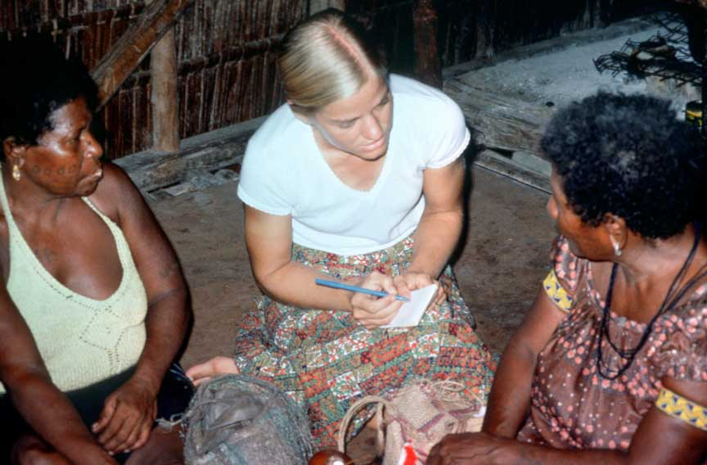
Inspecting their catch of fish | Ruthann collecting language data

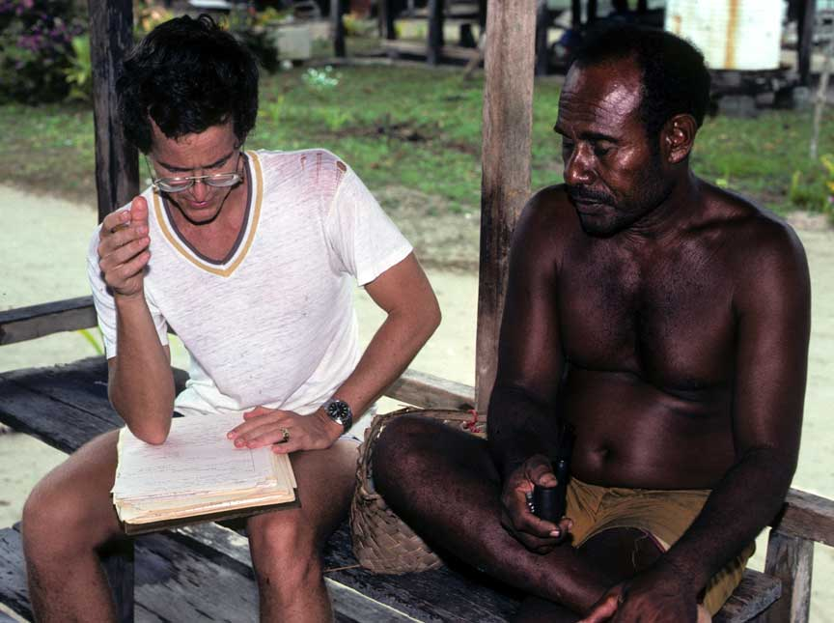 | 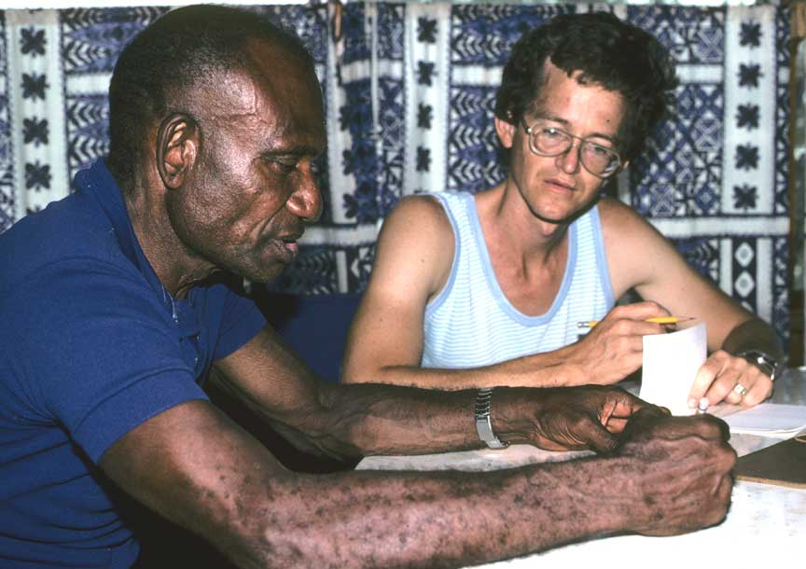
Keith collecting language data | Keith collecting language data

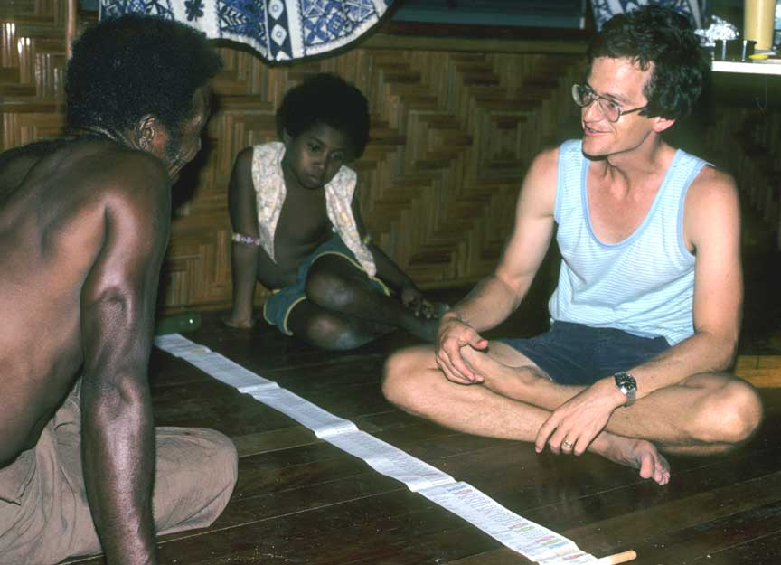 | 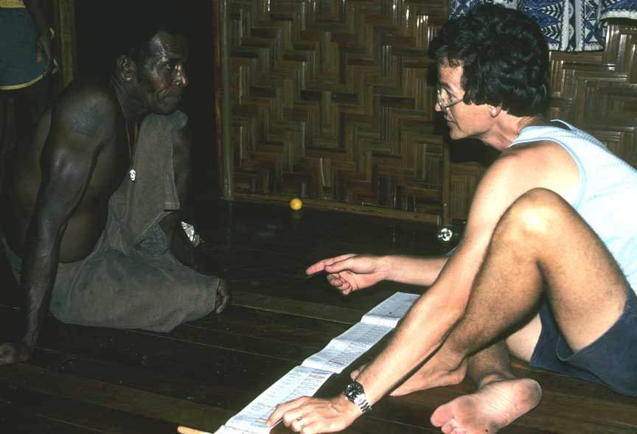
Keith explains the Bible timeline story using the “stik bilong stori” scroll of human history | Manu Titans didn’t understand the Biblical framework of human history

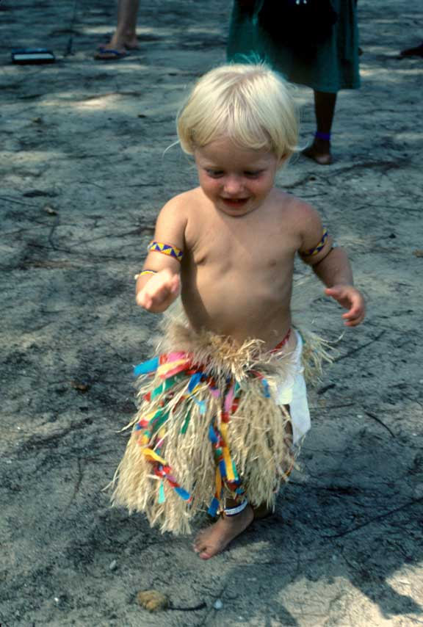 | 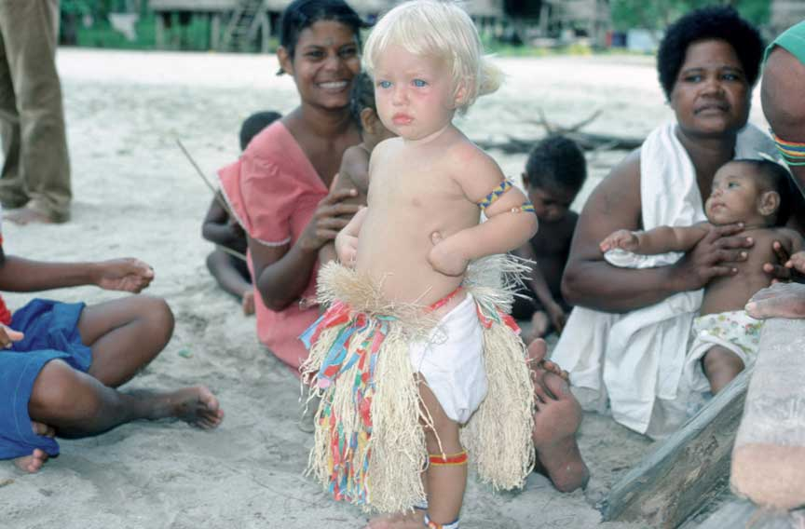
Carrie Beth doing a “singsing” | The Titan people called Carry Beth “Kiteni”

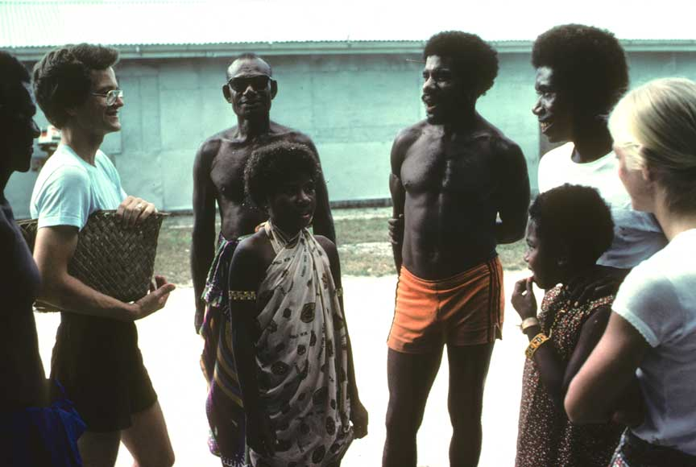 | 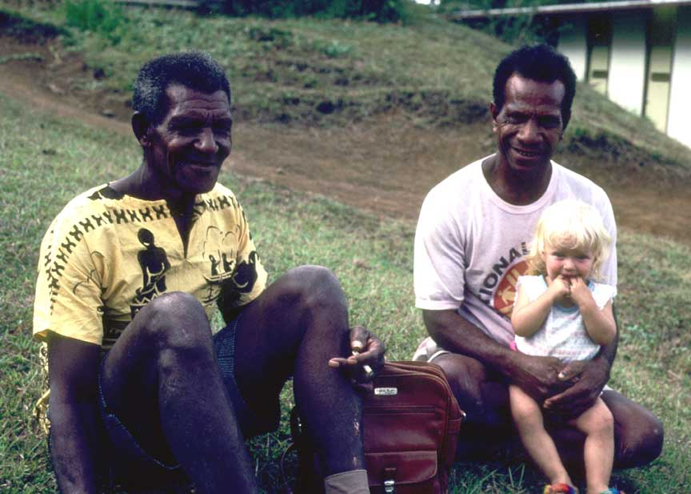
Titans loved Keith’s sense of humor | Titan men look after Kiteni at Ukarumpa

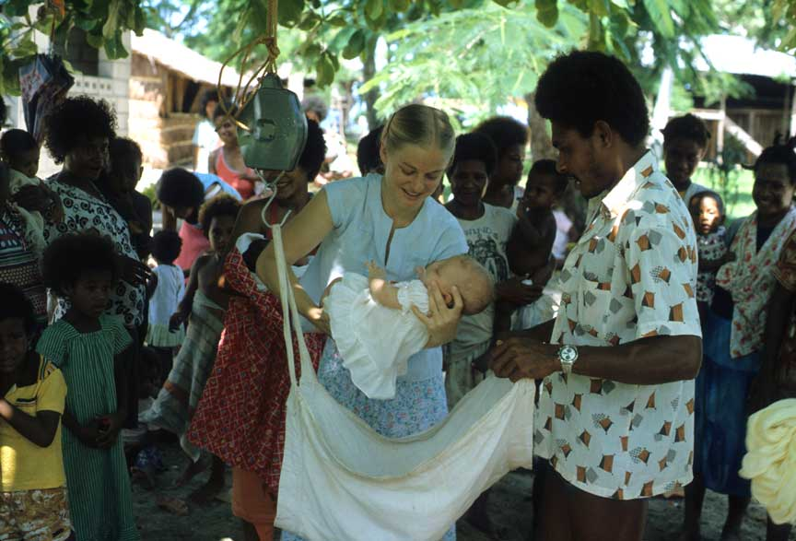
Little Carrie Beth getting weighted at a local clinic

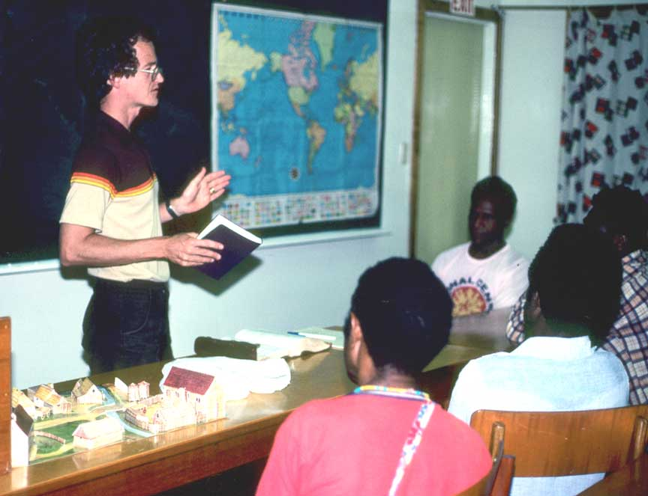
Keith giving a world history lesson from a Biblical perspective at Ukarumpa
After Keith died in 1987 there was no expatriate involvement in the Titan program for the next four years. SIL Members Bob and Barbie Hauser began living in Pere Village with the Titan people in 2001.

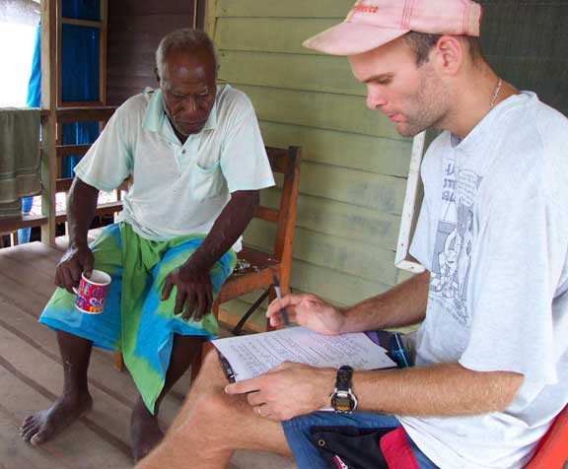
Bob Hauser learning Titan with Petrus Ponyalou (June 2001, Pere village)

Always a welcome sight in Pere village, Petrus gave much for the Titan project work from 2001-2003, providing transportation, accommodation, and language learning assistance. Petrus and his extended family welcomed the Hausers’ into Pere.

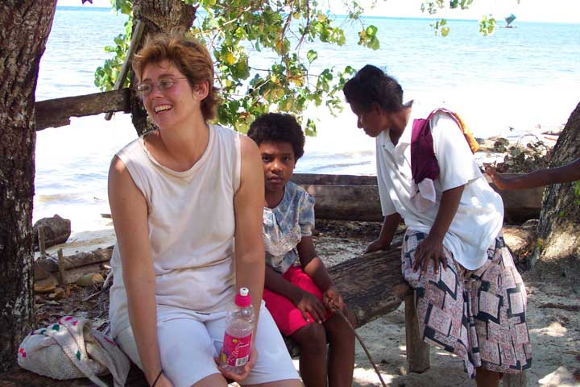
Barbara in conversation on the Pere shoreline (October 2001, Pere village)

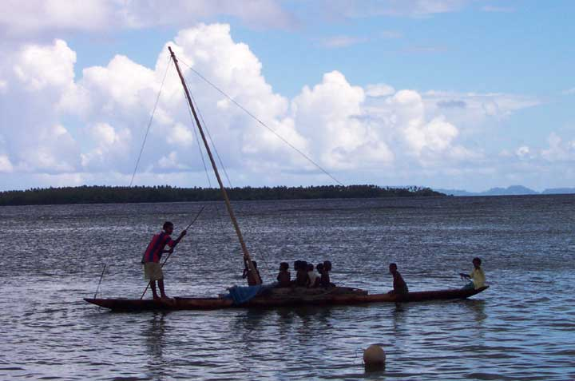
A common sight at Pere village where traditional canoes and
fishing techniques bring in daily bounty from the sea

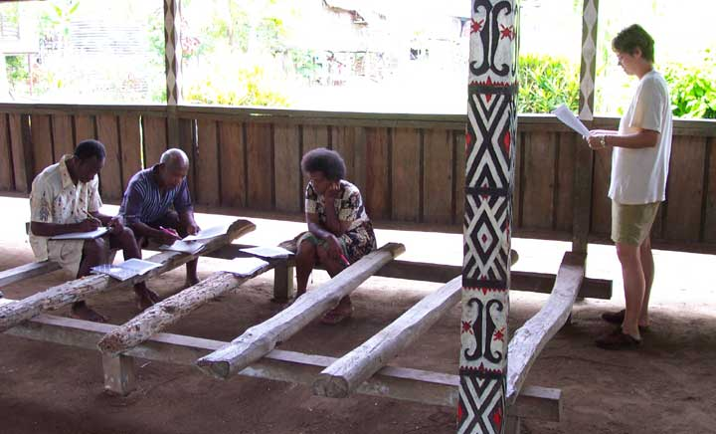
Barbara leading a writer’s workshop (January 2002, Pere village)

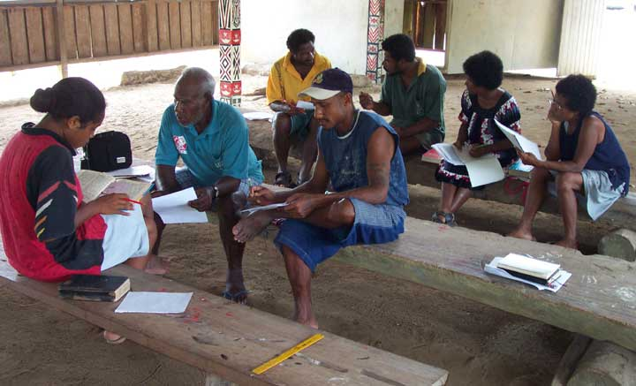
Writer’s workshop, (January 2002, Pere village)

Barbara and Bob held a writer’s workshop gathering Titan stories from participant-authors who received the stories compiled in booklet form.

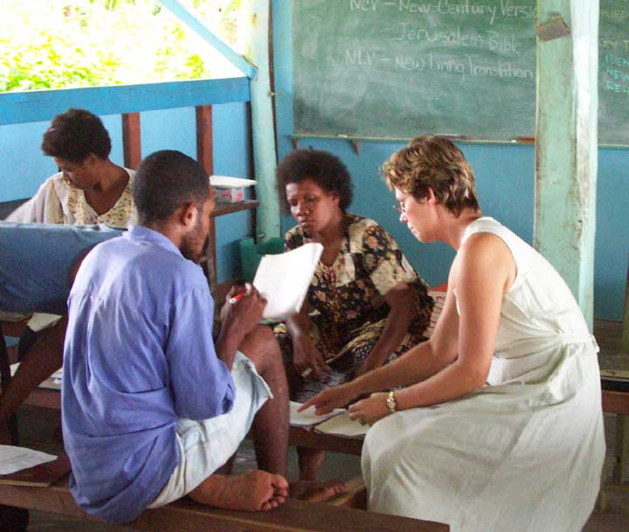 | 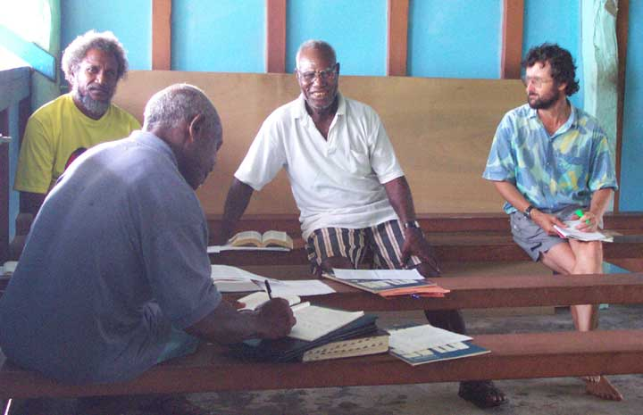
Barbara assisting at Look Learn Do workshop in Pere village (March 2002, Pere village) | SIL member Phil Carr with Titan leaders during a workshop. (March 2002)

Phil & Chris Carr came to Pere in March 2002 to lead a Look Learn Do translation workshop. Titan participants translated early stage drafts of Jonah led by Phil & Chris Carr and assisted by the Hausers.

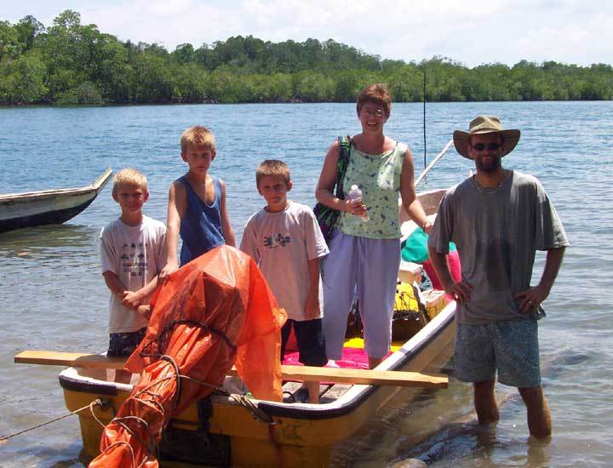
Luke Raube (on left) joins the Hausers (Ben, Daniel, Barbara, Bob) as they prepare for the boat ride from Loniu Bridge in Manus out to Pere village (October 2002, Loniu bridge)

Kurti
PBT members Wes and Alta Beasley began living in Souh village with the Kurti people in 1981.

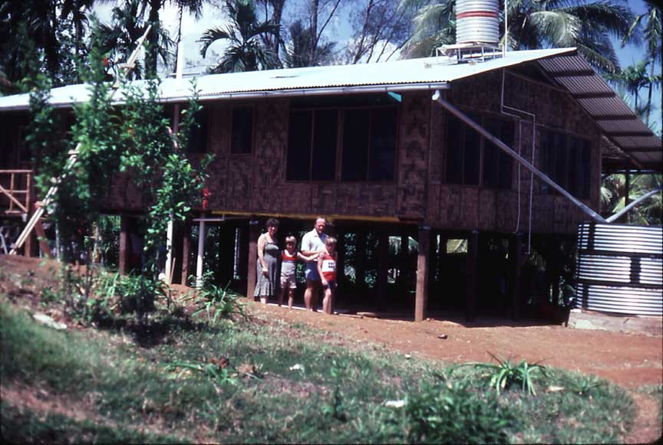
The Beasleys at their village house in So-uh on the north coast of Manus Island

[more to be written] – plus other pictures from the Beasleys]
SIL members Bob and Marla Uebele began living in Kari village with the Kurti people in 1993. It was exciting to combine the Kurti people’s love for their language with God’s Word. The first few years included many Alphabet meetings to allow Kurti people to make decisions about spelling.

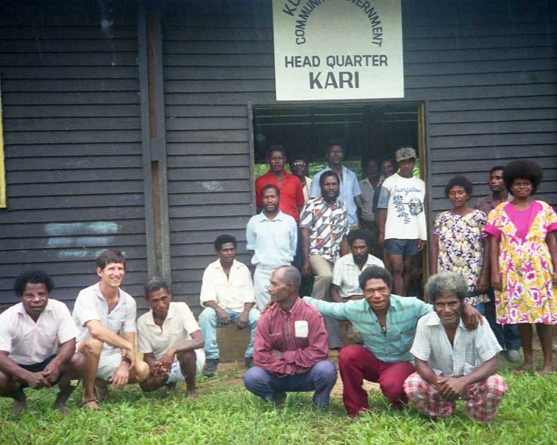
The first of seven Kurti Alphabet meetings was held 14-17 November 1994 in Kari village. This first meeting included three Primary school teachers.

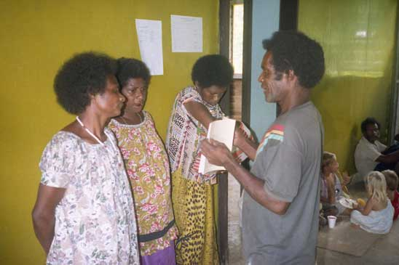
Anton Neu attended the first Kurti Alphabet meeting in 1994
and was very excited to see a Kurti story made into a book!

Under the Uebele’s mentoring the work of Bible translation began with Herman Seyek from Patlok village and Steven Yah from Derimbat village translating the book of Genesis.

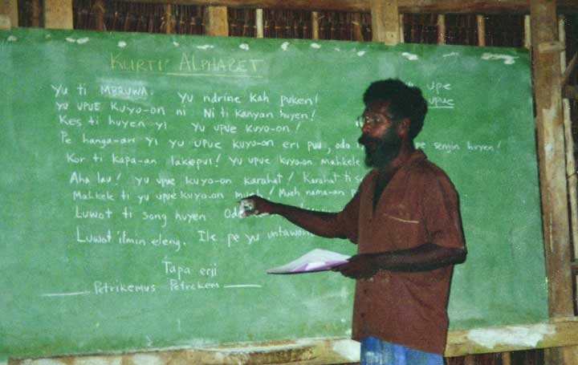
In 1996, Gabriel Londron became the Alphabet chairman
and he led the discussion of how to spell Kurti words.

In 1998, Gabriel Londron became the Kurti Bible Translation team Chairman. His experience as a radio news producer with Radio Manus was very helpful in translating the meaning of the Bible into the local language. He translated the Gospel of Mark, and also led team discussion for the revision of Genesis. Bill Sawa of Mundripudeu village translated the books of 1Timothy and Galatians.

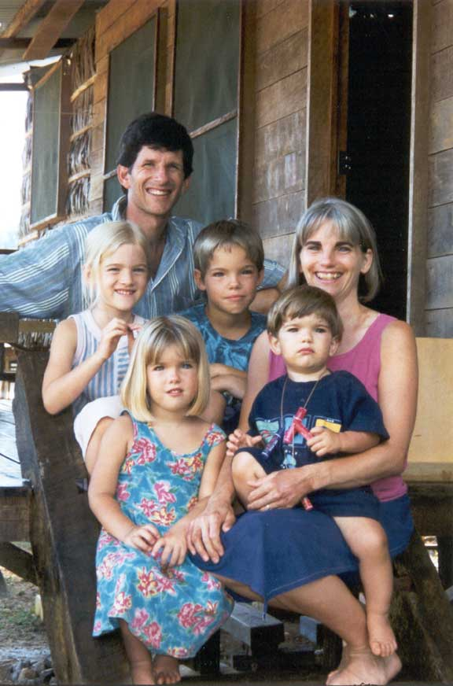
Bob and Marla Uebele lived in Kari village from 1993 – 2004.
Bob and Marla Uebele and their four children Daniel, Laura, Mandy and Michael.

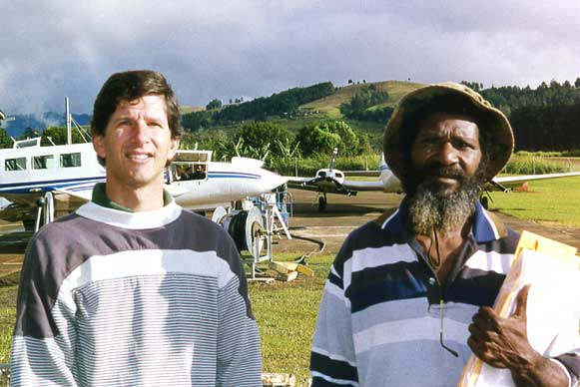
Gabriel departing from Ukarumpa to Manus after attending the BTA Annual General Meeting in June 1999, and attending the SIL Bible Translation Training workshop.

Gabriel functioned as a mentor for the Kurti students at the April NTC held in Lorengau Manus.
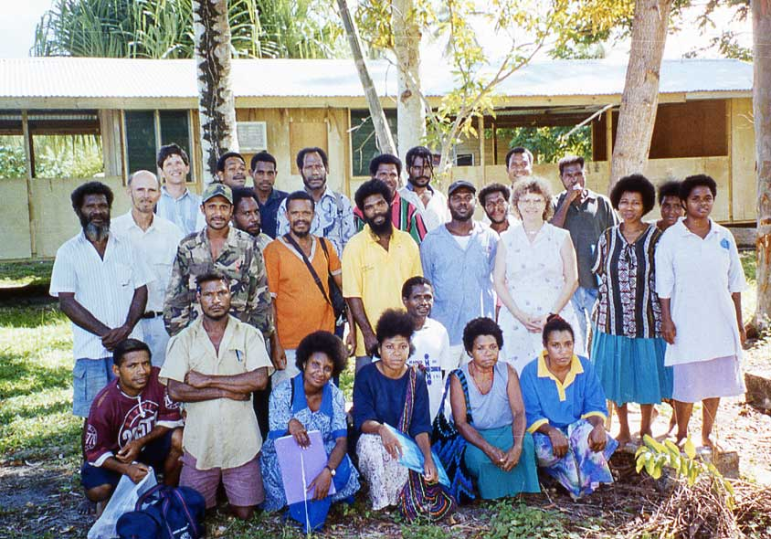
Manus people from five language areas attend Bible Translation training
in Lorengau from 3-19 April, 2000

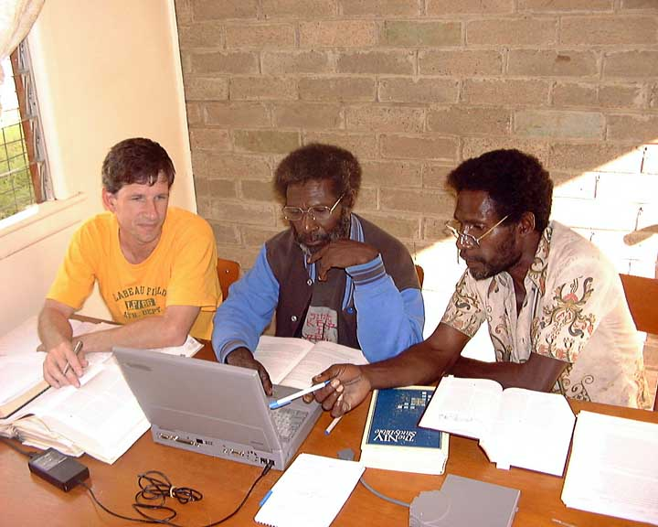 | 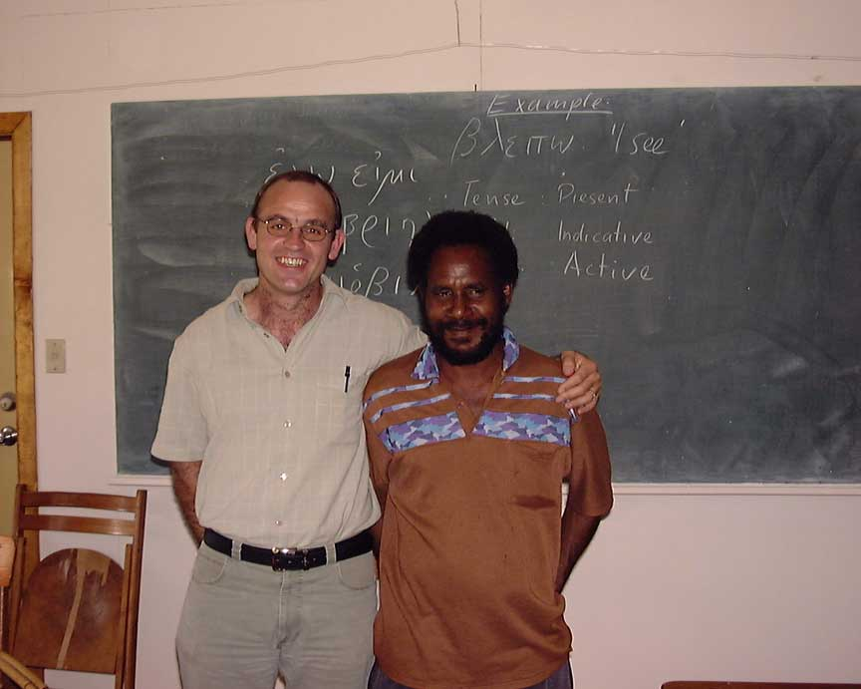
Bob Uebele, Gabriel Londron and Steven Yah working on Kurti Bible translation at Ukrumpa in October 2003 | Bill Sawa from Mundripudeu village attended a Biblical Greek course at Ukarumpa for three weeks from 17 Feb – 7 March 2003. He is pictured here with instructor Gerhardt Tauberschmidt with SIL.

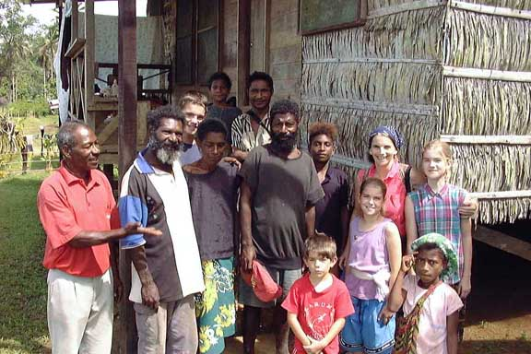
Marla Uebele and children along with Kari village friends in July 2003

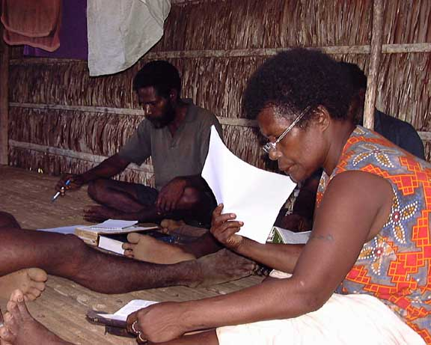 | 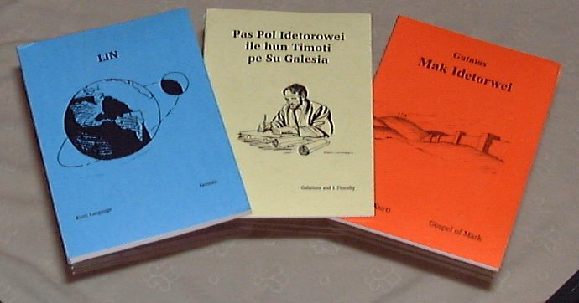
Steven Yah leading the discussion of a draft of the Kurti Bible translation in Derimbat village, June 2003 | Some of God’s Word is available in the Kurti language: Genesis, Gospel of Mark, 1Timothy and Galatians

These four Bible books: Genesis, Mark, 1Timothy and Galatians were printed and distributed to all the Kurti villages in 2004 with the help of Charles Kowak of ECOM.

Since 2004, Bob and Marla Uebele and their family have been living in the USA, but they came back to visit Manus in 2012 to help with the distribution of “AudiBibles”. These are solar powered audio players that contain the Kurti Gospel of Mark.
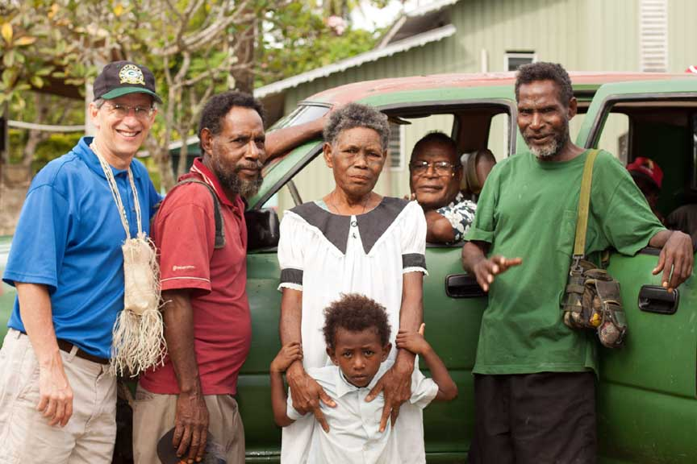
In June 2012 Charles Kowak helped coordinate the distribution of the audio version of the Kurti Gospel of Mark on “AudiBibles”. Pictured is Bob Uebele, Bill Sawa, Lucy, Charles Kowak and Steven Yah


Bob and Marla Uebele. Children: Laura, Daniel, Mandy and Michael, photo taken 2011

Nali

The Nali Translation Program may have been the first of the most recent Bible Translation efforts in Manus Province since the 1950s. In 1978, Luke Pahun Masta attended a Lahara Course at the University of Papua New Guinea, and began to commit himself to working on Bible Translation for the people who speak his own mother tongue – the Pwandrau dialect of the Nali language. During the next decade, Luke attended several training courses sponsored by SIL and by the newly formed organization, the Papua New Guinea Bible Translation Association or BTA.

Luke learned translation principles at the National Translator’s Course (NTC) at Ukarumpa, in the Eastern Highlands Province. He also studied literacy principles and produced literacy materials at the National Literacy Course held at Ukarumpa in 1983.

Luke became one of the early members of the PNG-BTA, and served for a while on the BTA Council. While he was working on his translation assignments for NTC, SIL Members Jerry and Sue Pfaff arrived in PNG in 1987. The leaders of SIL and BTA asked Luke about having the Pfaffs come as SIL advisors to the Nali Translation Program, and they visited Manus for the first time in July of 1987 while attending the Pacific Orientation Course. They officially began their assignment to work with Luke and the Nali Program in January of 1988, settling in Karun Village on the Manus Highway where Luke lived.

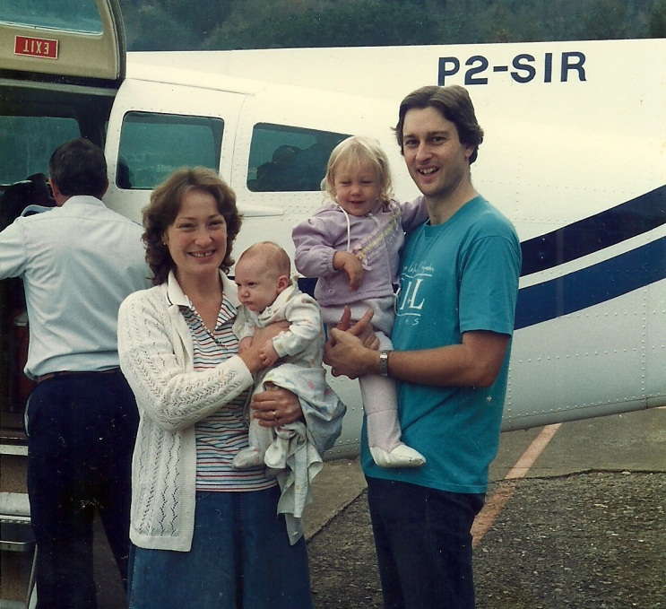 | 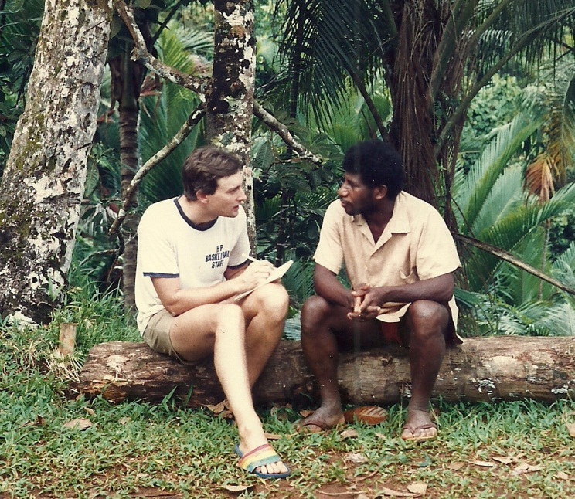
Sue (holding newborn son Matthew) and Jerry Pfaff (holding daughter Julie) prepare to board their first flight to Manus Island in January 1988. | Jerry beginning to learn the Nali language from Luke Pahun Masta in early 1988.

The Pfaffs spent most of the following two years learning the Nali language, building a home, and settling into the Karun community. By 1990, they were ready to help Luke and start working on revising the translation of the Old Testament books of Ruth, Jonah, and Esther that he had drafted during and after his studies at the National Translator’s Courses. Their advisory work included training and helping to mentor two other members of the team, David Ndrayeu and Johnson Moses, at the NTC 1 course in Ukarumpa in April-May of 1990.

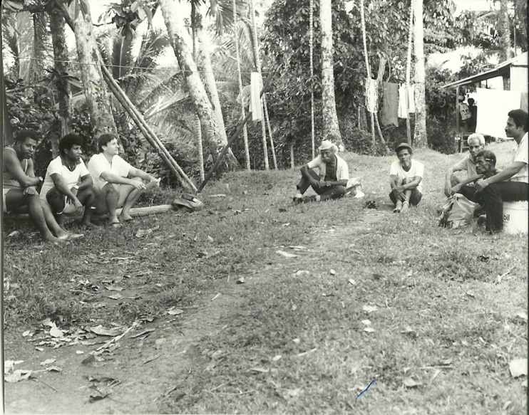 | 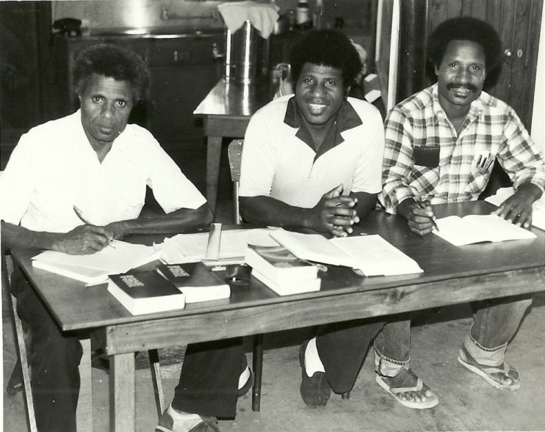
A discussion about translation in Karun Village in the early 1990s. | Luke Pahun Masta (center) mentors David Ndrayeu (left) and Johnson Moses (right) at the 1990 National Translator’s Course in Ukarumpa.

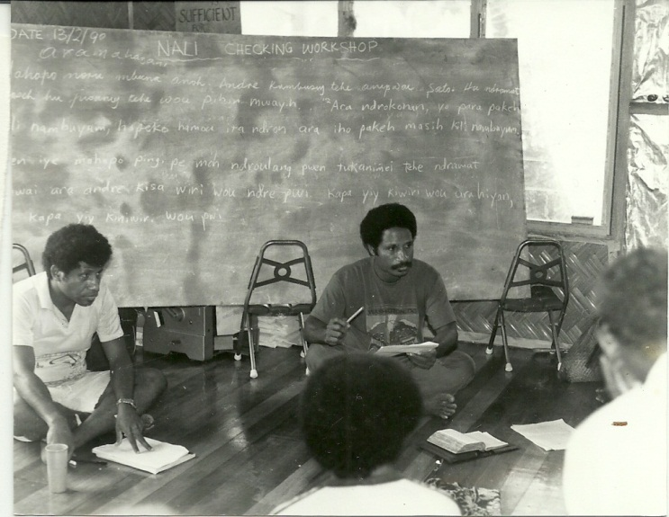 | 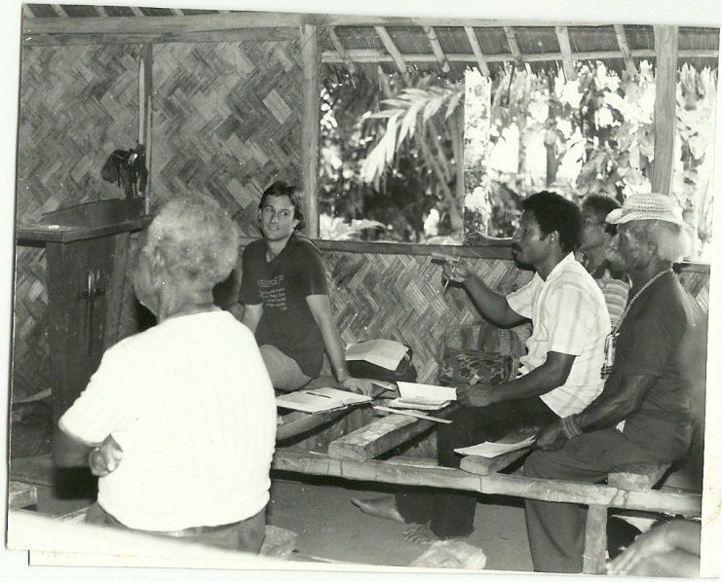
Luke Masta and Johnson Moses conduct village checking of the translation of the Nali language book of Ruth in February 1990. | Jonah Pokarou, Jerry Pfaff, Johnson Moses, and Titus Kiwah checking some of Luke Pahun’s translation work at the Ndariyuh church in 1990.

By 1991, the books of Ruth, Jonah and Esther had been published in one volume, and Luke began to serve a wider portion of the Manus population by working in the Provincial Non-formal Education Office developing literacy efforts for the province. The Pfaffs began to train and mentor other members of the Nali community, and the work expanded. By the mid-1990s, Johnson Moses had drafted the Gospel of Luke, and members of the Nali team from Karun and Pwihan (Bulihan) Villages had started drafting the books of Genesis and Exodus.

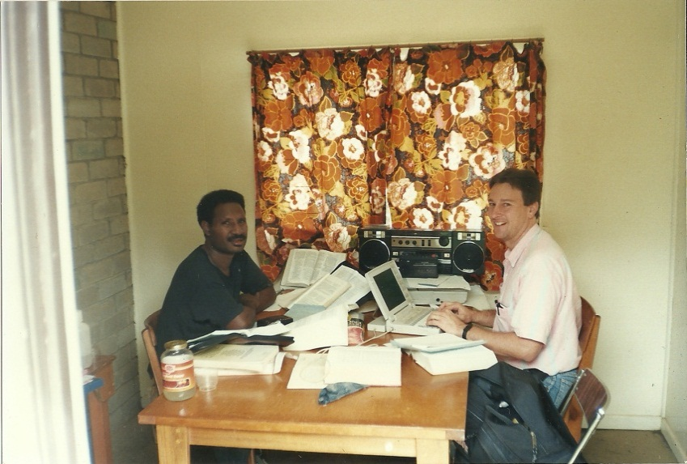 | 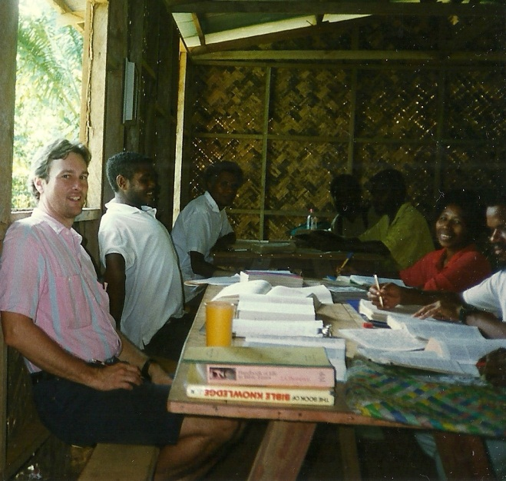
Johnson Moses and Jerry Pfaff work on drafting Luke’s gospel at Ukarumpa in 1994. | A translation session in Pwihan Village in 1995 working on the book of Exodus.

Throughout the 1990s and into the early part of the years after 2000, slow progress was made in drafting and checking the very large book of Genesis. Jerry began to serve on the SIL Executive Committee, eventually becoming the Chairman and spending more time away from Manus while working at the SIL Headquarters at Ukarumpa in the Eastern Highlands. But the team continued to work, and Jerry would come to Manus when he could to encourage their progress. Members of the team began to also draft other books, mostly from the New Testament during their own time.
As God would put it on the hearts of people, they would work on translation, seeking guidance by the Holy Spirit, for the ability to translate His Word as best they could in the Nali language. At one point Michael Kailou’s wife, Rebecca, walked from her home in Kopou village to Karun to meet with translator Martha Pohonum to ask for help. Without anyone else on the Nali team knowing about it, God had prompted Rebecca to work on translating Exodus, and she arrived with more than half of the book already drafted! Only God can work in this way in people’s hearts, and we are amazed at the way He sometimes chooses to work!

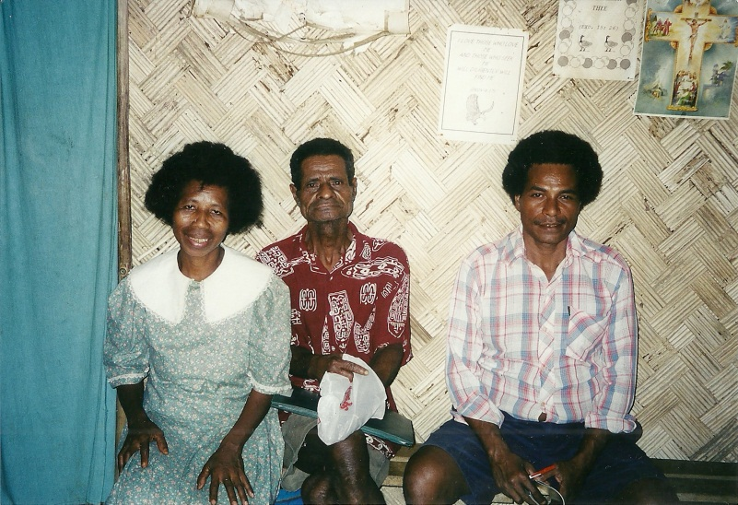 | 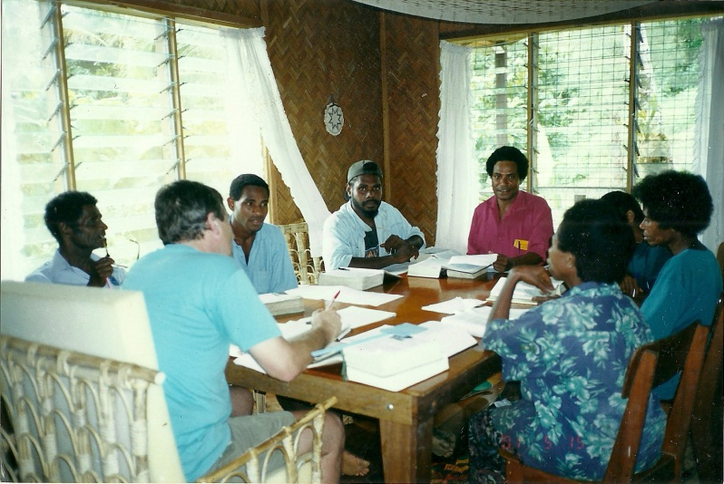
Nali translation team members Martha & the late Matthew Pomoh Pohonum with Elijah Kiwah Kanau around 2000 | Translating at the Pfaff’s home ~2000: Jerry, Matthew & Thomas Pohonum, Jeffrey Lemen, Elijah Kanau, … Ruth John and Martha Pohonum.

The Pfaffs always saw their work as not so much being the primary translators of the Bible for the Nali language group, but as advisors, mentors, and trainers – helping the Nali people to learn the skills to translate and check the work themselves. Jerry would help with checking the accuracy of the translation drafted by members of the team, and the whole group would go over what one person had drafted, checking and revising it until it was as clear, accurate, and natural as they could make it. Then a consultant would come and check their work so that they could be certain that it was ready for publishing.

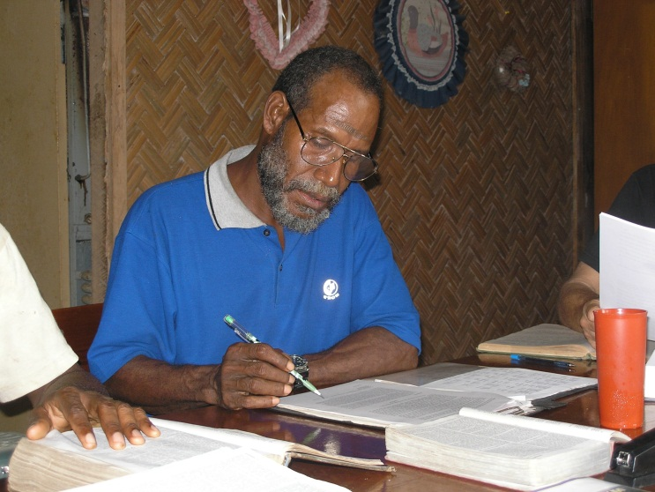 | 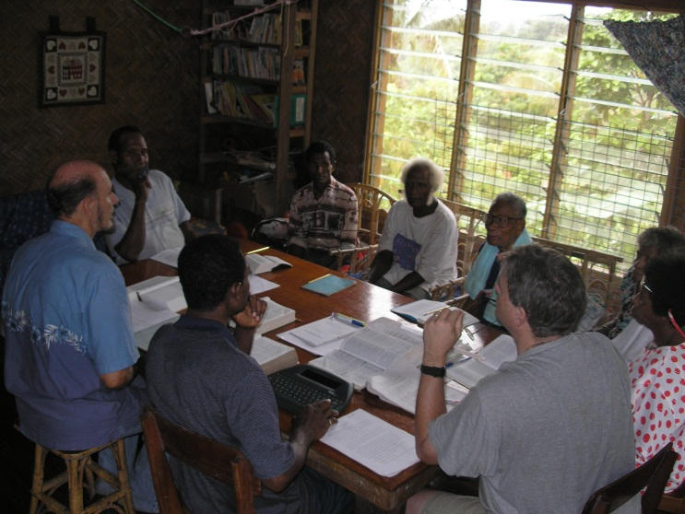
Enoch Titus has become a leader of the team from Karun village. Here he helps to check the trans-lation of Genesis so that it sounds natural. | Translation Consultant, David Scorza, who had completed a translation in the Sepik, came to Manus to check Nali Genesis before publishing.

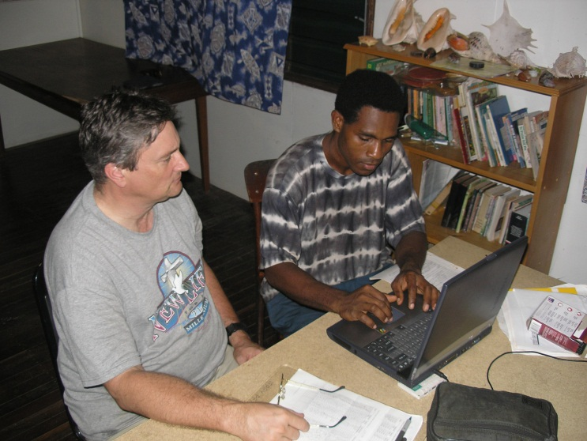 | 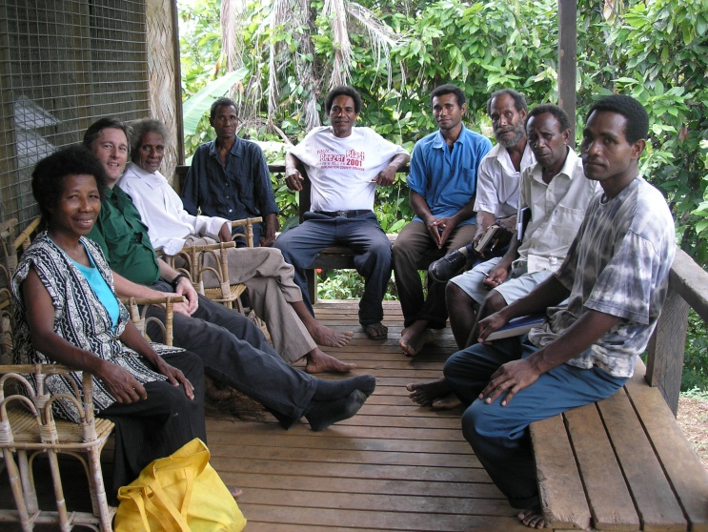
Besides training in translation, the Pfaffs have provided other training as well, in skills like typing, word processing, and computer use. | The Nali Translation Committee and other community members occasionally meet to provide help/support for the translators. (As here in 2006)

Always looking for opportunities for more training, the Pfaffs have encouraged Nali team members to attend courses and workshops to improve their language and translation skills. Some courses have been held on Manus Island, and some at the SIL Headquarters or the BTA Training Centre at Ukarumpa. They are also helping to train Nali team members to be able to train others so that they can pass on their skills to people from other language groups in Manus province as well as in other parts of Papua New Guinea.

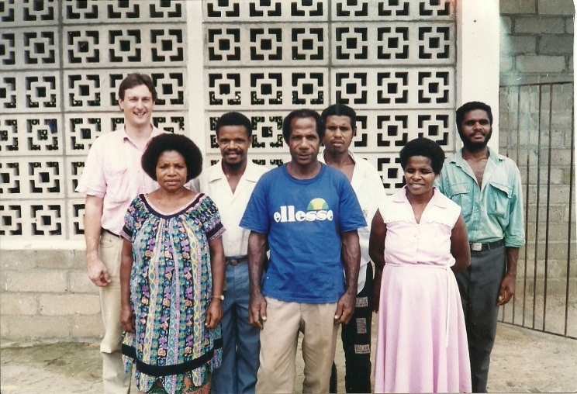 | 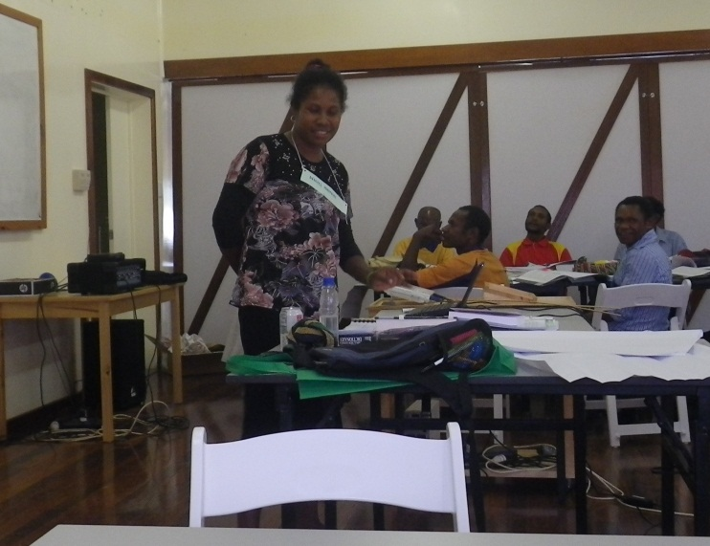
Nali translation trainees at the 1994 NTC 1A Course in Lorengau: Back row: Jerry Pfaff, with Daniel Muwan, Kim Tapo, and Pomwat Ndrayeu (all from Pwihan village); Front row: Ludwina Kupe (Sohoniliu), Michael Kailou (Kopou), and Helen Ndrayeu (Pwihan) | At the 2012 Translation Training Course at the new SIL and BTA Training Centre at Ukarumpa, Naomi Pohonum teaches a module on Study Skills to new Translation trainees. In the future she hopes to be able to teach these skills in courses on Manus Island as well.

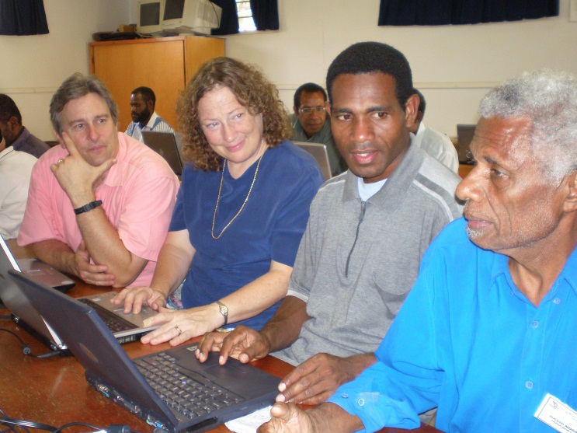 | 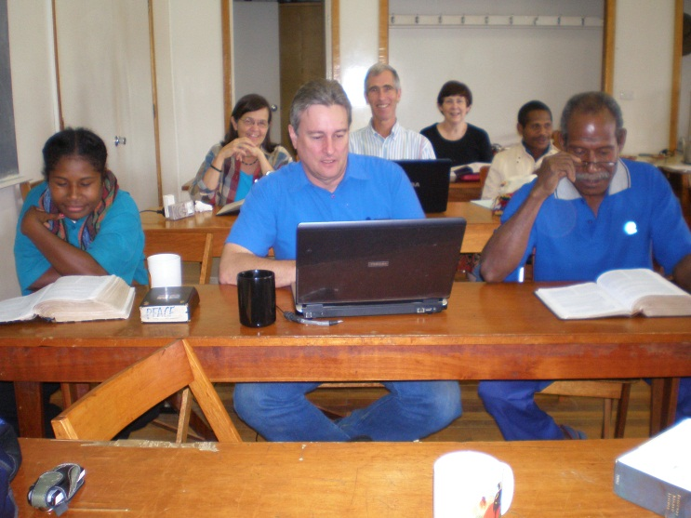
The Pfaffs and Thomas Pohonum look to David Ndrayeu for language insights at a dictionary-making workshop at Ukarumpa in 2007. | Jerry works with Naomi Pohonum and Enoch Titus at a workshop on the book of Revelation, also at Ukarumpa, in 2008.

It is thrilling when a book of the Bible is completed. But the completion is a long process. First someone must study the Bible to prepare for translation. Then the translator translates a first draft, writing it out on paper, or in a notebook or exercise book. Later someone will type the book onto a computer so that copies can be printed for checking. The translator who wrote the first draft may check his or her own work several times before feeling like it is ready for the advisor or team to check it. And then there may be multiple checks before everyone feels it is ready for a consultant to check it. Even after the consultant check there is more work to do, like selecting the pictures/illustrations that go in the book, choosing a design and colour for the cover, and planning a dedication celebration and making plans for distribution. In November of 2008 the Nali team finally celebrated the publishing of the book of Genesis with a dedication ceremony near the Mwakou church in Karun Village, south of the Lawes River.

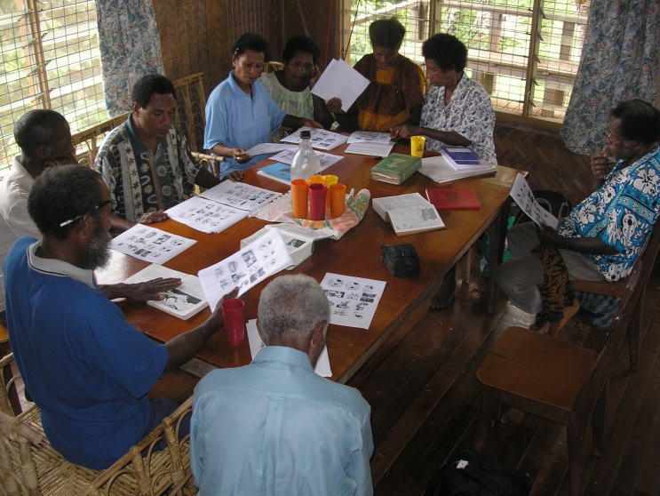 | 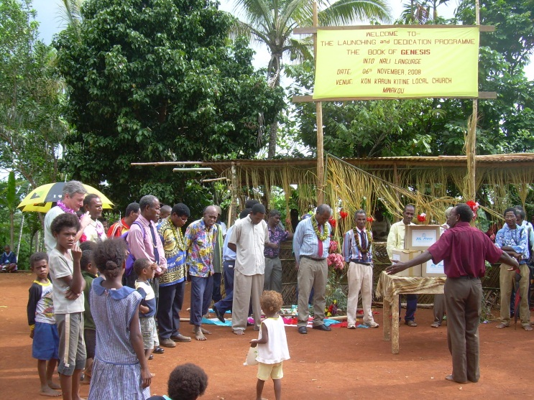
Even after translating is finished there is still more work yet to be done before a book is printed, like choosing illustrations (photo above) and a cover. | 6 November, 2008. Dedicating the book of Genesis near the Mwakou church in Karun. Pastor Patrick Onlom leads in a dedication prayer.

While the motivation of many of the Nali team members is the translation of God’s Word, the Bible, into the Nali language, there are other reasons for doing translation and language work. Writers’ workshops preserve cultural stories and give writers practice in using their mother tongue for writing and publishing. At other times, helpful information, like booklets about HIV/AIDS, can also be translated for the benefit of the community.

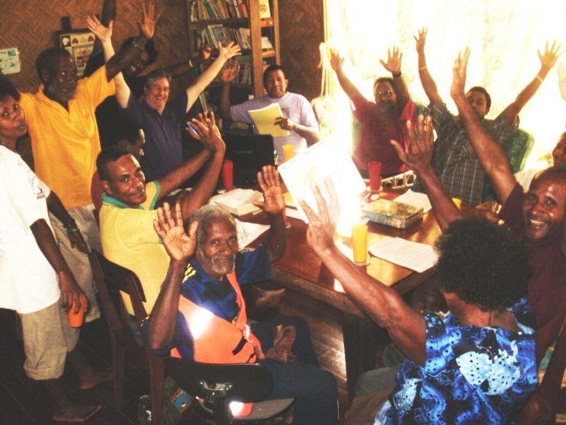 | 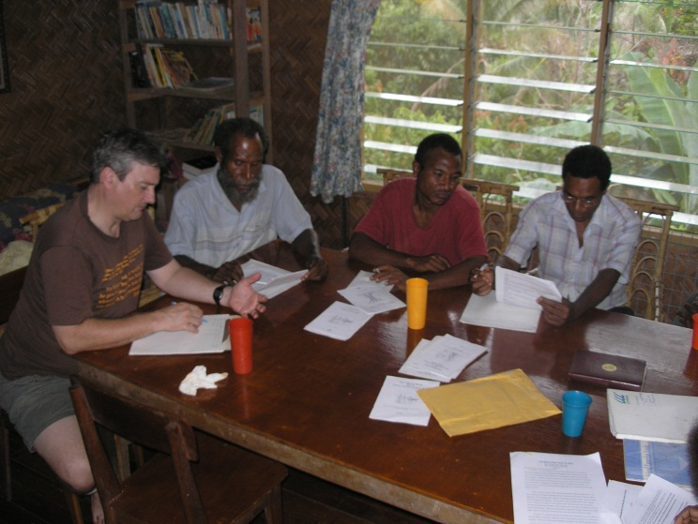
Each time a milestone is reached it is worth celebrating. Here, the Nali team rejoices in having just finished the final consultant check of the gospel of Mark, in November 2011. | Besides Bible translation, the Nali team also does other language work. In September 2007 they translated a book about HIV/AIDS for community awareness.

It often helps to have the encouragement that comes from meeting and sharing ideas with other people from other language groups who are doing the same kind of language and translation work. Courses, workshops, retreats, and meetings of any kind can provide support and encouragement for translators who find it difficult sometimes to endure the hard struggle of working alone.

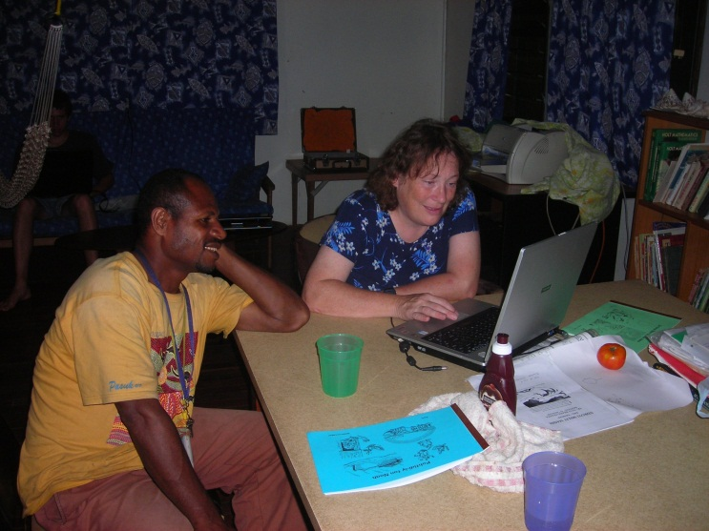 | 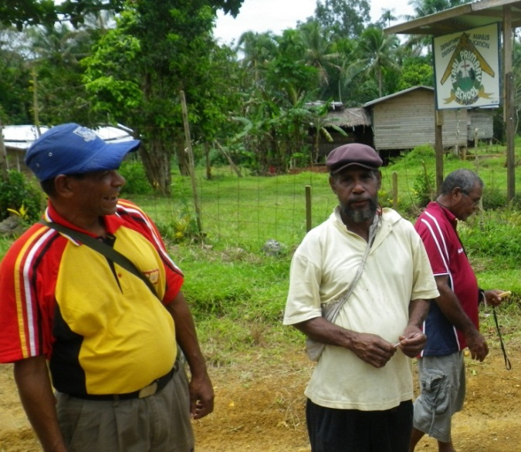
Ere/Ede language translator Pius Piti looks over some photos with Nali advisor Sue Pfaff at the BTA House at Lugos Station in May of 2008. | On a visit to Kari Village in March of 2012, a photographer captured a picture of translators from three different Manus Language groups together: Elijah Kanau (Nali), Bill Sawa (Kurti), and Charles Kowak (Nyindrou).

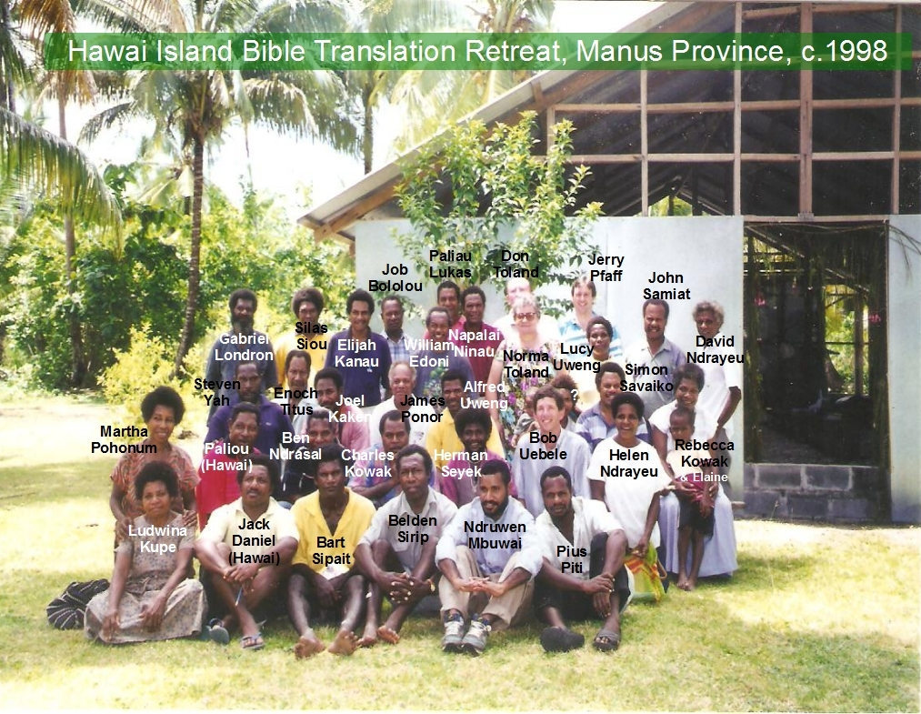
One of the largest meetings of translators from various Manus languages occurred at a Retreat that was held at Hawai Island in 1998(?). It included SIL, BTA, and independent workers from all around Manus Province

It is still too early to project when a complete Bible, or mini-Bible will be published in the Nali language. The first draft of all the books of the New Testament have been completed by various members of the team each taking a book or several books and working through them to produce a first drafts for each book. There are also 5 books from the Old Testament translated, 4 of which have already been published. There is still a lot of checking that needs to be done, but hopefully it will not bee too many more years before the Nali-speaking people of Manus have a significant part of God’s Word available to them.

The Pfaffs children are all grown and have left PNG, but each of them continues to support and encourage their parents and the Nali Translation Program.

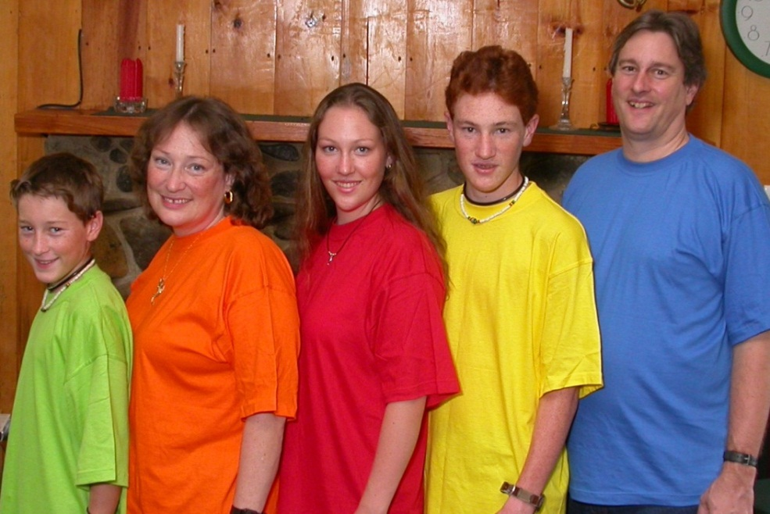
A colorful photo of the Pfaff family in 2004, just before the children began to leave PNG after finishing high school. Left to right: Nathan, Susan, Julie, Matthew, and Jerry

Khehek
Stephan Beard began living at Ndrehet village with the Khehek people in 1989. He worked with Alfred Uweng and mentored him in translation at the National Translators Course at Ukarumpa.
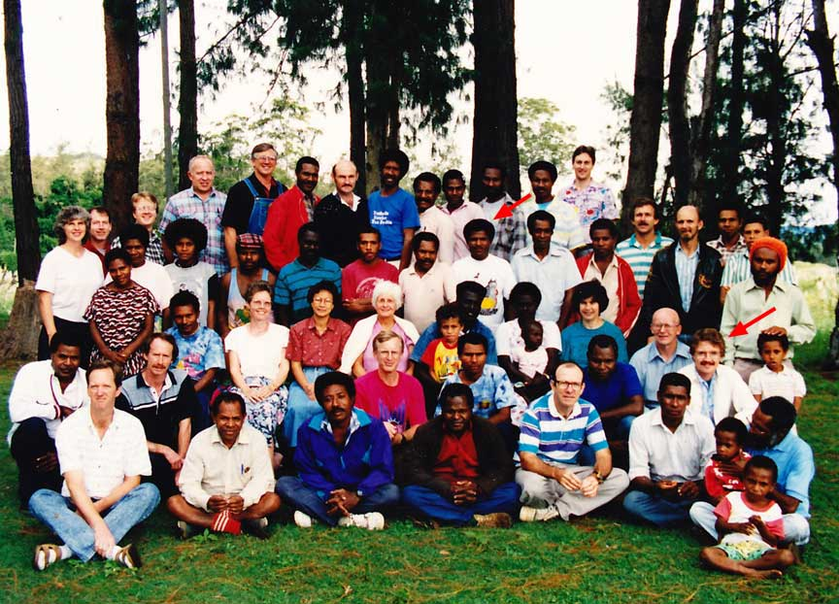
National Translators Course at Ukarumpa – Alfred Uweng and Stephan Beard (red arrows)
Alfred continues to be associated with the Khehek program. Charles Kowak sees him from time to time, but progress on translation work has been slow. There has been no SIL involvement in the Khehek program since Stephan’s death in 1999.

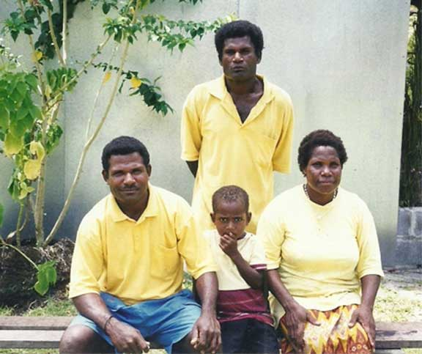
Alfred Uweng (left) at Manus Translation
Retreat circa 2001 on Hawai Island

Lou
Robert and Verna Stutzman worked with the Lou language group from October 1991 until June 1995. They worked with Solok Pwaka, who translated the books of Jonah, Ruth and Esther. They trained him to start vernacular pre-school on Lou Island and helped him compile a Lou – English Dictionary. The Lou dictionary is available online and can be accessed by anyone who has an Internet connection at http://pnglanguages.org/pacific/png/show_author.asp?pubs=biblio&auth=13596.

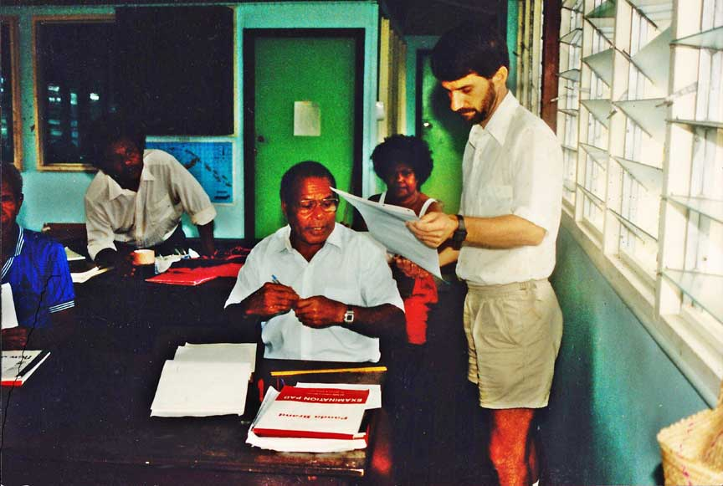 | 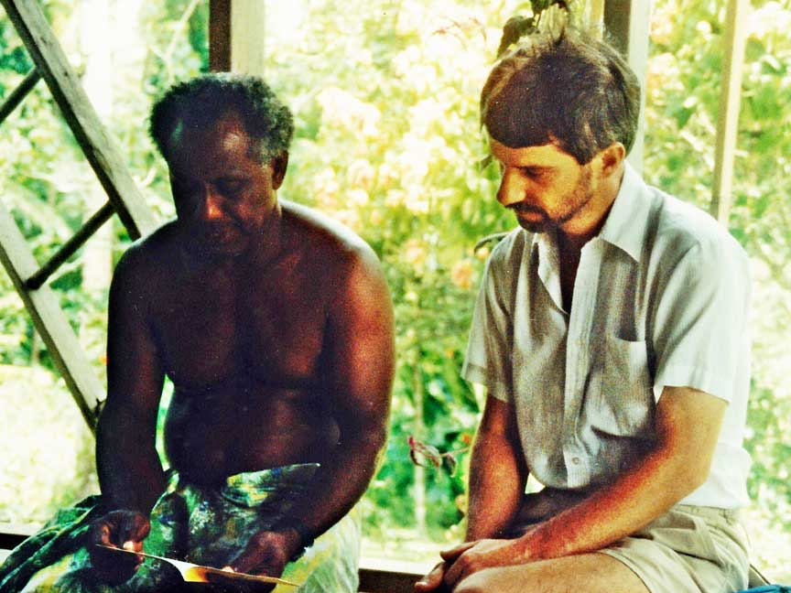
Robert assisting Solok Pwaka (Solang Village, Lou Island) in a Pre-School Literacy workshop held on Manus Island | Robert listening to Narko Sevua reading the Jonah story in his own language in Lako Village, Lou Island. The Jonah story was translated by Solok Pwaka from Solang Village, Lou Island
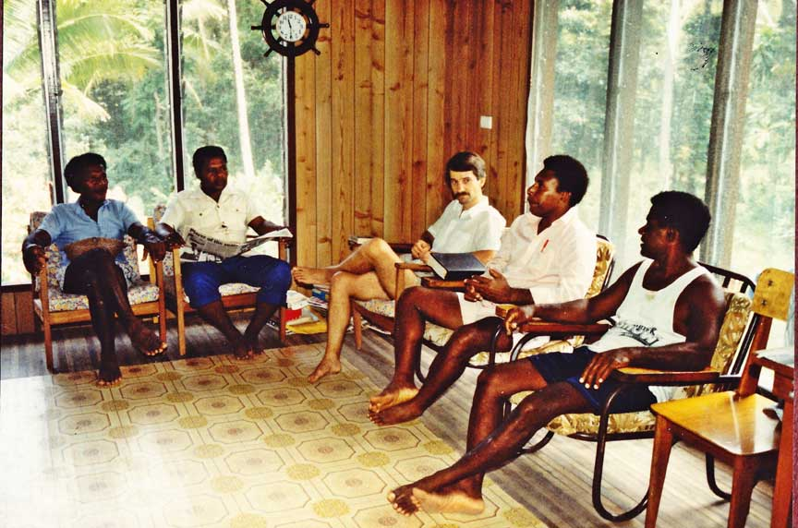
Robert, with the Lou Translation Committee in Narko Sevua’s house at Lako Village, Lou Island

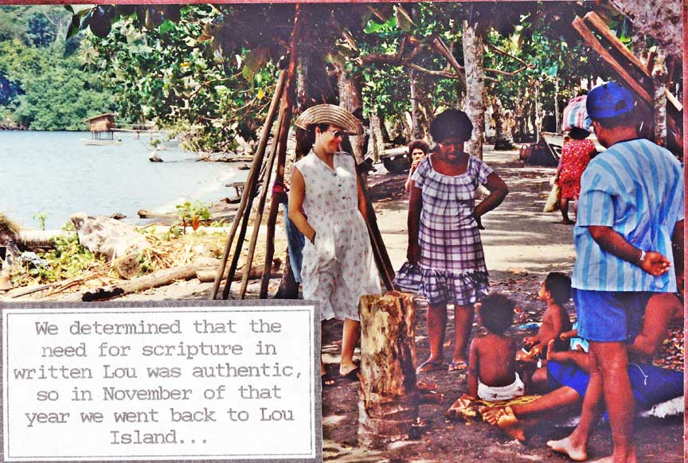
Verna, with the villagers on the beach in Solang Village, Lou Island

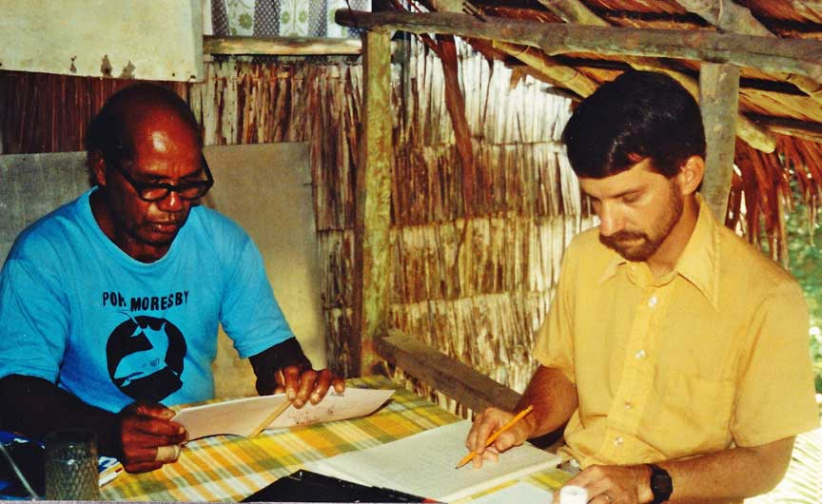
Robert working with one of the villagers in Solang Village

Wuvulu
Vinton & Audrey Goff arrived in PNG in July 1991 to do language surveys as their first assignment. Those surveys included several language areas of Manus Province. They were not young, and were fresh out of SIL linguistic training. They did six language surveys and then settled in Onne village on Wuvulu Island in 1992. They were encouraged by the long-standing interest and persistence of the Wuvulu people to get a New Testament in their language.

The Goffs recorded some local stories and a young lady transcribed them. Wawa told a story about the first person who arrived on Wuvulu Island from the Seventh Day Adventist Church. On the porch of the SDA guest-house, they printed Wawa's story by using the simple method of silk-screening.

The community rallied around the project, a site for a house was selected, and Vinton paid the football team to build a house. The Goffs never lived in the house, but the Haffords did! Family concerns took Vinton and Audrey back to Canada, where they stayed to look after Audrey’s mother. Audrey returned to Wuvulu Island in 2005, with two friends (Sheila and Amanda Lamb), to enjoy the dedication of the New Testament. It was at this time that James told Audrey that he had memorized those stories that they had recorded. He would go around the village and tell the stories to others as part of his language-learning.

The dedication was a time of rejoicing for Audrey as I viewed the finished New Testament, and visited dear friends. Max introduced Audrey at the dedication ceremony, as the SIL person who 'kik-statim dispela wok.' However, Audrey thinks differently. She saya, “Well, I don't think so. It all started long before the Goffs came on the scene, when God placed in the hearts of many to see this work accomplished.”

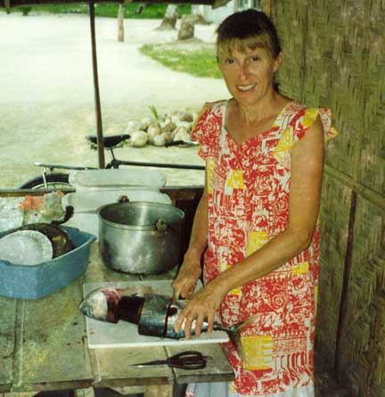
Audrey is cutting up a barracuda, a gift from some kind person

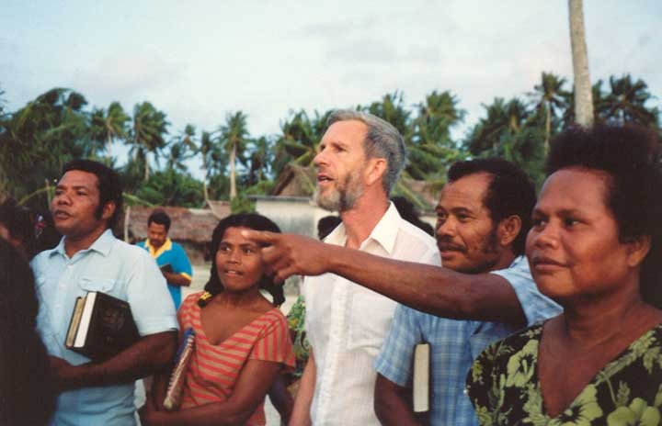
Samson, Janet, Edward, Naomi and Vinton are watching a skit

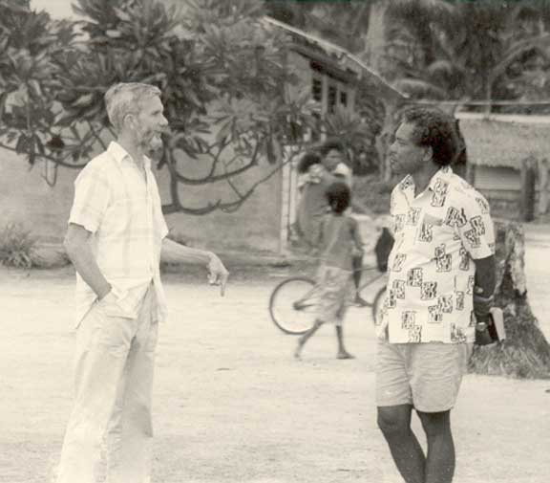
Vinton and friend talking

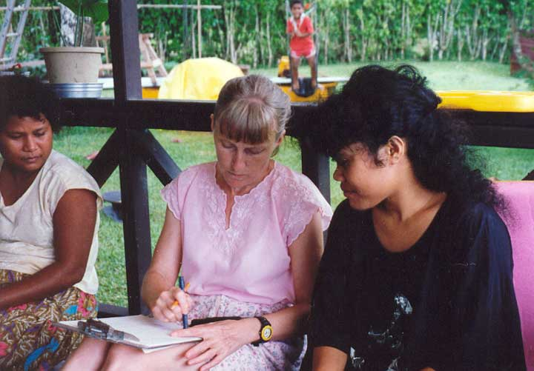
Delmay is giving Audrey words as she writes them down

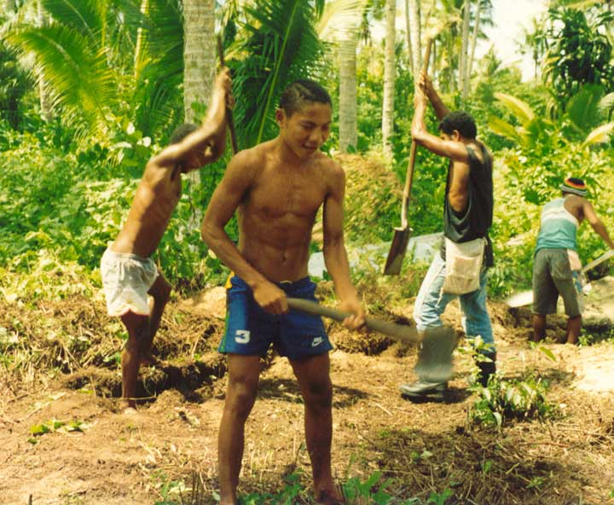
The football team is hard at work

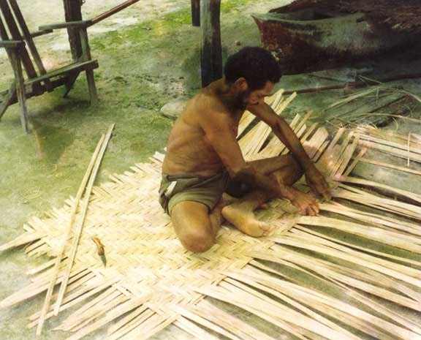
James Taiwe weaves a wall for the new house

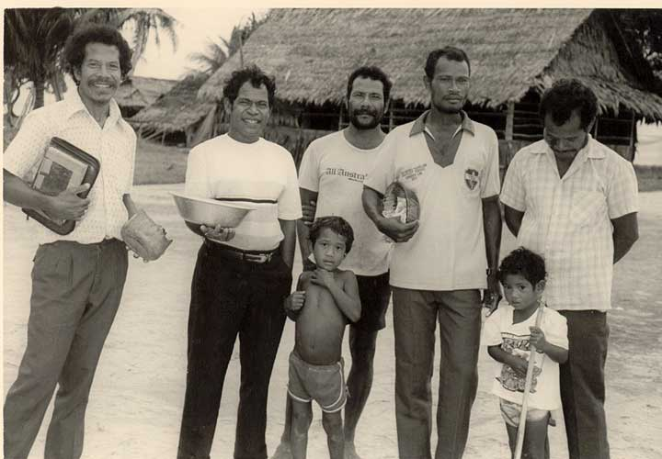
Some Church Elders

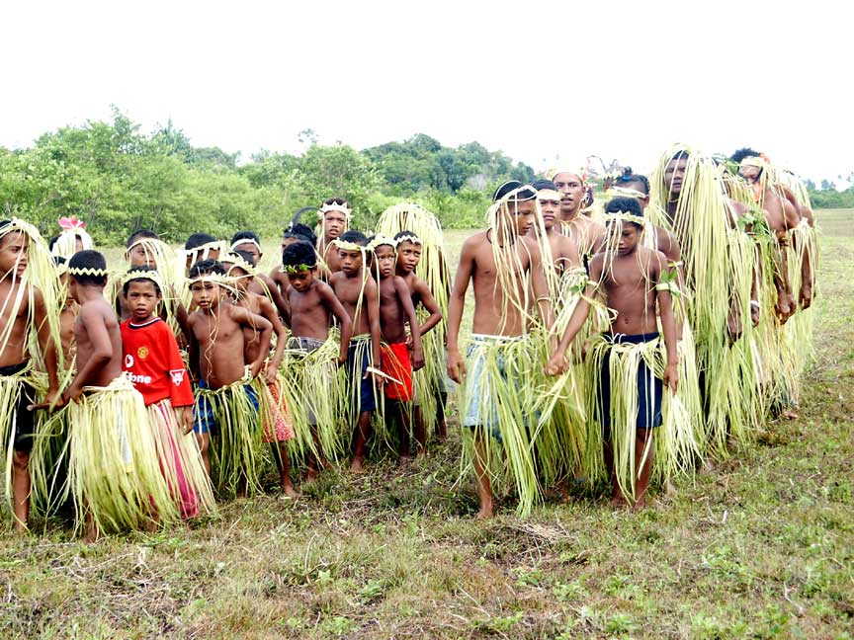
Wuvulu New Testament Dedication: Dressed up for the special occasion

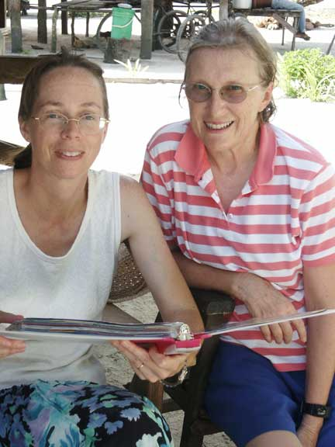 | 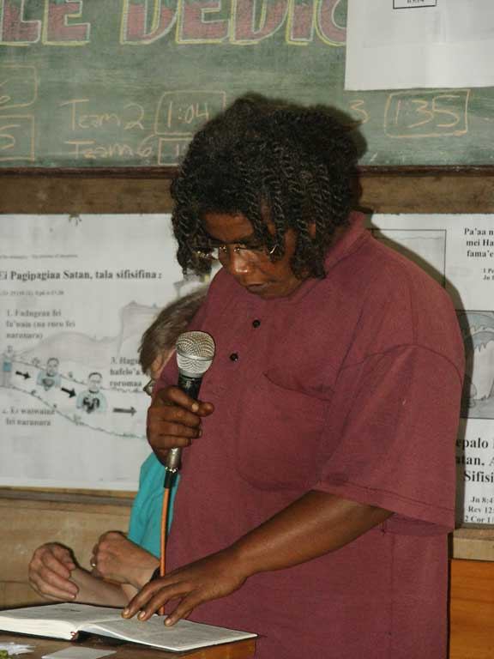
At Dedication: Lois and Audrey | Translator Lucy reading from the New Testament

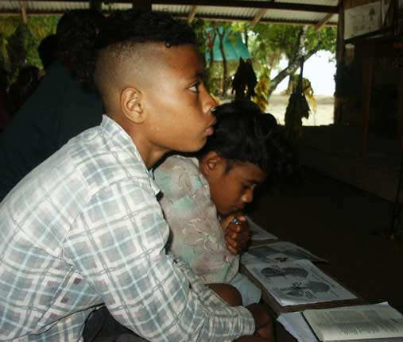
Boys listening to the teaching

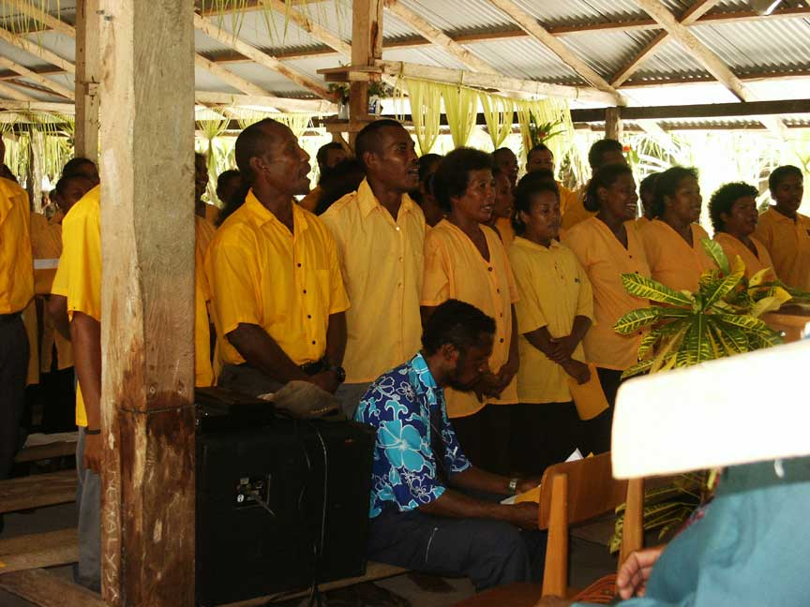
Auna choir

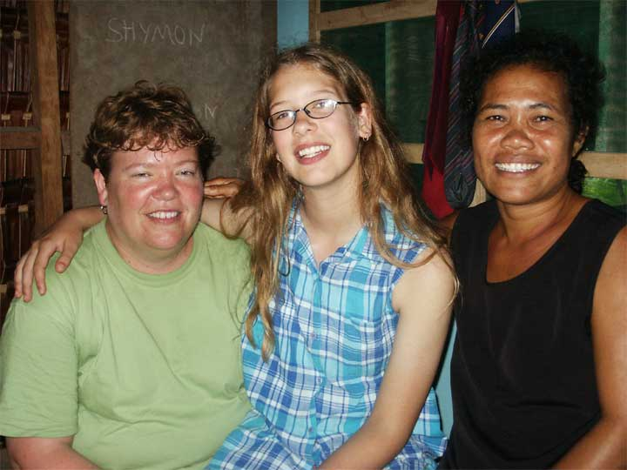
Sheila, Amanda and Delmay

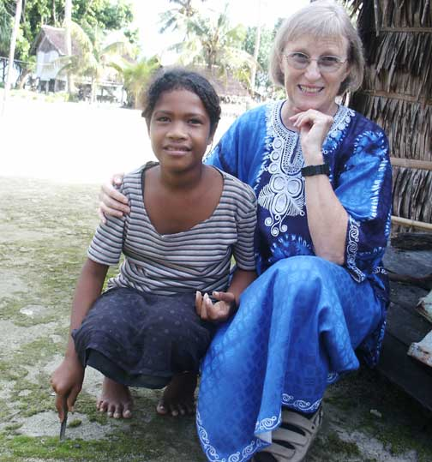
Two Audreys

James and Lois Hafford began living in Onne village with the Wuvulu people in 1995. They replaced the Goffs as SIL advisors to the Wuvulu translation program, and were able to help the Wuvulu team complete the translation of the New Testament, which was dedicated in 2005.
[to be written – plus pictures from the Haffords]

Seimat
The Seimat people (population approx: 1500) live in the Ninigo Islands which is part of Manus province in Papua New Guinea. The Ninigo archipelago is located some 370 km northwest of Manus Island and 250 km north of Wewak on the mainland.
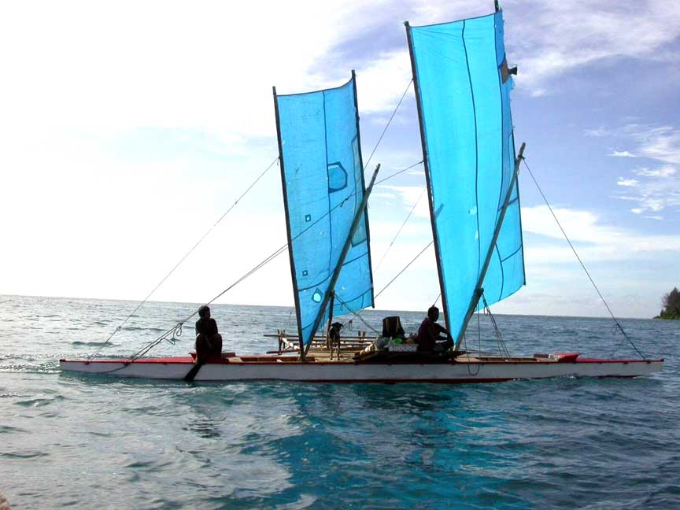
A Seimat sailing canoe

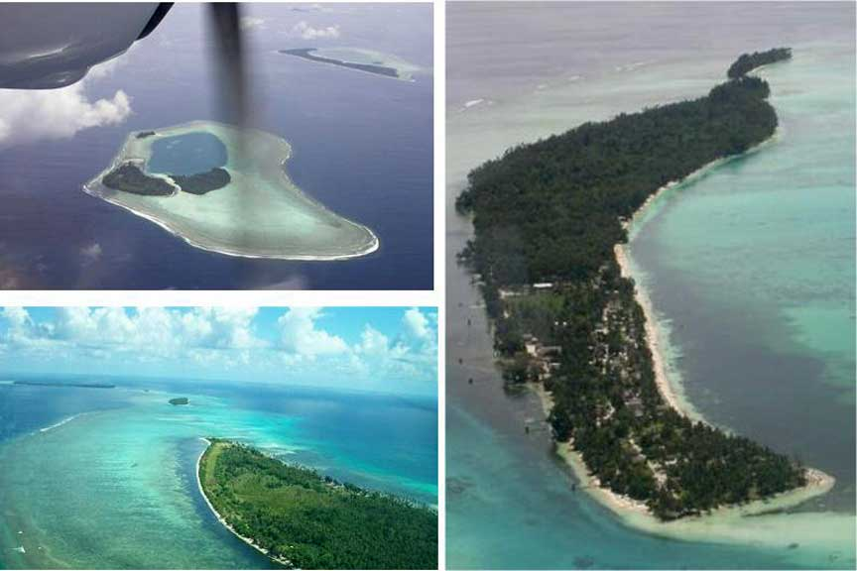
Some of the Ninigo Islands
Beata Wozna (Poland) and Theresa Wilson (United Kingdom) began living with the Seimat people on Pihon Island in 2002.

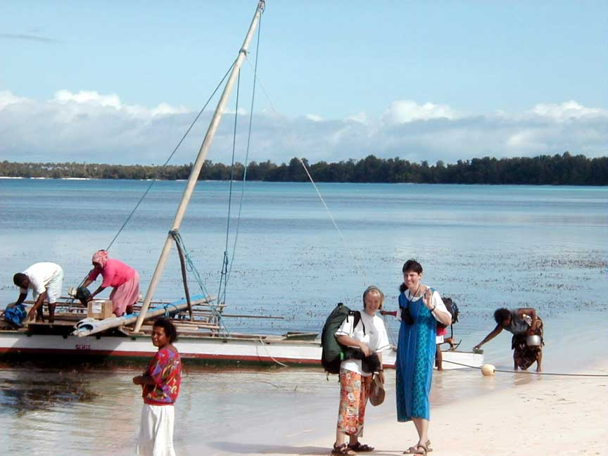
Theresa and Beata about to board the a sailing canoe in the Seimat group in March 2002

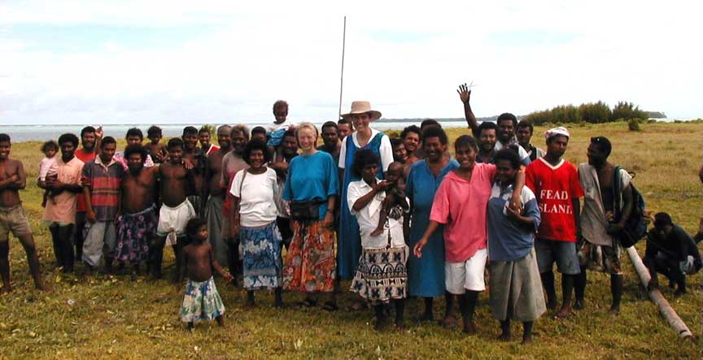
Theresa and Beata with Mal Island people in 2002

They first visited the Ninigo Islands with their SIL Regional director James Hafford in March 2002 and later returned to start working there in August that year. During those first few weeks on Pihon Island, many people came down with Dengue Fever including Beata and Theresa who had to be evacuated to the SIL clinic in Ukarumpa, Eastern Highlands. Having recovered from this they returned to Ninigo to start work again in February 2003.

They started learning and analysing the Seimat language and a workshop for the Seimat community leaders and teachers was held on the 4th July 2003 to decide on the trial Seimat alphabet. A series of literacy workshops were then run in four of the island communities in the years following to give both adults and children practice in reading and writing in their mother tongue and so gain confidence and higher levels of fluency. They also worked together to translate children’s story books and produce other materials for the Seimat elementary teachers to use. This was all essential foundation work which the newly trained Seimat teachers were able to participate in and benefit from. The first Seimat elementary class started on Mal Island in 2003, on Pihon, Liot and Amix in 2004 and on Similam in 2005.

The SIL team then ran workshops to teach and train on the principles of translation work, leading to the initial drafting of the translation of the Gospels by different groups from Patexux, Pihon, Amix, Liot and Mal Islands in 2006. Since then the SIL team has worked together with those from the different communities who had committed themselves to the work. Through the in depth process of translating and checking each book of the New Testament, their goal was to ensure that the Seimat translation is meangingfully accurate, clear and natural. Once the books were checked and approved by SIL translation consultants in Ukarumpa, final read-throughs led to the typesetting of the completed book in Ukarumpa, February to April 2012. The printing of the Seimat New Testament books was completed in 2012 and the Dedication of the Seimat New Testament is due to take place in the Ninigo Islands 21st-23rd May 2013.

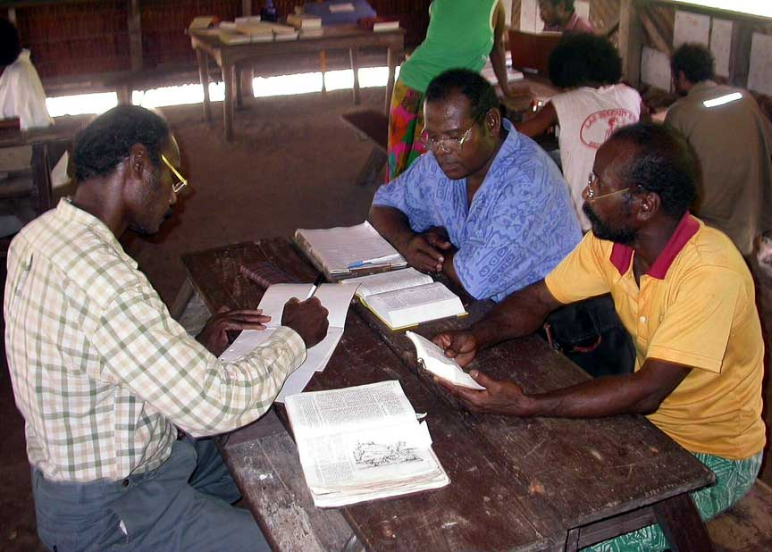
2005 Patexux - Drafting Matthew
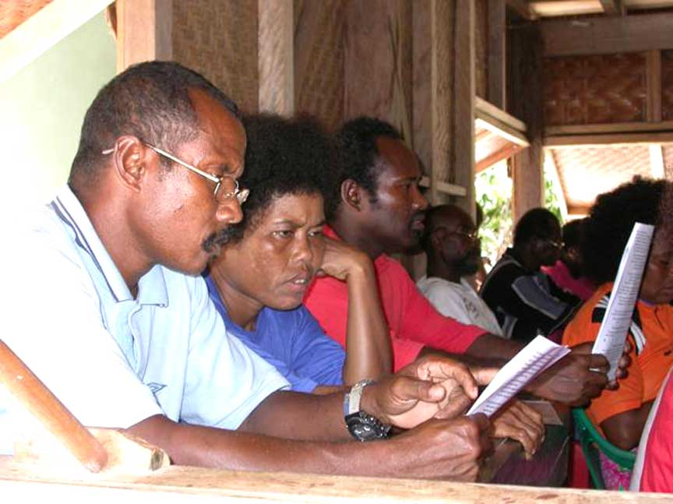 | 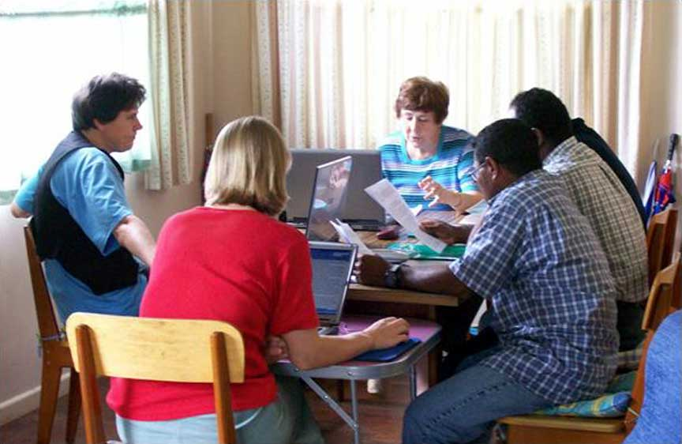
Reading through and checking the translation | Consultant checking Seimat Scripture Ukarumpa

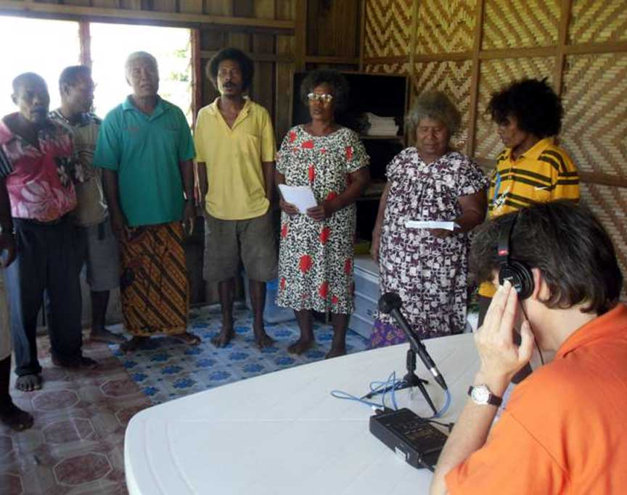 | 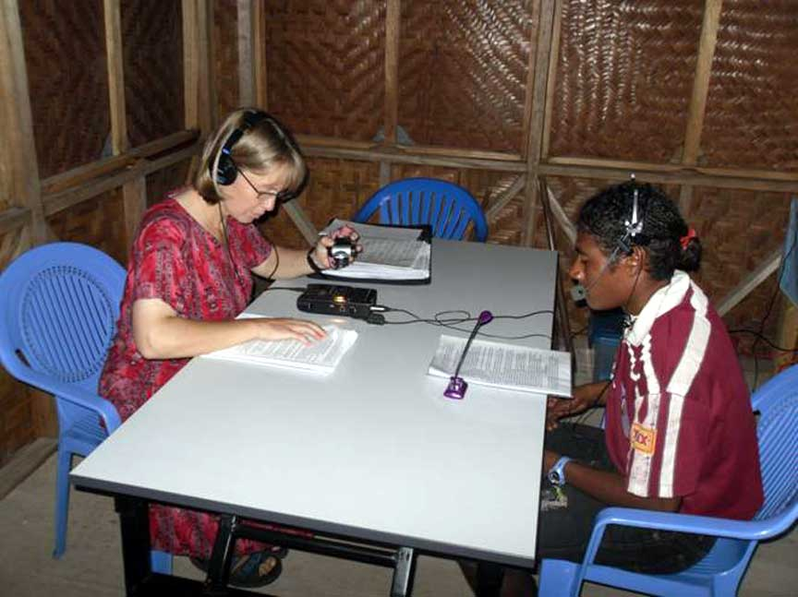
Recording Seimat songs for Manus Radio | Recording some Seimat Scripture stories for Manus Radio

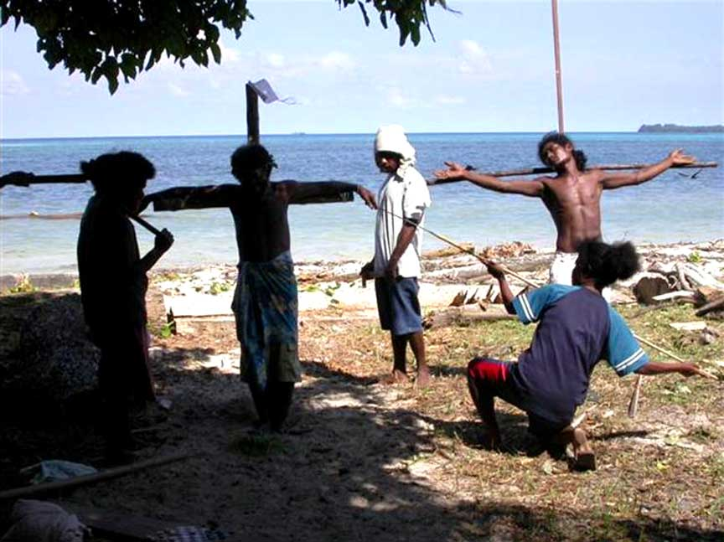
John’s Gospel in Seimat – Drama on Lau Island 2008

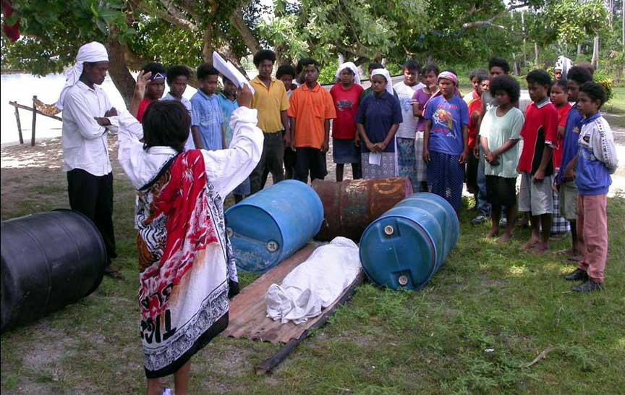
Mal school grade 8 drama of Lazarus 2009

This translation and literacy work among the Seimat people has been supported in prayer and finances by Christians in Beata and Theresa’s home countries, by the SIL PNG branch and by the International SIL and Wycliffe organisations.
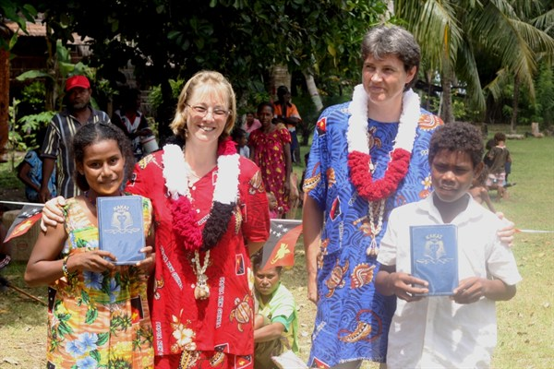
Dedication of Seimat New Testament – 21-23 May 2013

Manus Bible Translation Programs Managed Primarily by Manus People
SIL and the PNGBTA have limited staff and so there are not enough SIL and BTA language teams to allocate in every language group in Manus Province. Over the years many Manus people from various language groups have learned about the benefits of having a translation of the Scriptures and literacy materials in their mother tongue language. God is calling Manus people to be involved in the work of Bible translation in their own mother tongue languages. Some language groups that had SIL involvement in the past are now translating God's Word without direct SIL involvement. Others Bible translation programs are now underway in areas where no SIL or BTA staff have been involved.

Harengan
The Harengan language is spoken on an Island a few kilometers off the northwest corner of the main Manus Island. No SIL team has been available to help the Harengan people, however, Belden Sirip participated in village translation workshops in Lessau village in the Nyindrou area. He was also involved in a trial of the Adapt It program at Ukarumpa in 2001 that determined that the Harengan language could be drafted by adapting it from the Nyindrou text using the Adapt It software program. Since that time Belden has been working on the draft of the Harengan New Testament. Belden attended an Adapt It and Paratext workshop at Ukarumpa in June-July 2013.

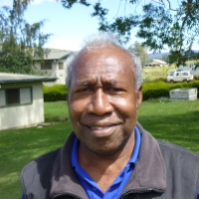 | 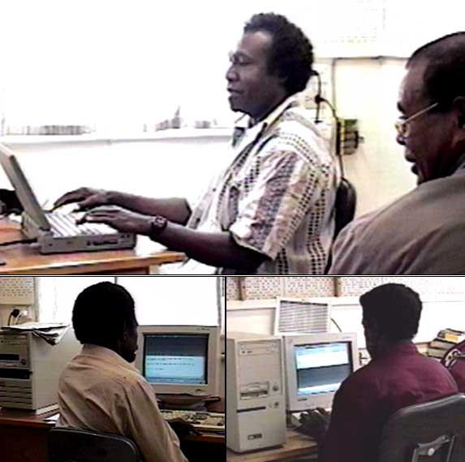
Belden Sirip of Harengan Island | Belden and Charles (top) at Adapt It trial 2001.  Arnold (Bipi) and Herman (Levei) (bottom)

Bipi
Bipi is a language that is spoken by the inhabitants of Bipi Island off the west coast of the main Manus Island. Many Bipi people are bilingual in the Nyindrou language, and some are even using the Nyindrou New Testament that was dedicated in 2002. Before the Nyindrou New Testament was dedicated, Arnold Sikot worked on adapting the Scriptures from Nyindrou to Bipi as part of a 3-week trial in 2001 (see picture above).
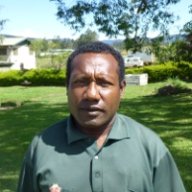
David Hipom from the Bipi language group
More recently, David Hipom has experienced God's call on his life and has committed himself to translating the Bible for his Bipi people. David attended the Adapt It and Paratext workshop at Ukarumpa in June-July 2013. During that workshop David started the process of adapting the Nyindrou language text into the Bipi language.

Sori
The Sori language is spoken on the main Manus Island as well as some other islands in the region of the northwest part of Manus, not far from the Nyindrou language area. The Sori language is closely related to the Harengan language, and some linguists consider the two languages to be dialects of the same language, called Sori-Harengan. Because of their proximity to the Nyindrou many people in the Sori area are bilingual in the Nyindrou language. Therefore it is possible to use Adapt It to create a draft translation from Nyindrou into the Sori language.
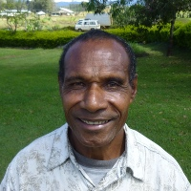 | 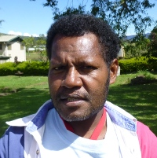
Pastor Paul Posong from the Sori language group | Alex Sapa from the Sori language group
Two Manus men from the Sori language group, Paul Posong and Alex Sapa, attended the Adapt It and Paratext workshop at Ukarumpa in June-July 2013. During that workshop they started the process of adapting the Nyindrou language text into the Sori language.

Khehek
The Khehek language is spoken on the north coast of the main Manus Island. A member of SIL named Stephan Beard worked among the Khehek people, but died while on furlough in the USA.
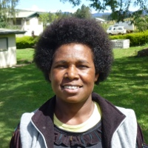
Rachel Ndrelan from the Khehek language group

Recently Rachel Ndrelan felt God's call to help translate the Scriptures into Khehek. Rachel's father worked for many years as a pastor within the Nyindrou language area, so Rachel is a fluent speaker of Nyindrou. Therefore, she attended the Adapt It and Paratext workshop at Ukarumpa in June-July 2013. During that workshop she started the process of adapting the Nyindrou language text into the Khehek language.

Ede (Ere)
The Ede language is spoken in the mid section of the main Manus Island along and inland from the south coast. The Ede language is part of a dialect chain that stretches across the island from the south coast to the Kurti language on the north course.

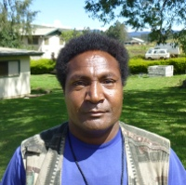
Philip Wowok of the Ede language group

Philip Wowok, from the Ede group attended the Adapt It and Paratext workshop at Ukarumpa in June-July 2013. During that workshop Philip experienced God's call on his life and committed himself to the work of translating God's Word into his Ede language.

Kurti
The Kurti language is located along the north coast and inland in the mid section of the main Manus Island. Kurti is at the northern end of a dialect chain that begins with the Ede language on the south coast. Two expatriate teams worked in the Kurti language group in the past: Wes and Alta Beasley with Pioneer Bible Translators, and Bob and Marla Uebele with SIL. Both expatriate families needed to leave the work in Manus before the Kurti program could finish translating the Scriptures. Now, however, God has been raising up some Kurti people to continue the work.

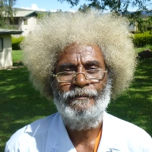
Thomas Putleu of the Kurti language group

Thomas Putleu, from the Kurti group attended the Adapt It and Paratext workshop at Ukarumpa in June-July 2013. During that workshop Thomas experienced God's call on his life and committed himself to the work of translating God's Word into his Kurti language.

Titan, Penchal and Lenkau
The Titan language is spoken in many locations around the south and east coasts of the main Manus Island. On Rambutso Island, Titan is spoken along with two other Manus languages, Penchal and Lenkau. Two SIL expatriate teams worked in the Titan language group in the past: Keith and Ruthann Lusk, and Bob and Barbie Hauser. Keith died before the Lusks could help the Titan people translate the Scriptures. Later, the Hauser family needed to leave their work with SIL in PNG. Now, however, God has been raising up some Titan speaking people from Rambutso Island to continue the work - not just in Titan, but in the two other languages spoken on Rambutso Island: Penchal and Lenkau.

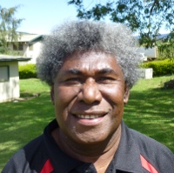  Pastor Bob Kepui of the Titan and Penchal language groups | 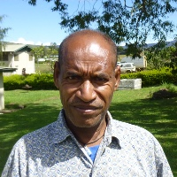  Pastor Mark Pisil of the Titan and Lenkau language groups
Two Manus Pastors, Bob Kepui and Mark Pisil, attended the Adapt It and Paratext workshop at Ukarumpa in June-July 2013. During that workshop they started the process of adapting the Scriptures using the Adapt It and Paratext programs. They are excited about the possibility of translating the Scriptures for three language groups which they are fluent in: Penchal, Lenkau and Titan.

Lele
The Lele language group is spoken in and around the Lorengau town area as well as inland from Lorengau in the main Manus Island. One SIL expatriate family worked in the Lele Hai dialect of the language group in the past: Dixon and Doralice Barthel. The Barthel family needed to leave their work with SIL in PNG in the late 1980s. Now, however, God has been raising up some Lele speaking people to continue the work - now in two different dialects of the Lele language.

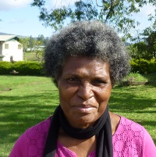  Elizabeth Pokawin from the Hai dialect of the Lele language | 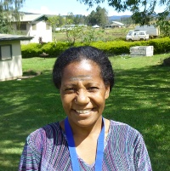  Miriam Pokanis of the Lundret dialect of the Lele language | 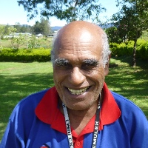  James Pokalai of the Lundret dialect of the Lele language

Former Governor of Manus Province, Stephen Pokawin, has been working for a number of years to translate the Scriptures into his dialect of the Lele language. Stephen is being assisted by his wife Elizabeth who attended the Adapt It and Paratext workshop at Ukarumpa from June-July 2013. God has raised up a number of other Lele people to help with the work of Bible translation into the Lele language and its dialects: Miriam Pokanis and James Pokalai also attended the Adapt It and Paratext course at Ukarumpa in June-July 2013. All are eager and committed to completing the translation of the Scriptures into the Lele language.

Pak/Tong
Pak-Tong is a language spoken on two small islands located east of the east end of the main Manus Island. A man named James Ponor from Pak Island actually drafted the entire New Testament into his Pak language - apart from any assistance from SIL or any other organization. He drafted it by hand on exercise books, but James died before he could carry his Bible translation efforts any further. There is interest on the part of the Pak/Tong people to see the work completed that James started. The translation draft that James did has been transcribed and so it now exists within the Paratext Scripture editor. It is awaiting further revision work by committed translators before it can be published and made available to the Pak/Tong people.

Likum
Likum is a small language spoken in a single village within another language group - the Nyindrou language. The Likum group has expressed interest getting the Scriptures translated for their people, even though the Likum people can read and understand the Nyindrou Scriptures. It would be possible for some Likum speakers to adapt the Scriptures from Nyindrou into Likum. The work is currently awaiting committed Likum translators to do the adaptation and translation work.

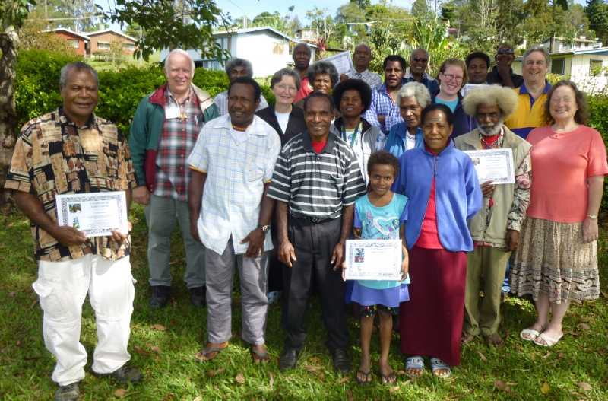
Participants at the Adapt It and Paratext Workshop at Ukarumpa June-July 2013

Underwriting of Scripture Publications and multi-media equipment
Many people in the rural areas of Papua New Guinea cannot afford the true cost of published Bibles, New Testaments and individual Scripture books. To help cover the cost of publishing these books and multi-media equipment used to communicate the message of the Bible, a number of organizations have helped to underwrite the cost of these materials and equipment. The Bible League and Wycliffe Bible Translators has funded the publication of many of the Scripture publications in the Manus programs, so that those materials can be sold to village people at a cost they can afford.

The SeaCoast Grace Church of Cypress California and the Kingdom Works Foundation has graciously funded the cost of the multi-medial equipment and generator for the showing of the Nyindrou Luke video among the Nyindrou villages.

Many publications produced in Manus programs have been self-funded through the gifts of individuals, both overseas and locally within the language group.

Acknowledgments
We SIL and PBT expatriate families who have worked in Manus Province could not live there and help Manus people translate the Bible into their own languages and develop their literacy programs without the assistance of the individuals, communities and churches of Manus. We thank them for helping us in so many ways too numerous to count. We owe a debt of gratitude to our village families for sharing their lives, their languages and their cultures with us. We rejoice with them and Praise the Lord of Life who makes it possible for the Manus people to hear the Words of Life in their own heart languages.

The survey was conducted in 1980, but was later formally published in Pacific Linguistics as SCHOOLING, Janice; SCHOOLING, Stephen J., authors. 1988. "A preliminary sociolinguistic and linguistic survey of Manus Province, Papua New Guinea." Pacific Linguistics A 76: 211-41
The Nyindrou-English Practical Phonology was published locally in July 1982. It was revised and reprinted in various forms in September 1982, February 1983, April 1983, October 1983, October 1986, and April 1993.

